The Trail Tail
(Run #11, 5 February 2000)

Great turn out today, 14 total, including 5 Virgins; new record. Keep bringing the virgins to sacrifice. The hares, Little Blow Peep and NN Dave (to be named later in article), planned a strategic trail in an attempt to avoid being snared by Drag Queen. What they didn't plan on was NN Pat and his knowledge of the hills. The trail started out on time thanks to someone other than Drag Queen volunteering to Hare. After handing out all of the awards to stand ins since the actual awardees failed to show up, the pack headed out the main gate and straight down the road. Several, or should I say, many check points later, the trail finally turned right up parallel to the river and up, up, up the hills. After everyone found out that they really weren't in shape, the trail headed down to the streambed. Not sure where it went after that, since Drag Queen made several short cuts and helped the pack out with his whistle and short cut markings. The trail circled back down the road, up a brick road (where the hares were snared by NN Pat who obviously is allergic to flour and chalk since he never saw trail), and over behind the park behind Cookies. Drag Queen broke out his military tactics book and decided that the hares had to come down since there was no place for a car to drive, and laid a shortcut trail along the bottom (already determined he was out of shape from the previous hill and didn't have to be told twice) which most of the pack followed. Swing This must have been screwed by short-cutting hounds at his old hash, because he didn't take advantages of any of the shortcuts and ended up being LRB; welcome to the hash. Voting on the Hash Shit was close. Was it going to be Little Blow Peep for being uncoordinated and falling down and then telling someone about it, NN Hillary for not showing her breasts to the male hashers at a Boob Check, or NN Stan and Orgasmizer for not showing up for a competitive run as planned; well, it don't take a genius to figure it out, the titty vote wins and so did NN Hillary. After posing for photos taken by Ajama, the group again awarded NN Hillary for winning a competitive run. NN Dave got his name today. Choices ranged from I G-Spot, Gofer, Infant Genitalia (my favorite), Limp Noodle, or No Taste, No Balls. Well, although those were good, NN Dave became Orgasmizer; congratulations. Photos will be developed before the next hash, but no promises. The film was 24 Exposures and the display said 36 and kept on taking photos. May have missed some photos from past hashes. Now that NN Anna is our Hash Flash, hopefully this won't happen again.
Down-Down Activities

Virgin(s): Swing This, NN Mike Garcia, NN Don Willey, NN Tony Poland, NN Kevin Huggins
Visiting Hasher(s): None
Returning Hasher(s): None
Last Timer(s): None
5th Timers (Named): NN Dave Lorenz (Orgasmizer)
6th Timers (Whistle): None
10 Timers: Drag Queen
20 Timers: None
Birthdays: None
Hash Shit: NN Hillary (NN Cathy is sponsor).
FRB: NN Pat (Stop and Blow is sponsor)
LRB: Swing This (Orgasmizer sponsor)
Virgin Hares: None
Hares: Little Blow Peep, Orgasmizer
Oldest Hasher: Orgasmizer
Hasher with Most Runs: Drag Queen
Mismanagement

Religious Advisor: Drag Queen
Grand Master: Too Good To Swallow
Grand Master Apprentice: Little Blow Pep
On-Sec: Drag Queen
Hash Cash: Drag Queen
Habadasher: TBD, Need Volunteer
Beirmeister: TBD, Need Volunteer
Head Giver: TBD, Need Volunteer
Hare Raiser: Drag Queen
Song Meister: TBD, Need Volunteer
Hash Flash: NN Anna
Woody: TBD, Need Volunteer

For more info TSTH3 go to:
http://www.geocities.com/dragqueen_hhh/Taegu_San-Tokie_Hash_House_Harriers.html
Or e-mail Drag Queen at: dragqueen_hhh@yahoo.com
For info on other hashes in Korea go to: http://members.aol.com/SngMstr/korea.html

HARELINE
To sign up to be a hare see Drag Queen.

- 18 Feb: 2000, Full Moon Hash, Start location "normal", Hares Drag Queen, NN Kevin
- 26 Feb: 1400, Start location "normal", Hares TBD
- 5 Mar: 1000, Seoul Marathon, Contact DQ ASAP
- 17 March: 2000, Full Moon Hash, Start location "normal", Hares TBD
- 1 Apr: 1400, Start location "normal", Hares TBD
- 21 Apr: 2000 Full Moon
- 29 Apr: 1400
- 19 May: 2000 Full Moon
- 26-29 May, Hash Around The Rock, Starts in Seoul, make runs at most Hashes in Korea
- 16 Jun: 2000 Full Moon
- 24 Jun: 1400
- 26 Aug: 1400, 1st Anniversary Run

* Normal Start Location = Btwn Camp Walker Bowling Alley and Community Activity Center

Info on the Taegu San-Tokie HHH

- Meets on the Friday closest to every Full Moon (8 P.M.), last Saturday of every month (2 P.M.), and on holidays and special occasions; ** dates will be adjusted around conflicting events so read the hash trash and watch the TSTH3 Home Page
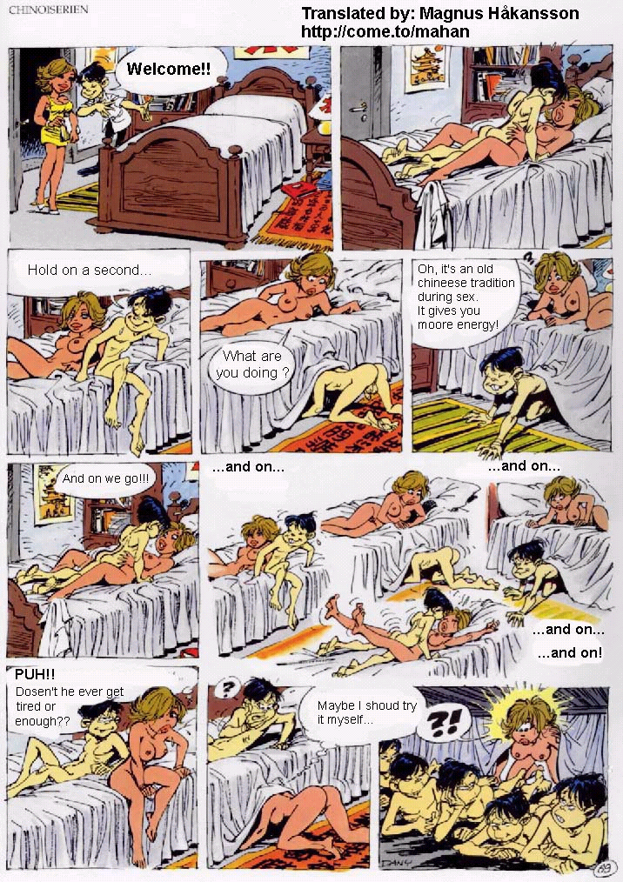
- Cost is $5 or W1,200 to pay for beer, food, & other expenses associated with hashing
- Trails: Saturday about 5-6 miles, Full Moon about 4 miles
- Hares get 15 minute head start plus pack walks for 2 minutes on Saturday runs and Hares get 10 minute head start plus 2 minute walk for Full Moon runs
- Bring money for bus, subway or taxi back home after Down Down
- Hares plan an On-On-On after Down Down for all to go to and eat, drink and socialize

Joke(s) of the Week

A couple of women were playing golf one sunny Saturday morning. The first of the twosome teed off and watched in horror as her ball headed directly toward a foursome of men playing the next hole.
Indeed, the ball hit one of the men, and he immediately clasped his hands together at his crotch, fell to the ground and proceeded
to roll around in evident agony. The woman rushed down to the man and immediately began to apologize. She explained that she was a physical therapist: "Please allow me to help. I'm a physical therapist and I know I could relieve your pain if you'd just allow me!" she told him earnestly.
"Ummph, oooh, nnooo, I'll be all right. I'll be fine in a few minutes," he replied breathlessly as he remained in the fetal position still clasping his hands together at his crotch. But she persisted, and he finally allowed her to help him. She gently took his hands away and laid them to the side, she loosened his pants, and she put her hands inside. After a short massage she asked him, "How does that feel?"
To which he replied: "It feels great, but my thumb still hurts like hell!"

A man bumps into a Woman in a hotel lobby and as he does, his elbow goes into her breast. They are both quite startled. The man turns to her and says, Ma’am, if your heart is as soft as your breast, I know you’ll forgive me.” She replies, “If your dick is as hard as your elbow, I’m in room 221.”

