Masks of West Africa are some of the most unique and fascinating of all the masks in Africa. Each mask has its unique meaning and speaks of the belief systems of the people as to their cosmology and social order. These masks are authentic in that the people with whom these masks originate make them.
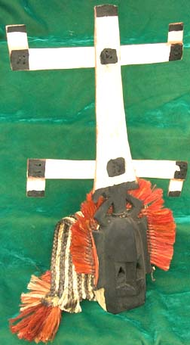  AM1405 "Kanaga" mask-Dogon tribe, Mali | 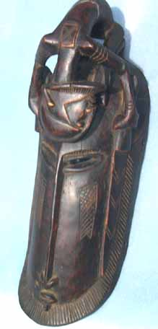  AM1890 Warriors fealty mask-Dogon tribe, Mali
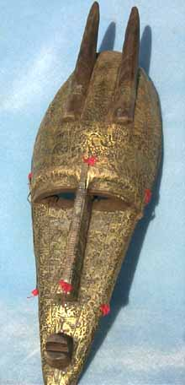  AM1916 Maraka antelope mask, bronze clad-large-Maraka people, Mali- Large  AM1916a Medium antelope mask | 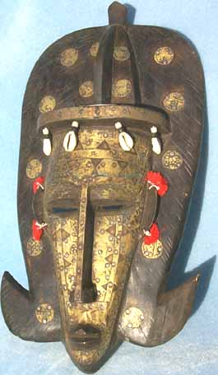  AM1917 Maraka Queen-Large bronze clad, approx 18"-Maraka people, Mali- Large  AM1917a Medium Maraka Queen

