Masks of West Africa are some of the most unique and fascinating of all the masks in Africa. Each mask has its unique meaning and speaks of the belief systems of the people as to their cosmology and social order. These masks are authentic in that the people with whom these masks originate make them.
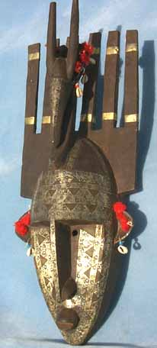  AM1918 Many horned initiation mask-large. @ Antelope on top-Bambara people, Mali | 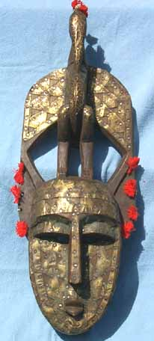  AM1947 Many horned initiation mask-large. @ Bird on top-Bambara people, Mali
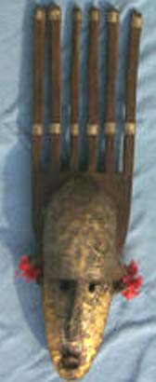  AM2508 Many horned initiation mask- med-Bambara people, Mali | AM2509 Monkey mask-Dogon people, Mali

