Passport Masks are small masks that, it is said, were carried by members of the different people groups to be shown as identification as to what group they belong. These small masks are great for collectors who have limited space to decorate.
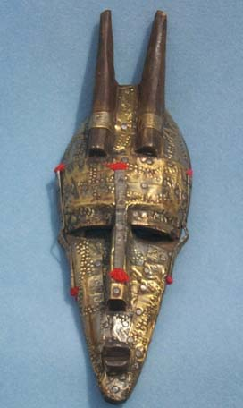  AMP1855 Maraka antelope passport mask, Mali | 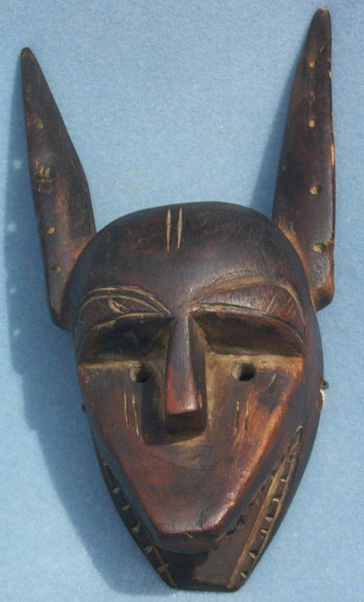  AMP1856 Dogon Hyena Passport mask, Mali
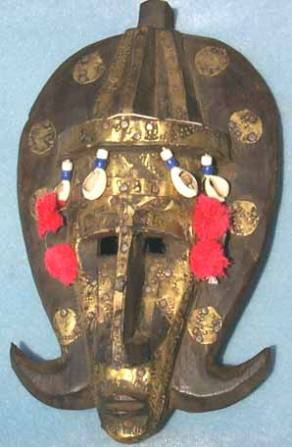  AMP1919 Maraka queen passport mask, Mali | 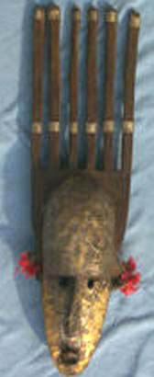  AMP1920 Maraka queen passport mask, Mali

