Passport Masks are small masks that, it is said, were carried by members of the different people groups to be shown as identification as to what group they belong. These small masks are great for collectors who have limited space to decorate.
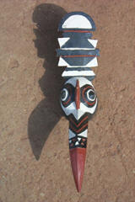  AMP2409 Bobo passport mask-hornbill- approx. 7 to 10" | 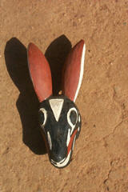  AMP2410 Bobo passport mask-rabbit-  Approx. 7 to 10"
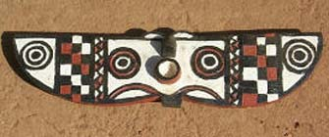  AMP2411 Bobo passport mask-butterfly- approx. 7 to 10"  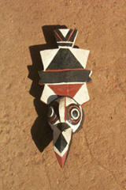  AMP2412 Bobo passport mask-crow- approx. 7 to 10" | 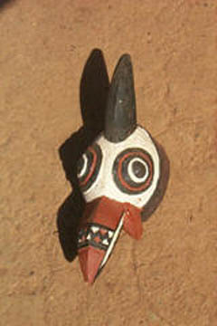  AMP2413 Bobo passport mask-Guinea hen-  Approx. 7 to 10"

