Passport Masks are small masks that, it is said, were carried by members of the different people groups to be shown as identification as to what group they belong. These small masks are great for collectors who have limited space to decorate.
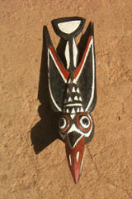  AMP2414 Bobo passport mask-winged bird- approx. 7 to 10" | 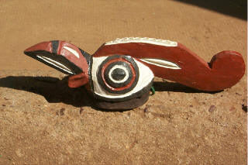  AMP2415 Bobo passport mask-rooster- approx. 7 to 10"
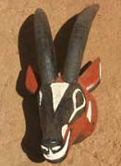  AMP2416 Bobo passport mask-Roan antelope- approx. 7 to 10" | 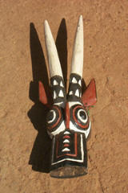  AMP2417 Bobo passport mask-comic roan  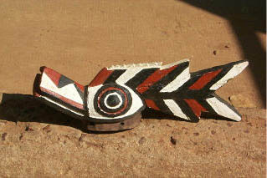  AMP2418 Bobo passport mask-fish-a croc- approx. 7 to 10"

