Batik Paintings are created by covering all parts of the design, that one does not want dyed, with wax, and then dyed with one color. This process is repeated for each color to be used on the painting. The artist, Theodore Asohola, uses the ceremonies and daily life of the peoples of West Africa as his themes. Many of his portrayals are done in the cubistic style made popular by Picasso.
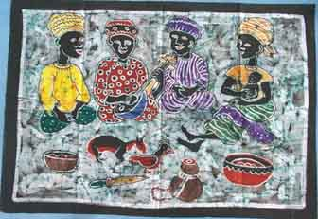  APB2130 Thank you for Yesterday, 24 x35" | 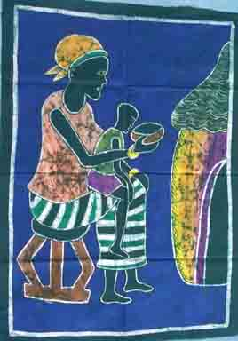  APB2131 Mother's Love of Child
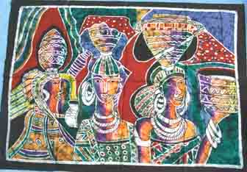  APB2133 African Sisters 27x38" | 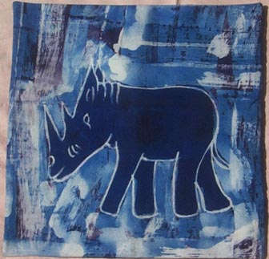  APB2463 Rhino batik painting, approx 13" x 14"

