Batik Paintings are created by covering all parts of the design, that one does not want dyed, with wax, and then dyed with one color. This process is repeated for each color to be used on the painting. The artist, Theodore Asohola, uses the ceremonies and daily life of the peoples of West Africa as his themes. Many of his portrayals are done in the cubistic style made popular by Picasso.
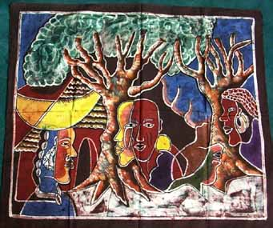  APB2806 The Iroko Purification Celebration | 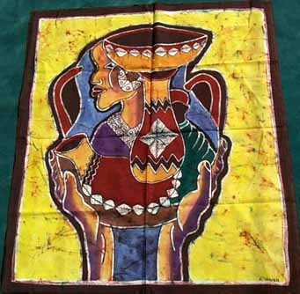  APB2807 The sacred Pottery
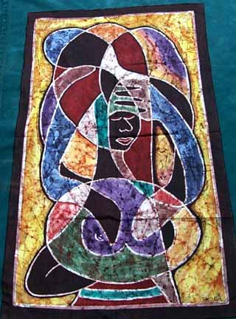  APB2808 A women’s dreams | 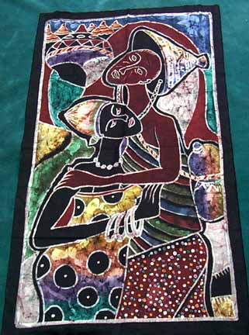  APB2809 Forgive me

