Batik Paintings are created by covering all parts of the design, that one does not want dyed, with wax, and then dyed with one color. This process is repeated for each color to be used on the painting. The artist, Theodore Asohola, uses the ceremonies and daily life of the peoples of West Africa as his themes. Many of his portrayals are done in the cubistic style made popular by Picasso.
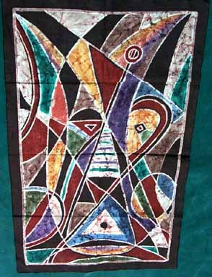  APB2814 The sacred goat of the harvest | 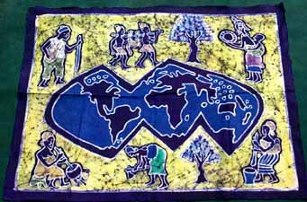  APB2815 Map of the world
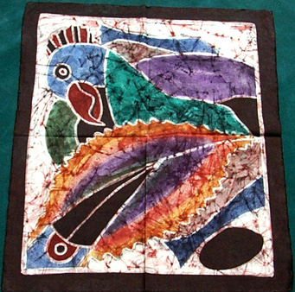  APB2816 The Parrots | 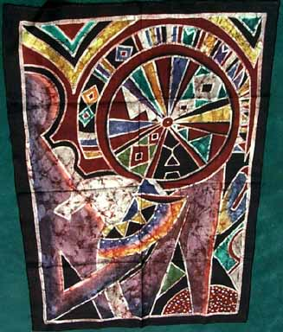  APB2817 My Child

