Mud cloth Paintings are created in the same way that the mud cloth clothing are made, except painted as a picture. Cotton fabric is soaked in a fixative tea called “Galama,” preshrinking the fabric. The patterns are painted with a specially prepared mud mixture, dried, and then rewashed. The variety of earth tone dyes come from various leaves and barks from local plants.
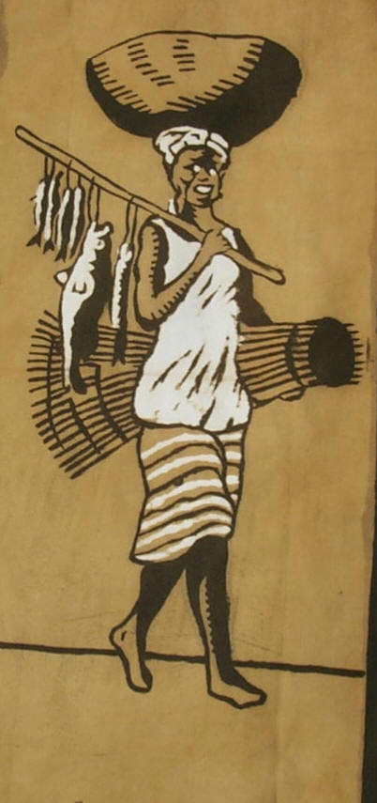  APM1314 Mud cloth painting- Bozo Women With Fish-approx 15 X 25" | 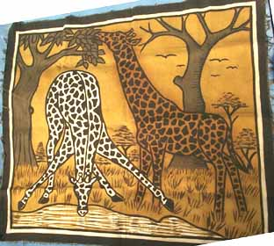  APM1985 Picture-mud cloth giraffe drinking 29 1/2 x 25 1/2"
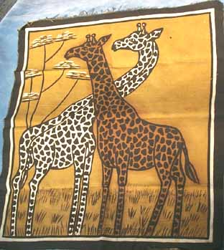  APM1987 Picture-mud cloth giraffe standing 29 1/2 x 25 1/2" | 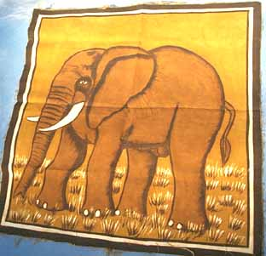  APM1988 Picture-mud cloth elephant 24" x 24"

