Oil Paintings by Mouctar from Mali, capture in vivid colors the views of his home land and those of the neighboring countries. From the mighty Sahara desert to the costal fishing villages, he captures in almost photo-like quality the exotic views of the African landscape. and it’s peoples.
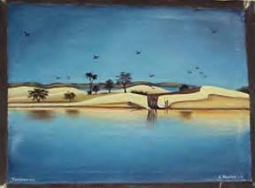  APO2492  Oil painting- "River scene" - 14"X 11" | 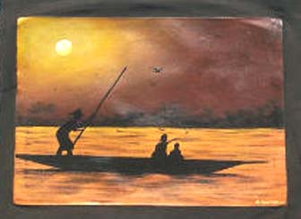  APO2493  Oil painting-Family poling the Niger - approx 14 X 11"
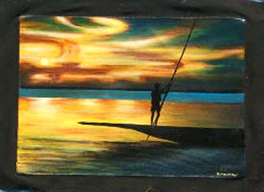  APO2494  Oil painting-Sunset on the Niger - approx 14 X 11" | 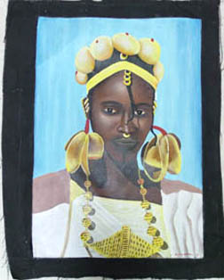  APO2495  Oil painting- Fulani Women- approx 11 X 14"

