 |  |  |  |  |  | Division of General Motors Corporation |  |  |  |  |  |  |  |  | 
MODEL: 1987 GRAND NATIONAL |  |  |  |  |  |  |  |  | VEHICLE IDENTIFICATION NUMBER: 1G4GJ117XHPXXXXXX
DEALER TO WHOM DELIVERED:
DELIVERD TO DELAER AT:  ^{(IF DIFFERENT FROM ABOVE)} |  |  |  |  |  |  |  |  | FINAL ASSEMBLY POINT: PONTIAC, MI. U.S.A.
THE FOLLOWING ITEMS ARE STANDARD ON THIS MODEL AT NO EXTRA CHARGE UNLESS REPLACED BY OPTIONAL EQUIPMENT:
* 3.8 L TURBOCHARGED V6 * POWER STEERING * AIR CONDITIONING * DUAL HORNS
-SFI WITH INTERCOOLER * FIXED MAST ANTENNA * LEATHER WRAP STRG WHL * DUAL REMOTE CONTROL
* AUTO OVERDRIVE TRANS * BUMPER GUARDS * INSIDE HOOD RELEASE O/S MIRRORS
* POWER FRT DISC BRAKES * BUMPER RUB STRIPS * LAMP GROUP- COMPLETE * MOLDINGS- DOOR EDGE
* 15’’ ALUMINUM WHEELS * CARPETING- FRT & REAR * HEAVY DUTY BATTERY GUARDS
* STEEL BELTED RADIAL * COLOR KEYED SEAT & * ‘’HDLMPS ON’’ INDICATOR* VISOR VANITY MIRROR
PLY EAGLE GT TIRES SHOULDER BELTS * HALOGEN HEADLAMPS * HIGH MOUNT STOP LAMP
MANUFACTURERS SUGGESTED RETAIL PRICE OF THIS MODEL INCLUDING DEALER PREPARATION |  |  |  |  |  |  |  |  |  |  |  |  |  | 16,154.00
MANUFACTURER’S SUGGESTED RETAIL DELIVERED PRICE FOR OPTIONAL EQUIPMENT INSTALLED ON THIS VEHICLE BY MANUFACTURER
AU3  A01  A31  A90  B88  CD4  CF5  C49  C95  D64  G80  K34  LC2  N33  UM6  US7  UW4  VK3  WG1  19U  *** |  | ELECTRIC DOOR LOCKS  SOFT RAY TINTED GLASS  POWER WINDOWS  ELECTRIC TRUNK LOCK RELEASE  PROTECTIVE BODY SIDE MOLDINGS  2-SPEED WINDSHIELD WIPER/DELAY  POWER ASTRO ROOF, ELECTRIC SLIDING  ELECTRIC REAR WINDOW DEFOGGER  FRONT SEAT READING LAMPS  LIGHTED VISOR VANITY MIRROR  PASSENGER SIDE  LIMITED-SLIP DIFFERENTIAL  ELECTRONIC CRUISE CONTROL  ENGINE- 3.8 LITRE (231 CID) SFI  TURBOCHARGED V6 W/INTERCOOLER  TILT STEERING COLUMN  DELCO-GM CASSETTE TAPE AND ETR  AM-FM STEREO RADIO WITH  SEEK AND SCAN, AUTO REVERSE  AND CLOCK  AUTOMATIC POWER ANTENNA  CONCERT SOUND SPEAKER SYSTEM  FRT LICENSE PLATE MOUNTING  POWER SEAT 6-WAY (DRIVER SIDE)  EXTERIOR COLOR – BLACK  TRIM 583 – BUCKET SEATS IN  GRAY CLOTH |  |  | 145.00  NO CHARGE  210.00  50.00  60.00  NO CHARGE  925.00  NO CHARGE  24.00  50.00  NO CHARGE  175.00  NO CHARGE  NO CHARGE  NO CHARGE  70.00  95.00  NO CHARGE  240.00  NO CHARGE NO CHARGE
THIS GM PRODUCT, INCLUDING ALL COMPONENTS, IS PRODUCED FOR BUICK
BY VARIOUS GM OPERATIONS AND SUPPLIERS TO GM WORLDWIDE.
Compare this vehicle to others in the FREE GAS MILEAGE GUIDE available at the dealer. |  |  |  |  |  |  |  |  |  |  | OPTIONS SUBTOTAL |  |  | 2,044.00
 | CITY MPG   |  | 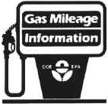 |  |  |  | HIGHWAY MPG   |  |  |  | DESTINATION  CHARGE |  |  | 430.00
 |  |  |  |  |  |  |  |  |  |  | TOTAL AMOUNT  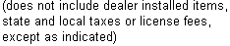 |  |  | 17,703.00
 |  |  |  |  |  |  |  |  |  |  | 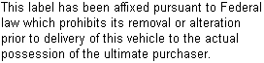

THE GM PROTECTION PLAN, AVAILABLE AT EXTRA COST, SUPPLEMENTS YOUR NEW VEHICLE WARRANTY. ASK
FOR DETAILS AND PRICES
ON THE NUMBER ONE PLAN IN THE U.S.
 | 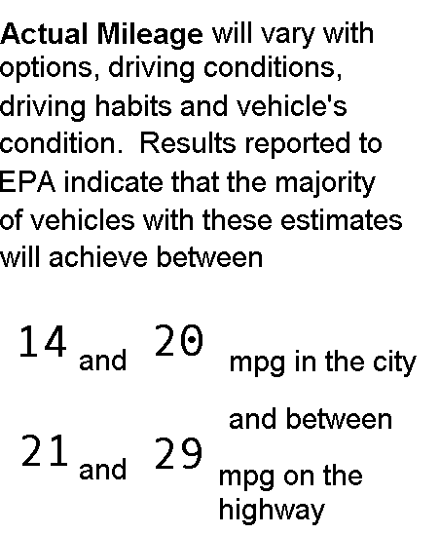 |  | 1987 REGAL  3.8 LITER V6 TURBOCHARGED ENGINE  FUEL INJECTION, AUTO LOCKUP MID-SIZE  4 SPD TRANS  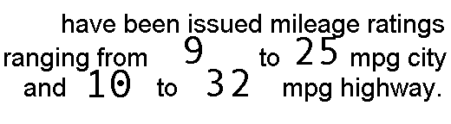  CATALYST,  FEEDBACK FUEL SYSTEM
Estimated Annual Fuel Cost: $825

G7D
 | 1G4GJ117XHPXXXXXX
(This is an approximate reproduction of the original window sticker)

