
END USE SOLUTIONS

Assessment of a Gas Quality Survey for Interchangeability:
Industrial Process Heaters

Topical Report, GTI Project Number 20420
February 2007

GTI Technical Contact:
Tanya Tickel, PhD
847-544-3429
tanya.tickel@gastechnology.org

David Cygan
david.cygan@gastechnology.org

John Wagner, PhD
john.wagner@gastechnology.org

David Rue
david.rue@gastechnology.org

M. Frank Johnson, PhD
frank.johnson@gastechnology.org

Assessment of a Gas Quality Survey for Interchangeability:

Industrial Process Heaters

Introduction
Industrial process heaters, both varied and versatile, are designed to accommodate the diverse needs of every type of manufacturer. No study with publicly available data exists to predict interchangeability issues for the many burners used in industrial processes, but the Gas Technology Institute (GTI) will soon begin interchangeability testing on selected industrial process heaters for the California Energy Commission, with final results publicly available in early 2009. Burner tests for residential and appliance applications that compare performance using domestic natural gas quality and simulated international LNG compositions tend to indicate they can operate within the NGC+ Whitepaper specifications, however maladjusted legacy appliances may pose an additional risk that must be assessed and handled during the implementation process for any new supply.
The major differences between residential gas-fired equipment and industrial gas-fired equipment are that emissions may be regulated, and that the fuel/air ratio is adjusted on site for optimum performance with the local gas. About 45% of the total gas used by manufacturers in the Northeastern U.S. goes to process heat, according to 2002 census data (reference EIA MECS Database). Figure 1 compares this and the other manufacturing uses of natural gas. Stakeholders identified combustion equipment in process heating only for assessment, mainly the HVAC/Facility applications are not expected to present an interchangeability issue within the range of gases specified in the NGC+ Whitepaper. Although this is a reasonable assumption, poorly maintained or adjusted equipment may exist that could pose an emissions problem; these applications will be discussed briefly. Within process heating, there are low temperature and high temperature applications. Low temperature applications have process temperatures below 1000°F, and include steam generation, sterilizing and other food preparation, thermoforming, curing and drying, heated baths for cleaning or coating, and burning volatiles from process exhaust. They outnumber high temperature applications, but high temperature applications represent a significant portion of the total process heat used. High temperature applications include ceramics or porcelain firing, gypsum production, glass production and forming, and metals production.
Figure 1. Northeastern Manufacturer consumption data (2002 MECS)
Heating, ventilation, and cooling (HVAC) applications and small boiler burners are in prevalent use in both large and small facilities, and may pose more of an interchangeability risk than the process heaters, because they can be more poorly maintained. A recent SoCal Gas study (reference Southern California Gas, Gas Quality Study) on modern appliances included studies on boilers; standard boilers showed increased emissions as Wobbe Number increased, and a low-NO_{X} boiler increased in NO_{X} when adjusted to the low-Wobbe gas and fired on the high-Wobbe gas, and increased in CO when adjusted to the high-Wobbe gas and fired on the low-Wobbe gas. No performance changes that affected operational stability or safety were noted. The base adjust gas used in that study had a Wobbe Number of 1342, and gases with Wobbe Number up to 1437 were used as substitutes.
Many modern burner designs are fuel-flexible, and can fire oils, propane, or natural gas. For less flexible equipment, vendors sell systems that allow peak shaving by feeding a 1:3 propane:air mixture in place of natural gas with no change to pipe sizing. The existence of this equipment implies that, at least for some applications, the relatively small changes in the chemical composition of natural gases may not cause a noticeable deviation in product quality or process operation. There is one major difference though: burner operators who switch fuels themselves have tuned each system to operate properly: they know what is coming, and are controlling it. An unanticipated change in natural gas composition does not allow tuning. Both fuels may be natural gases; but when equipment is being pushed to its operating limit, a change in the fuel composition can be the additional extra disturbance that can halt production. Figure 2 is a schematic with the five main issues in industrial process heating. Issues common to each particular end use application are discussed later in this document.
Figure 2. Schematic of Process Heating Application

(1) Air/Fuel Ratio. A fuel with higher HHV needs more air per volume of fuel for complete combustion. A higher Wobbe Number fuel will inject HHV faster than the lower Wobbe Number fuel, but the air supply will be the same. This is the main reason why Wobbe Number is the most important metric of interchangeability in combustion applications: too great an increase in Wobbe Number, and there will not be sufficient air to combust the fuel.
(2) Liftoff or Other Loss of Flame Sighting. Some type of flame monitoring is required by insurers or rulemaking bodies. Optical detectors or flame rods are placed to see the flame, or sometimes the spark igniter itself is used. Ions are present during combustion that allow current to flow through the igniter or flame rod to signal a flame is present. Flame rods are notoriously difficult to set up. Liftoff above the flame rod placement, even if the flame is stable, could result in a nuisance shutdown. A full furnace purge and light-off would be necessary to restart. In applications where this is known to be a problem, multiple flame rods are installed for redundant detection. The rod itself is under $100, then add the cost of additional wiring, engineering time, and installation. For a furnace with 10 burners, presuming the burner manufacturer has previously installed multiple flame rods in that type of burner, cost could be up to ten thousand dollars to pay for a week of a few engineers’ time, not including the cost of furnace down time. The other option is to adjust the burner to something in between the 1345 and 1400 Wobbe, and hope that the ±2% fluctuation on either side is not enough to lose sight of the flame. That would require an emissions monitor, a few engineers from the burner manufacturer, and time to iteratively adjust and test the burner emissions until the right %O₂ in the exhaust is recorded.
(3) Product Quality. It is probable that product quality will only be an issue at extremes of equipment operation. Gas quality fluctuation can affect flame stability when operating at an extreme low firing rate, causing incomplete combustion and increased CO emissions. These emissions can sometimes affect the product. Overheating may occur faster if product is being held at the lowest firing rate possible and the process downstream cannot slow down further. Adjustment of firing rate or air/fuel ratio would require an operator’s time and some equipment down time. Overheat is also mitigated in practice by opening furnace doors during firing. Cost of adjustment is a few hours of personnel time per burner adjustment, or the added cost of wasted fuel for the open furnace door.
(4) Long-Term Operating Costs. Furnace refractories, boiler tubes, and other process heating equipment that are exposed to high temperatures eventually age and must be replaced. Extended over-firing without adjustment, accumulated exposure to overheat, or cyclic heating and cooling could shorten part life. It is difficult to estimate the scale of the long-term operating costs, and the role that variation in gas quality would play in equipment life.
(5) Emissions. Particularly in regulated areas where plants must pay for their emissions, a change in emissions is a very important effect of variation in gas quality. The more modern, highly engineered burners are designed to operate with as low as 5% excess air, compared with the 15% to 20% excess air of the more conventional burners; or 1%, 2.5% and 3.2% O₂ present in the stack exhaust. Excess air is a safety margin used to accommodate variation in both gas quality and air density. Many operators reduce the excess air to between 5% and 10% to save fuel, which increases the chance for incomplete combustion if a high Wobbe Number fuel is used. Emissions monitoring systems would compensate automatically, and would likely not cause operating problems unless the burner were firing at the edge of its operating limits. Unmonitored systems would require adjustment of the air/fuel ratio to allow a higher %O₂, provided the burner can remain stable, to mitigate emissions for the higher Wobbe Number natural gas. The use of additional excess air would increase operating cost. This would cost a day to a week of consultant time, depending on plant size and the number of burners used, to bring in emissions analyzers and perform a one-time tune up. Annual or semiannual tune-ups are recommended but often not performed.
The following section provides an overview of burner technologies, listed by end-use application, and summarizes the anticipated behavior changes when possible.

Industrial Process Heaters

Space Heaters
Space heaters are in prevalent use in garages, warehouses, and shops in the manufacturing sector, although they are not used for industrial process heat. Most space heaters are vented to exhaust their combustion products outdoors, but smaller, ventless gas heaters also exist. Ventless space heaters exhaust into the room, so it is important that combustion is complete to keep carbon monoxide emissions below the 200 ppm limit identified by OSHA; the modern ones are fitted with an oxygen sensor and shut off automatically upon detecting low oxygen. They come in four basic designs: (1) the most common type fires a line burner into a box to exchange heat with clean air blown through a tube into the room. (2) Recent models have been introduced with the opposite geometry: flame is blown through the inside of the tube and air is blown over the outside. In both of these, the combustion products vent to the outside of the building, and a blower is needed for the combustion air and sometimes to circulate hot air in the room. (3) The ventless line burner, at the bottom of Figure 3, is smaller and uses no blowers. (4) Radiant heaters are also ventless without need for a blower, but there is no open flame: Combustion is retained inside a steel or ceramic mesh that becomes hot and radiates heat. Upon installation, the heaters are adjusted for the proper firing rate. The control system either operates the heater on/off or with high/low/off firing. 1400 Wobbe Number fuels would inject about 4% more heat than the AGT historical fuel, presumably reducing cycle time for these burners but not otherwise affecting their ability to heat the room. Heat exchanger tube life could be shortened slightly because of longer, hotter flames from the regasified LNGs, but whether the change would be measurable is unknown, and it is not as important as the possibility of increased CO emissions.
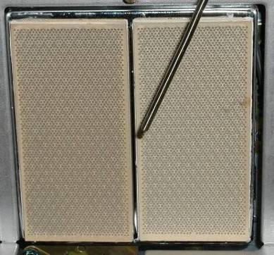
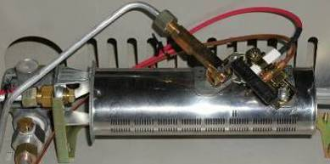
Figure 3. Ventless Radiant (top) and Line Burners
The major concern for these systems is the potential for incomplete combustion when its fuel gas changes to a higher Wobbe Number, especially for the ventless models. The regasified LNGs up to a Wobbe Number of 1400 can inject up to 4% more heat at the same burner setting, requiring up to 4% more air to combust completely. As a rule of thumb, combustion systems are set to operate with about 10% to 20% more air than is necessary to accommodate day-to-day variation in gas quality and barometric pressure, so the 4% increase in demand for combustion air should be covered by this margin of error. In addition, ventless units are equipped with safety sensors that measure %O₂, meaning they should shut off if ever incomplete combustion occurs. Still, ideal conditions are different from those seen in real use, and carbon monoxide emissions could be the one issue of concern with space heaters. Venting and CO monitors should be installed wherever they are required. An orifice may need to be installed to change the range of fuel pressures into the burner. This would be more likely. Orifices alone sell for $3 to $15 on the internet, and orifice replacement kits sell for about $35. A single site may have over 20 space heaters.

HVAC/Facility Heaters
HVAC heaters also are not expected to present a significant interchangeability issue in the range of gases in question, but are discussed for completeness. This category describes furnaces and make-up air burners, which would be in service not only at industrial sites but also in office buildings, schools, warehouses, or other large buildings. Furnaces operate much like space heaters: a burner combusts in a chamber and vents to the outdoors. There is a heat exchanger that keeps the combustion products separate from the air that is recirculated in the building. The burner for a water heater is shown in Figure 4. Combustion air for all of the burner types listed is drawn by the moving gas through slots upstream of the burner. The most likely performance change when switching to a higher Wobbe Number LNG is the slightly longer, hotter flames that may reduce the life of the heat exchanger element. The magnitude of the change is not expected to be very great, and is likely more dependent on poor burner adjustment than on gas quality. A make-up air burner is a duct burner that heats up air drawn into the building to compensate for air that leaves the building. It combusts downstream of a blower, and in some cases the exhaust from the make-up air burner goes into the building along with the heated air, but is a small component of the total flow. Wings, illustrated in Figure 5, allow the burner to hold the flame despite the high cross flow. Perforations in the wings allow additional combustion air through. If any deviation from normal operation is caused by a change to the higher Wobbe Number LNGs, it would again be an increased carbon monoxide output. This would only happen if the air flow is so fast over the burner that the flame quenches before it can completely combust the fuel. This can also happen when firing traditional domestic fuels, if the wings of the duct burner are adjusted incorrectly. The cost of this adjustment is the time lost due to evacuation for high CO levels, plus labor to adjust and test the degree of wing opening to fully combust the fuel. It is possible, because this burner exhausts directly into an enclosed space, that it could receive more public attention than other burners, so a possible additional cost of having a variable gas quality could be time spent on public relations issues.
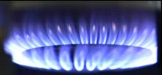
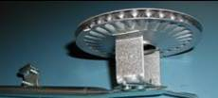
Figure 4. Example Water Heater Burner and mixing schematic
Figure 5. Duct Burner for Make-Up Air

Boiler burners
Boiler burners are a unique category: there are so many of them that they are specially regulated for emissions. Large boiler burners have been engineered for lower and lower NO_{x} emissions; this comes at the price of robust stability, and often the newer boilers have control systems to precisely proportion air and fuel in response to damage. Even without varying fuels between LNG and domestic natural gas, low-NO_{x} boiler burners that are out of tuning can be excited to cause pressure fluctuations and noise. No research is available on fuel gas interchangeability for large boiler burners. With the added variability of a changing natural gas composition, it is possible that a significant change in emissions or vibration will occur when the representative LNGs are first introduced. Re-adjustment is likely all that is necessary, which would require two or three days of a skilled technician’s time.
Equipment | Application
Boiler | Nearly every end use, in different sizes. The biggest ones are for paper and sugar mills—they are more likely to use the low NO_{x} burners
(1) Fuel/Air Ratio Issues
- The most common fuel/air proportioning device for boilers is an adjustable control valve, often called a jackshaft controller. The fuel flow is mechanically linked to the air flow. The linkage has a cam with a number of screws to precisely adjust the fuel valve opening and give the proper proportion with respect to the air valve. The image to the right is a Coen AC Flow Control Valve (Adjustable Characteristic) with 21 different adjustment screws. |  | 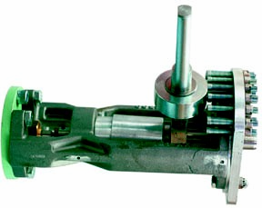
(2) Flame Sensing Issues
- Both infrared and flame ionization detectors are used to monitor boiler burners and their pilot flames. Boiler applications have process temperatures well below 1400°F, meaning the flame monitors must always be on. Liftoff or other ways to lose flame sight have not been reported in small commercial water boilers. The likelihood of it occurring in industrial boilers is not known. Excessive nitrogen in the fuel gas may increase liftoff.
(3) Product Quality Issues
- variation in gas quality is not expected to affect the product: heat from the flame is transferred indirectly to the water, and from the water to the product.
(4) Equipment Lifetime Issues
- Decreased tube life or shorter maintenance schedule is expected because of flame quenching and soot deposit on tube. (Soot impedes heat transfer.) Gas quality is one of many factors related to tube life, such as poor burner adjustment. The contribution of gas quality to decreased tube life may not be measurable.
- Vibrations and noise—the pressure inside of the tube or chamber where a boiler burner fires is controlled. Even a small change in combustion product volume and temperature could change the pressure in the boiler tubes enough to excite vibration. Combustion and pressure control system response will be assessed as part of GTI’s upcoming burner study funded by the California Energy Commission..
(5) Emissions issues
- Higher CO emissions: The low process temperature in boilers makes boiler flames susceptible to premature quenching, meaning they will be more likely to produce excessive CO emissions because of incomplete combustion.
- Low- NO_{X} burners operate at low excess air, for an increased tendency to emit incomplete combustion just because of the change in fuel/air ratio.
Ranking: Significant change expected.
- CO Emissions likely to exceed limit if a low-NO_{X} boiler is used
- Vibrations that would reduce equipment life may occur. Probability unknown.
Recommendation
- If vibrations or increased CO emissions are noticed, then a service person would be called to adjust the screws that set the fuel/air ratio. There can be a lead time required for the service person. Two or three days would be needed to adjust the ratio and monitor operation before and after the change.

Low Temperature Process Heaters
Low-temperature process heaters provide heat for process temperatures below 1000°F. Boiler burners operating with similar temperatures are described separately. Temperatures at the burner can be hotter than 1000°F, but the materials used in the process will not be. Energy efficiency for these burners is important, but it is not so important to push burners to any limit of stability; they should in general be robust to the variations in fuel composition expected from the representative LNGs. If there is lifting, it will be a nuisance in these applications, because the NFPA 86 Standard for Ovens and Furnaces (reference NFPA), which is used by many insurers, requires flame sighting for furnace temperatures below 1400°F. If the flame lifts off out of the sight of the flame sensor, it will cause a nuisance shutdown that may even require re-adjustment of the flame sensor. Whether or not liftoff will be an issue is unknown for industrial burners; there are no data available, and it is part of a GTI study on interchangeability in the coming year. Also because temperatures are relatively low, NO_{x} emissions are not expected to change significantly. CO, on the other hand, presents a possible interchangeability issue: incomplete combustion is predicted for many of the LNG compositions in the accompanying report, “Properties of the Representative LNGs.” One of the first indicators of incomplete combustion is an increase in CO emissions.
The problem of CO emissions is greater in the low-temperature applications because (1) there are more of them, and (2) the burners may not be as well adjusted or maintained. Particularly if the combustion systems exhaust indoors, the potential for a dangerous situation is high. Even though it is the responsibility of the end user to maintain burner adjustment, it is important that all stakeholders are aware of the potential issues.
The low-temperature process heaters will be listed and described in alphabetical order. Each of the manufacturing processes that use them will be described in more detail in the next section of the document, with images that refer the reader back to the descriptions in this section.
- Blown burners
- Duct burners
- Indirect heaters
- Infrared burners
- Line burners (Pipe burners)
- Reciprocating engines
- Surface burners

Equipment | Application
Blown burners | Drying, roasting, and baking for food and textiles manufacturers.  Indirect heating by blowing over a heat exchanger or inside a large tube in chemical or food applications.  Drying of two-sided paper. Melting waxes or surface heating parts prior to dip coating in chemical manufacturing.
(1) Fuel/Air Ratio Issues
- Premix blowers usually have a mechanical linkage to proportion fuel relative to air. The most common is a cam linkage but pressure balance regulators such as the one in Eclipse’s RatioMatic burner (right) are also used.  - These devices have a fixed fuel/air ratio. These are usually run with 2% O₂ to 3% O₂ in the exhaust, which is sufficient for complete combustion of LNG compositions with Wobbe Number ≤ 1400. Pressure balance regulators do not give the same ratio over their operating range, meaning some firing rates may have less or more air. |  | 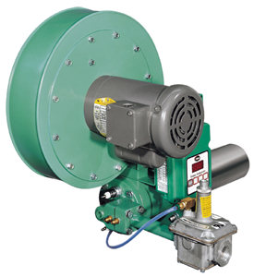
(2) Flame Sensing Issues
- For these applications the flame sensor, if there is one, is often the spark plug. The likelihood of a gas quality change causing liftoff is not currently known but will be investigated in an upcoming GTI study.

(3) Product Quality Issues
- Processes with direct firing will be exposed to different combustion products. This may be an issue for foods or some metal applications, but any application that is very sensitive to its atmosphere is more likely indirect-fired.

(4) Equipment Lifetime Issues
- These burners are often set to one or two different firing rates, and the controller simply switches between them to maintain the set temperature. A higher-Wobbe fuel could increase the frequency of switching and add wear to the equipment.
- Flame impingement on an oven wall, and the associated damage, is a possibility. This depends on the length of the combustion chamber, and the burner settings. Extreme settings are more likely to have performance issues.

(5) Emissions issues
- More NO_{X} is expected from these burners; they operate at about 2% O₂ to 3% O₂ and the higher Wobbe fuel will reduce this to probably 1% O₂ to 2% O₂, for a hotter flame and more NO_{X}. Whether the amount is enough to cause problems is not known.
- Excessive CO emissions are unlikely for properly adjusted burners, but if the blower is blocked or equipment poorly maintained, high CO emissions may occur.

Ranking: Possible change expected.
- NO_{X} emissions may increase nitrosamines in food.
- Poorly adjusted proportion could lead to CO emissions.
Recommendation
- Make sure there is 2% O₂ to 3% O₂ in the exhaust.
- Watch for flame impingement.
- Adjustment of the fuel/air ratio will take a few days to verify operation before and after adjustment.

Equipment | Application
Duct burners | Large tunnel ovens in food or textile industries  Burning volatile effluent in paper, wood, fabricated metal, asphalt, rubber, chemical, and electronics industries
(1) Fuel/Air Ratio Issues
- Duct burners usually feed in gas and no air, and draw all of their combustion air from a passing stream. In some applications, some but not all air could be mixed in to the gas. The wings in the figure to the right are perforated and angled so that proper mixing is achieved. |  | 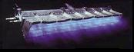
(2) Flame Sensing Issues
- It is unknown whether there will be liftoff or other flame sensing issues.

(3) Product Quality Issues
- NO_{X} emissions are not expected from this type of burner because of its lower flame temperature.

(4) Equipment Lifetime Issues
- These burners are robust and often used to incinerate caustic effluent. No damage to the equipment is expected from a change in gas quality.
(5) Emissions issues
- These burners operate at very high excess air and usually have low peak flame temperatures; below what is likely to contain NO_{X}. There is plenty of air to ensure complete combustion. If combustion is incomplete, the wings of the duct burner are likely not wide open enough and they must be adjusted.

Ranking: Change is not expected.
- It is unlikely that NO_{X} emissions will occur with the low flame temperature. If it does, nitrosamines could form in the food.

Recommendation
- If there is an increase in CO or some other problem, the wings of the burner should be adjusted wider. Adjustment could be done by in-house personnel, but plant operations must stop and the oven must be cool for this adjustment.
- If there is a significant increase in flame temperature, the conveyer speed can be increased without any adjustment to the burner.

Equipment | Application
Burners for Radiant Tubes | At low temperatures, indirect heat for food or tobacco, plus immersion heating for frying, or for solution tanks for cleaning.  At high temperatures, indirect heat for heat treating steels or for other metal treatment applications.
(1) Fuel/Air Ratio Issues
- Fuel and air are commonly controlled by a pressure balance regulator, but Venturi inspirators are also used.  - Both devices have a fixed fuel/air ratio. These burners are usually run with 2% O₂ to 3% O₂ in the exhaust, which will accommodate the LNG compositions with Wobbe Number ≤ 1400, with sufficient excess air for complete combustion. Pressure balance regulators do not give the same ratio over their operating range, meaning some firing rates may have less or more air. |  | 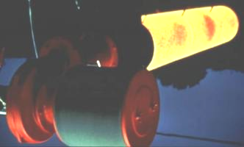 Pyrocore single-ended radiant tube system
(2) Flame Sensing Issues
- For this burner type, the flame sensor is usually a flame rod separate from the spark igniter. The likelihood of a gas quality change causing liftoff will be investigated in an upcoming GTI study.
(3) Product Quality Issues
- Combustion emissions will not be in contact with the product, and the furnace temperature is controlled, so there are no expected issues with product quality.
(4) Equipment Lifetime Issues
- These burners are often set to one or two different firing rates, and the controller simply switches between them to maintain the set temperature. A higher-Wobbe fuel could increase the frequency of switching and add wear to the equipment.
- Flame impingement on a tube wall or other types of poor temperature distribution are possible. This depends on the length of the combustion chamber, and the burner settings. Tobacco curing is a low temperature process, so there is probably not enough heat to compromise equipment.
- Pressure variation from the different combustion products and temperatures may stress the tube
(5) Emissions issues
- More NO_{X} is expected from these burners; they operate at about 2% O₂ to 3% O₂ and the higher Wobbe fuel will reduce this to probably 1% O₂ to 2% O₂, for a hotter flame and more NO_{X}. Whether the amount is enough to cause problems is not known.
- Excessive CO emissions may occur if the process temperature is low, because the flame may quench prior to complete combustion. Excessive emissions due to a poor fuel/air ratio is unlikely because 1% O₂ in the exhaust is sufficient for complete combustion. If the blower is blocked or equipment poorly maintained, high CO emissions may occur.
Ranking: Possible change expected.
- For low-temperature applications, radiant tube heaters should not pose problems because flame impingement would not likely overheat the tube material.
- If there is premature flame quenching, however, emissions will increase.
- It is unknown whether pressure variation is an interchangeability issue. GTI will investigate this in its 2007 burner interchangeability study.
Recommendation
- Make sure there is 2% O₂ to 3% O₂ in the exhaust.
- Watch for flame impingement.
- Monitor pressure.
- Fuel/air ratio adjustment will take a few days to verify operation before and after.

Equipment | Application
Infrared Burner | Drying applications in food, paper, and textiles industries.  Heating to set paints in fabricated metals industries.  Plastics thermoforming in many industries, including electronics.
(1) Fuel/Air Ratio Issues
- The most common fuel/air proportioning device for infrared burners is a premix blower whose fuel valve is linked to the air valve with an adjustable cam.  - Venturi inspirators are also common; they are popular because they obviate the need for a blower. The Venturi has an adjustable spud to allow fuel momentum to draw in the correct amount of air.  - Usually operated with on/off firing or high/low firing: there is either one or two firing rates set for the burner. |  | 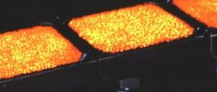
(2) Flame Sensing Issues
- The spark igniter also serves as the flame sensor for these burners. The flame should be easy to sense since it is retained inside the face of the burner.

(3) Product Quality Issues
- The firing rate for these burners is set for a specific burner surface temperature so the panels generate a particular infrared wavelength to correspond with a crucial wavelength in the product—such as the wavelength of maximum absorption for water. An increase in Wobbe Number would increase the firing rate, but temperature controls should just toggle the firing to maintain the proper burner face temperature. Overheating may occur if the burner is firing high/low, and the low firing rate is too hot.
- NO_{X} can create nitrosamines in food, so increased NO_{X} would be an issue. The risk of this happening is low because the face temperature of the burner is below the critical thermal NO_{X} formation temperature of around 2800°F.

(4) Equipment Lifetime Issues
- The porous medium that retains the flame should have a controlled temperature, so a change in gas quality is not likely to reduce the screen’s lifetime. There will be rapid damage to the burner If the flame escapes the porous medium. This will be investigated in GTI’s 2007 study.
- An increased frequency of switching between on/off or high/low firing will add wear to the valves and reduce their lifetime, though the role of gas quality, compared with other factors, may not be measurable.

(5) Emissions issues
- Increased CO emissions are unlikely because most infrared burners should fire with 10% to 15% excess air, which can accommodate the 4% change in Wobbe Number.
- Data are currently unavailable to measure the change in NO_{X} as gas quality changes. This is one of the topics that will be addressed in GTI’s 2007 study.

Ranking: Possible change expected.
- A change in NO_{X} emissions can add nitrosamines to the product.
- Consequences of the flame escaping the burner face are severe. Probability is low.
Recommendation
- If flame escape or product issues are noticed, then an in-house employee could adjust the screws or Venturi stub that set the fuel/air ratio. It would take a day or more, depending on the number of burners, to adjust the ratio and monitor operation before and after the change.
- If the low firing rate becomes too high, then it will need to be adjusted. This just requires the time of an in-house employee, and probably some machine down time.

Equipment | Application
Line burners | Very common in baking applications.  Also used anywhere where a long length with somewhat constant temperature is needed, such as pipe heating during transport at chemical plants.
(1) Fuel/Air Ratio Issues
- Line burners are premixed; likely air is drawn through an adjustable slot using the momentum from the gas for pipe heating. The Flynn pipe burner to the right uses blown premixed air and fuel.  - Both ratio devices fix the fuel/air ratio which will be affected by a change in gas quality |  | 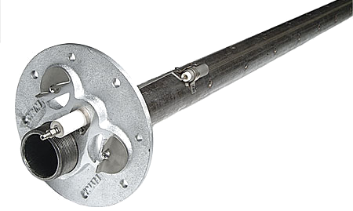
(2) Flame Sensing Issues
- It is unknown whether there will be liftoff or other flame sensing issues.

(3) Product Quality Issues
- In the application of pipe heating, product quality is not an issue, because the flame is separate from the product and the heating application is low-temperature so the risk of overheating is low.

(4) Equipment Lifetime Issues
- Flame impingement on the heated tubes may be an issue, but this is not expected.
- If flashback occurs, it may compromise equipment life.
(5) Emissions issues
- If these burners quench on the pipes that transport the chocolate, there could be premature extinction and CO emissions issues.
- These burners have low peak flame temperatures and emissions are not expected to be an issue.

Ranking: Change is not expected.
- It is unlikely that any change in gas quality would significantly affect performance.

Recommendation
- If there is an increase in CO or some other emissions problem, the fuel/air ratio should be modified. This is unnecessary in a well-maintained burner tuned to between 2% O₂ and 3% O₂ in the exhaust.

Equipment | Application
Surface burners | Heating of beverage in food industries or vats of dye in textiles or furniture industries.
(1) Fuel/Air Ratio Issues
- Surface burners usually use gas momentum to draw air to be premixed prior to leaving the burner. The fuel/air ratio is determined by how open the air slots upstream of the burner are, meaning it would change when gas quality changes. |  | 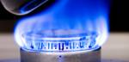
(2) Flame Sensing Issues
- It is unknown whether there will be liftoff or other flame sensing issues, but none have been reported for these burners’ appliance counterparts.

(3) Product Quality Issues
- NO_{X} emissions may occur; these burners are probably used for indirect heating so the product is protected by heat exchanger walls.

(4) Equipment Lifetime Issues
- Low mixture pressures mean flashback may be an issue, but this is unlikely because of the similarity in flame speed for all hydrocarbon constituents of natural gas. The consequence of flashback is very rapid destruction of the burner or burner nozzle.
- Flame impingement on oven surfaces may shorten part lifetime.
(5) Emissions issues
- Increased NO_{X} or CO may be an issue, and was noted in some appliance burner tests.

Ranking: Possible change expected.
- CO emissions and NO_{X} emissions could become high for extreme Wobbe Numbers or for poorly adjusted equipment.
- Impingement may or may not be an issue.

Recommendation
- If there is an increase in CO or NO_{X}, the air opening should be adjusted slightly larger. Adjustment would take anywhere from a day to a few days, including monitoring before and after adjustment.
- If there is a significant increase in flame temperature, and the firing is not cycled to match a temperature setpoint, the cook time should be decreased without any adjustment to the burner.

High Temperature Process Heaters
High-temperature process heaters provide heat when the process temperature is above 1000°F. These applications are very heat intensive . Energy efficiency for these burners is important, but it is not so important to push burners to any limit of stability; they should in general be robust to the variations in fuel composition expected from the representative LNGs. Also because temperatures can be high, NO_{x} emissions can be expected to change for some of these burners.. CO also presents a possible interchangeability issue: incomplete combustion is predicted for many of the LNG compositions in the accompanying report, “Properties of the Representative LNGs.” One of the first indicators of incomplete combustion is an increase in CO emissions.

The high-temperature process heaters will be listed and described in alphabetical order. Each of the manufacturing processes that use them will be described in more detail in the next section of the document, with images that refer the reader back to the descriptions in this section.
- High-velocity burners
- Oxygen fired burners
- Radiant tube burners
- Regenerative burners

Equipment | Application
High velocity burners | High heat applications such as primary metal, cement kilns, and some small-scale glass applications. Also popular when less heat is necessary, for stirring in a large furnace for even temperature, such as possibly in chemical processes or food applications. This is the most versatile and diverse class of high-temperature burners.
(1) Fuel/Air Ratio Issues
- The most common way to proportion fuel relative to air is with a pressure balance regulator.  - These devices have a fixed fuel/air ratio. These are usually run with 2% O₂ to 3% O₂ in the exhaust, but to save energy, operators could reduce the air. Anything below 1% O₂ will pose a problem for Wobbe Numbers near 1400 because of the risk of incomplete combustion. Pressure balance regulators do not give the same ratio over their operating range, meaning some firing rates may have less or more air. |  | 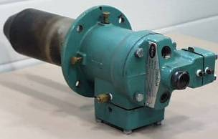
(2) Flame Sensing Issues
- Flame sensing is not required at furnace temperatures above1400°F.

(3) Product Quality Issues
- Product quality will probably not change.

(4) Equipment Lifetime Issues
- No interchangeability issues are anticipated for this application.

(5) Emissions issues
- More NO_{X} is expected from these burners; the flame will get hotter and more NO_{X} will probably form. This will be quantified by GTI during an experimental study planned for 2007.
- Excessive CO emissions may occur because firing with low excess air reduces energy use, and current gas prices have made this a hot topic. If there is less than 1% O₂ in the exhaust (about 5% excess air) then there will probably be incomplete combustion when the high Wobbe Number fuels are introduced.

Ranking: Possible change expected.
- Low excess air could lead to CO emissions and incomplete combustion. Common practice is to operate these burners with enough excess air to accommodate a change in gas quality to a Wobbe Number of 1400, but current energy prices may have made operators switch to a smaller margin of excess air.

Recommendation
- Make sure there is 2% O₂ to 3% O₂ in the exhaust.
- Fuel/air ratio adjustment will take a few days to verify operation before and after.

Equipment | Application
Oxy-fuel burners | Very common in the glass industry. Also used in other high-temperature applications such as aluminum melting, ceramics, and steel making. A few can be added to a furnace in other high heat application as boosters to increase production given a limited furnace volume.
(1) Fuel/Air Ratio Issues
- Fuel and air ratio must be separately controlled because of the hazards of oxygen use. Fuel/air ratio issues are not expected because of the separate control and the need to monitor the oxygen concentration in the exhaust.  - The image to the right, from Linde Gas, shows oxy-fuel burners in a glass furnace. |  | 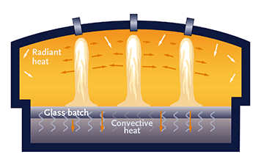
(2) Flame Sensing Issues
- Flame sensing is not required at furnace temperatures above1400°F.

(3) Product Quality Issues
- Product quality will probably not change with a change in gas quality.

(4) Equipment Lifetime Issues
- No issues are anticipated.

(5) Emissions issues
- More NO_{X} is expected from these burners because the flame will get hotter. This will be quantified by GTI during the experimental study planned for 2007.

Ranking: Possible change expected.
- There is a risk of an increase in NO_{X} emissions if there is too much nitrogen in the fuel because of the high peak flame temperatures possible in oxy-fuel combustion. Full oxygen-fired furnaces typically have very low NO_{x} emissions, so an increase, while large on a percentage basis, would likely be small on a mass basis and not be a major concern. The nitrogen content of AGT’s historical natural gas is about 1%.

Recommendation
- If more than 1% nitrogen is added to the LNGs for conditioning, and there are emissions restrictions for that site, then pre-emptive permitting action should be taken to ensure no fines are incurred for emissions excursions outside the permitted limit.

Equipment | Application
Burners for Radiant Tubes | Common in primary metal applications such as galvanizing where the combustion exhaust must not contact the product or with a combustible furnace atmosphere. Also for case hardening in fabricated metals, or for drying applications such as gypsum wallboard.
(1) Fuel/Air Ratio Issues
- Fuel and air are commonly controlled by a pressure balance regulator, but Venturi inspirators are also used.  - Both devices have a fixed fuel/air ratio. These burners are usually run with 2% O₂ to 3% O₂ in the exhaust, which will accommodate the LNG compositions with Wobbe Number ≤ 1400, with sufficient excess air for complete combustion. Pressure balance regulators do not give the same ratio over their operating range, meaning some firing rates may have less or more air. |  | Pyrocore single-ended radiant tube system
(2) Flame Sensing Issues
- Flame sensing is not required at furnace temperatures above1400°F.

(3) Product Quality Issues
- Combustion emissions will not be in contact with the product, and the furnace temperature is controlled, so there are no expected issues with product quality.
(4) Equipment Lifetime Issues
- These burners are often set to one or two different firing rates, and the controller simply switches between them to maintain the set temperature. A higher-Wobbe fuel could increase the frequency of switching and add wear to the equipment.
- Flame impingement on a tube wall or other types of poor temperature distribution are possible. At high temperatures, this could push the tube material to burn-through, thermal stress failure, or high creep which would cause the tube to bow. These tube are expensive and there can be dozens of them in a single heat treat line.
- Pressure variation from the different combustion products and temperatures may stress the tube.
(5) Emissions issues
- More NO_{X} is expected from these burners; they operate at about 2% O₂ to 3% O₂ and the higher Wobbe fuel will reduce this to probably 1% O₂ to 2% O₂, for a hotter flame and more NO_{X}. Whether the amount is enough to cause problems is not known. Emissions will be studied during upcoming interchangeability experiments at GTI.

Ranking: Possible change expected.
- High process temperatures mean the equipment could be damaged if flame shape or flame temperature change too much when gas quality changes. The relationship between performance change and gas quality is currently unknown.
- It is unknown whether pressure variation is an interchangeability issue.
- GTI will investigate both of these issues in its 2007 burner interchangeability study.
Recommendation
- Make sure there is 2% O₂ to 3% O₂ in the exhaust.
- Watch for flame impingement.
- Monitor pressure.
- Fuel/air ratio adjustment will take a few days to verify operation before and after.

Equipment | Application
Regenerative burners | Aluminum, other prime metal, or glass melting applications where the exhaust air would be clean, because it will be drawn through the burner for heat recovery.  Complicated to operate but highly efficient. NO_{x} can be an issue.
(1) Fuel/Air Ratio Issues
- Fuel and air ratio may be specially separately controlled, because the volume of air changes with temperature, and the burner must be able to fire both cold air and very hot preheated air.  - The image to the right, from Daido Steel, shows the regenerative setup: two burners face each other and fire one at a time. The exhaust travels through the other burner to heat a regenerator. After some time, the regenerative burners reverse firing. |  | 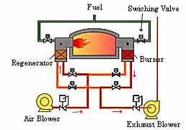
(2) Flame Sensing Issues
- Flame sensing is not required at furnace temperatures above1400°F.

(3) Product Quality Issues
- Product quality will probably not change.

(4) Equipment Lifetime Issues
- The timing of the firing cycle and the draft pressure are monitored and controlled for regenerative burners. A change in Wobbe Number could change the firing cycle, and would change the furnace pressure so that more control effort is needed to redirect the exhaust and to adjust the damper for furnace pressure. The amount of change in control effort is currently unknown, and will be investigated as part of the GTI interchangeability study. It may or may not produce a measurable change in equipment life.
(5) Emissions issues
- More NO_{X} is expected from these burners because the flame will get hotter. This will be quantified by GTI during the experimental study planned for 2007.
- Excessive CO emissions may occur because firing with low excess air reduces energy use, and current gas prices have made this a hot topic. If there is less than 1% O₂ in the exhaust (about 5% excess air) then there will probably be incomplete combustion when the high Wobbe Number fuels are introduced.
Ranking: Possible change expected.
- Low excess air could lead to CO emissions and incomplete combustion. Common practice is to operate these burners with enough excess air to accommodate a change in gas quality to a Wobbe Number of 1400, but current energy prices may have made operators switch to a smaller margin of excess air. This is not an issue if fuel and air are separately controlled according to stack %O₂ measurements.
The complex control scheme may respond incorrectly, or with excessive effort, to a change in Wobbe Number and the associated pressure and temperature changes in the furnace. This could decrease equipment life.
Recommendation
- Make sure there is 2% O₂ to 3% O₂ in the exhaust.
- Monitor control effort.
- Fuel/air ratio adjustment will take a few days to verify operation before and after.

Engines

A handful of engines were identified, either for electric power generation or for cutting mills or other moving equipment at a plant. Fuel gas interchangeability for engines is discussed more thoroughly in the accompanying report, “Reciprocating Engines, Gas Turbines, and Fuel Cells;” the main interchangeability criterion is the Methane Number, which correlates with the onset of knock. Large or heavy-duty engines with a high compression ratio are more likely to experience knock and are therefore more sensitive to a varying natural gas composition.

Equipment | Application
Prime movers and gas engines | To run cutting mills such as for wood or for sugar cane. Also can run water or vacuum pumps or to drive other systems inside of a factory. The image at right is a sugar cane mill.
(1) Fuel/Air Ratio Issues
- A change in fuel composition will not likely change fuel/air ratios: Equipment is sensitive to this change and relatively standard protective control systems monitor %O₂ in the stack exhaust and adjust fuel/air ratio accordingly.  - If the fuel/air ratio controllers are set through some mechanical linkage instead of with a computer control system, then ratio will be an issue. |  | 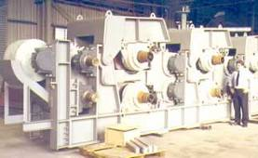
(2) Flame Sensing Issues
- Flame sensing is not an issue for reciprocating engines. Testing will be needed to determine whether flame sensing is an issue for gas turbines or microturbines.

(3) Product Quality Issues
- Machine operation is not affected by gas variation.

(4) Equipment Lifetime Issues
- Firing rates are most likely modulated, so no issues are expected.

(5) Emissions issues
- Higher NO_{X} emissions, especially if fuel/air ratio is not controlled, because the flame would be hotter for the same volume of flow, and if fuel/air ratio is not controlled, there would be less air, making the flame temperature even higher. Operation is more likely lean than rich, so incomplete combustion is not anticipated.

Ranking: Not much change expected.
- If air/fuel ratio are computer controlled no major performance problems are expected.
- If the customer’s NO_{X} emissions are tightly regulated, they may have to pay for increased emissions.
- Combustion instability may occur if fuel/air ratio are not controlled.
Recommendation
- Determine whether there is a fine or additional permit cost for higher NO_{X} emissions.
- Determine whether retrofit of the engine will trigger emissions-related retrofit requirements.
- If the fuel/air ratio is not computer controlled, then it may be necessary to adjust this. One cost estimate of equipment for retrofit is about $7000. A day to half a week or more would be needed to adjust the ratio and monitor operation before and after the change.

Equipment Population
Stakeholders provided detailed lists of the end use equipment that they considered potentially sensitive to variation in natural gas Wobbe Number. These lists were redacted and are summarized in Table 1 to Table 5 to help give an understanding of the scale of potential changes, burner service, or retrofits. The left column of the table lists the state and the service provider associated with the end use data. Detailed information about the manufacturing processes that were provided is provided in the next section, “Industrial Processes.”
Essentially all industrially burners and boiler burners can be adjusted relatively easily as described in this report. However, the authors advise caution in gas variability. Combustion systems perform optimally when operated with gas having the narrowest possible range of composition. Swings in composition can lead to loss of efficiency and equipment life concerns, depending on the equipment and application. The best approach to a providing a wider range of gas compositions than currently is prevalent is to continue to provide narrow gas compositions regionally or locally so that end users may see a 'new' gas composition but do not see a wider range of gas compositions.

SIC 205-214 and 220-230, or NAICS 311-316
Bakeries, food manufacturing, beverages and tobacco, and textiles manufacturing all are low-temperature applications that are not likely to be subject to emissions regulations. The one exception is in sugar cane refining; there is one such facility in ConEd’s service territory; if there are regulatory emission requirements they would restrict NO_{x} for the boiler. Then, if the boiler were a low-NO_{x} boiler, it would have a higher probability of requiring re-adjustment to fire the range of natural gases up to the NGC+ Whitepaper’s recommended Wobbe Number variation. Stakeholders often listed bakeries separately from other food manufacturing because of their high population; this high population and their small size cannot necessarily speak to whether their equipment is in good adjustment or not, but GTI would caution that these facilities may be the most likely to have maladjusted equipment, just because of a possibly smaller staff with more responsibilities assigned to single individuals. For the remaining industries, no particular special attention is anticipated outside of those recommended for all burners.
Table 1. Inventory of Potentially Sensitive Receptors; NAICS 311-316
 | Bakeries | Food | Beverage & Tobacco | Textiles through Apparel
 | SIC 205  NAICS 3118 | SIC 209  NAICS 311 | SIC 2082-2141  NAICS 312 | SIC 220-230  NAICS 313-316
BSG-NU, MA & NH | -- | 1 | 2 | 5
BSG-NU, ME | 1 | -- | -- | 2
ConEd, NY | 729 |  | 27 | --
Keyspan, NE | 26 | 93 | -- | --
Keyspan, NY | -- | 55 | -- | --
PSE&G, NJ | -- | 7* | -- | --
SCG/CNG, CT | 16 | 8 | -- | --
Yankee, CT | 27 | 6 | -- | --
*chiller and sterilization equipment were presumed to be in the food industry
Exceptions to the standard recommendation to suggest burner tuning:
- Special attention to the Sugar Refinery’s boiler, especially if it is Low-NO_{x}
- Special monitoring or communication with bakery owners because of their large population and maybe a higher probability to have maladjusted equipment.

SIC 26, 275-279, and 34, or NAICS 321-323
Wood products and paper manufacturing are low-temperature applications. Stakeholders identified only a few of them; BSG-NU has one paper pulping plant (recycled) in its territory. The pulping plant may be subject to emissions regulations for its boiler, which is likely large. This would require special attention. Presuming that the printing and paper drying applications have appropriate temperature and process speed control, there should be no interchangeability issues above what is mentioned for each burner. The possible issue for uncontrolled process speeds is an increased or varying heat input (that is the same as the % change in Wobbe Number) to the drying process. It is not expected to be a major issue for the printing industry, but the paper industry may see a decrease in finished product weight if more water is dried from the paper than is usual. Controlled processes should, again, not be affected.
Table 2. Inventory of Potentially Sensitive Receptors; NAICS 321-323
 | Wood Product Mfg | Paper | Printing
 | SIC 34  NAICS 321 | SIC 26  NAICS 322 | SIC 275-279  NAICS 323
BSG-NU, MA & NH | 1 | 5 | 1
BSG-NU, ME | 1 | 3 | 2
ConEd, NY | -- | -- | 243
Keyspan, NE | -- | -- | --
Keyspan, NY | -- | -- | --
PSE&G, NJ | -- | -- | --
SCG/CNG, CT | -- | -- | --
Yankee, CT | -- | -- | --
Exceptions to the standard recommendation to suggest burner tuning:
- Special attention to the paper pulping facility’s boiler, especially if it is Low-NO_{x}
- If problems or complaints arise, determine whether the end user has speed or temperature control installed, because that would likely fix the problem.

SIC 28-30, or NAICS 325-326
Chemical and allied processes, petroleum, and rubber and miscellaneous processes are also low-temperature applications, but the types of processes listed in a single classification are diverse. Chemical processes also include industrial gas manufacturing, which uses natural gas as a feedstock rather than in a combustion application. For this reason, the hydrogen reforming process identified by PSE&G is addressed in a separate section, “Feedstock Applications Including Liquefaction Facilities.” The chemical manufacturing applications range from plastics to perfumes, and the Petroleum applications listed are for asphalt products. Interchangeability issues for all of these receptors should be no different from those listed in the descriptions of the burners.

Table 3. Inventory of Potentially Sensitive Receptors; NAICS 325-326
 | Chemical & Allied, incl. Carbon Black | Petroleum &  Coal (and asphalt) | Rubber & Misc
 | SIC 28  NAICS 325 | SIC 29  NAICS 324 | SIC 30  NAICS 326
BSG-NU, MA & NH | 1 | 1 | 2
BSG-NU, ME | 1 | -- | 1
ConEd, NY | 81 | 1 | --
Keyspan, NE | 51 | -- | 19
Keyspan, NY | 44 | -- | 35
PSE&G, NJ | 7* | -- | --
SCG/CNG, CT | 125 | -- | 80
Yankee, CT | 58 | -- | 44
*all dryers were assumed to be in service in the chemical industry

SIC 32-35, or NAICS 327 and 331-333
Stone, clay, glass, concrete, and primary metals are the main high-temperature applications listed among the potentially sensitive receptors. Fabricated metals and machinery manufacturing also can reach high temperatures—this means that the potential for NO_{x} formation is higher for these applications, and emissions regulations are more common. It also means that flame sighting is not an issue for these burners, because the NFPA 86 standard does not require flame sighting when furnace temperatures are above 1400°F. The stone, clay, glass, and concrete section includes gypsum manufacturing as well as artisan glass and sculpture, so the range of furnace size is large. Concrete manufacture likely has emissions regulations that do not pertain to the combustion, but to effluent from the process. For the larger glass melting facilities, oxygen-fired burners mean the potential for NO_{x} will increase with the amount of nitrogen-conditioning that is performed on a fuel. With no nitrogen added, of course there is no NO_{x}. Up to 1% or 2% nitrogen addition would be about the same as what is currently in the natural gas supply. The furnaces for these applications have temperature control attached. No additional interchangeability issues exist for these applications that were not already described when the burners were introduced.
Table 4. Inventory of Potentially Sensitive Receptors; NAICS 337-333
 | Stone, Clay, Glass & Concrete | Primary Metals | Fabricated Metals | Machinery
 | SIC 32  NAICS 327 | SIC 33  NAICS 331 | SIC 339, 34  NAICS 332 | SIC 35  NAICS 333
BSG-NU, MA & NH | 2 | 2 | 2 | 1
BSG-NU, ME | 1 | 2 | 1 | --
ConEd, NY | 54 | -- | 270 | 135
Keyspan, NE | 13 | 68 | -- | --
Keyspan, NY | 18 | 26 | -- | --
PSE&G, NJ | -- | 1 | -- | --
SCG/CNG, CT | 36 | 80 | -- | --
Yankee, CT | 32 | 53 | 9 | --

SIC 24, 25, 36, and 38, or NAICS 334, 335, and 337
Electronic, electrical equipment, and furniture manufacturers would usually use natural gas in low-temperature applications, although it is possible that some electrical equipment, such as some metal fixtures may require higher temperatures. Emissions regulations, if they exist, are expected to pertain to the release of chemicals used in the process, and not combustion emissions, so emissions are not a concern. Temperature control is also expected to be automatic, so no major product quality change is expected. Semiconductor manufacturers, of which there are two identified by BSG-NU, six by Keyspan, and one by Yankee Gas, most likely use electric heat for their process and natural gas to thermoform the packaging; semiconductors require a more uniform furnace temperature than can usually be achieved by a gas-fired furnace. The applications identified are not expected to have any special response to gas quality variation outside of those identified when each burner was introduced.

Table 5. Inventory of Potentially Sensitive Receptors; NAICS 334-337
 | Electronic and Other Equipment | Electrical Equipment | Furniture and Related Products
 | SIC 365, 367, 38  NAICS 334 | SIC 36  NAICS 335 | SIC 24, 25  NAICS 337
BSG-NU, MA & NH | 1 | -- | --
BSG-NU, ME | 2 | -- | --
ConEd, NY | 108 | 54 | --
Keyspan, NE | 103 | -- | --
Keyspan, NY | 35 | -- | --
PSE&G, NJ | -- | 1 | --
SCG/CNG, CT | -- | 1 | --
Yankee, CT | 40 | 18 | --

Non-manufacturing applications
BSG-NU identified one waste incineration plant, one water treatment facility, and two gas supply interconnections for an assessment. The waste incineration plant is unlikely to exhibit any material change in performance due to fluctuations in gas quality, because the entire process must be robust enough to accommodate changes in the waste constituents that are much bigger than the change in the gas quality. For the water treatment facility, natural gas would likely be used for space conditioning, or else to generate electricity to power pumps. Power generation equipment is described in an accompanying report, “Reciprocating Engines, Gas Turbines, and Fuel Cells;” if the equipment has a high compression ratio and a high power rating but does not have knock sensing control, it is likely to need retrofit, otherwise it should operate without concern. If there are compressors at the gas supply interconnections, they would exhibit the same type of interchangeability issues as gas turbines or engines, depending on the type of compressor. Any impacts of LNG on the lifetimes of compressor seals and other parts are beyond the scope of this s study to evaluate.

Industrial Processes

This section summarizes the industrial processes identified by the stakeholders for assessment. Although there are no data to predict fuel gas interchangeability for industrial burners, their operation can be estimated based on the physics of combustion and the issues addressed during burner design. Except for some low-NO_{x} boilers, industrial process heaters are expected to operate with the variable gas supply represented by the LNG compositions studied. Emissions and possibly product quality are concerns above burner operation that must also be taken into consideration. Concerns will be described in the individual sections, and the most expense per unit that is expected is a week of an experienced technician’s time—but the number of units that may require this are few.
The major benefit of using the high-Wobbe Number natural gases is that the maximum heat input to a furnace in high heat applications will increase. This makes it possible to increase the production rate. The major problem, if there is one, would be incomplete combustion. The potential for there to be insufficient air to complete combustion has been exacerbated recently: recent energy costs have prompted a culture that recommends decreasing the excess air fired with the burner to save energy. Decreasing the excess air decreases the ability of the burner to fire a varying gas quality; common practice is to fire with 3% exhaust, which implies approximately a 7.4% range in acceptable Wobbe Number for combustion equipment that is otherwise insensitive to variability, presuming no changes in ambient conditions. At 2% the range is 5.6%, and at 1%, the range is about 3%; it may be necessary to inform clients that they should keep their air-to-fuel ratio above 1.5%.

311 Food Manufacturing and Baking
A high population of both small bakery ovens and small boilers is reported in the Northeast Stakeholder territories. The low-temperature applications most often use boilers, line burners, and surface burners, although other burners are also used. Increased emissions from ovens or from boilers is likely to be the most visible natural gas interchangeability issue in this sector: smaller establishments may have older, poorly maintained equipment that could exceed safe CO emissions with even a small change in gas quality. Even now, new equipment that is poorly tuned can pose a carbon monoxide hazard with the current domestic natural gas quality: their problem is an incorrectly tuned burner and not natural gas quality. Burner tuning that is nearly unacceptable now may become unacceptable when firing the available LNG compositions.
Flame lifting or a change in flame shape could also cause the flame monitor to lose sight of the flame and trigger nuisance shutdowns. Flashback, if it occurs, would overheat the combustion equipment to reduce equipment life. Combustion products impact food chemistry in direct fired cooking processes, often on purpose as in smoking. The impact of gas variability on food chemistry is estimated to be small. A complete analysis is outside the scope of the report., but information is available in reference Liteplo et al, 2002. This may or may not be a concern; investigation is out of the scope of this work. Manufacturers who do not want combustion products to contact food already use heat exchangers. Some applications, such as baking or roasting, where there are limited temperature capabilities besides the rate at which product is fed through the process may require modifications to their controls to account for a variable Btu content. The following sections describe different types of food manufacturing processes, by their NAICS classifications. The process descriptions are from a study by the Oak Ridge National Laboratory (reference CHPA). Many of the applications can use either electric or gas heating.

311312 Cane Sugar Refining
Cane sugar refining is a very energy-intensive process using engines in a milling train, large boilers for both washing the cane and for indirect use in evaporators, vacuums to remove moisture, and centrifuges (reference US Environmental Protection Agency). Variations in gas quality will not affect the quality of the product because heat is indirectly transferred to the sugar by water. Performance issues related to the power generation and engines are in a separate report but are briefly addressed in the following pages, along with the boiler issues. No additional issues besides those associated with boilers or reciprocating engines are expected; the boilers in this sector are often very large.

Equipment for cane sugar refining
Boilers
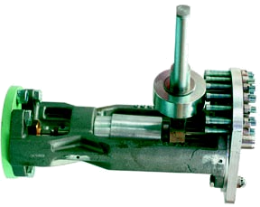 | Cane sugar refining uses large boilers that are likely to be subject to emissions regulations, and also likely to produce NOx Hot water to wash sugar crystals away from the syrup. Heat to melt the crystals. Steam to pass through heat exchangers for clarifying, evaporation, and drying (about 230°F)
Engines
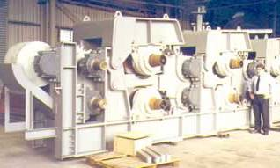 | Mills to cut the sugar cane and generation of electricity for pumps to vacuum dry the crystals. The function of engines that may run the mills would fall under the same rules as the reciprocating engines.

311911 Roasted Nuts & Peanut Butter Manufacturing

311920 Coffee and Tea Manufacturing
shows example roasters for roasting coffee (left) and for roasting nuts (right). The top left photograph is of a surface-style burner (atmospheric burner) that sits below the drums in the bottom left photograph to roast the coffee. Roasting is only one of the heating applications for this sector. Nuts can be fried, with a burner in a submerged tube heating the oil, and a number of applications exist that blow air across a flame to provide hot moving air for drying (reference US Environmental Protection Agency). Boilers can be used for hot water or steam to remove nut shells. Since combustion exhaust may come in contact with the food in this application, a change in emissions may affect the food quality.

Figure 6. Coffee roaster burner and drums (left) and Nut Roaster.

Process heaters for roasted nuts, peanut butter, coffee, or tea manufacturing
Blown burners
For nuts, roasting can be done in a rotating oven at about 800°F for 40-60 minutes. The process could be direct- or indirect-fired.
Special versions of these burners can fire in submerged tubes to heat oil to 300°F for 3-10 minutes of oil roasting

Boilers
Hot water or steam is used to remove nut shells. These boilers are not the very large ones, and so are not likely to be regulated for very low NO_{x}. This means the boiler burners are less likely to be susceptible to gas quality variation.

Duct burners
Nut shells can be removed with blasts of 300°F air. For nuts, dry roasting can be done at 800°F in countercurrent ovens for 40-60 minutes. These burners can also heat a chamber that contains an oil bath, for frying

Surface burners
Dry roasting can be done at 800°F in rotating ovens for 40-60 minutes. The product would be indirect-fired. If there is a significant increase in flame temperature, and the firing is not cycled to match a temperature setpoint, the cook time should be decreased without any adjustment to the burner.

311320 Chocolate & Confectionery Manufacturing from Cacao Beans
Chocolate manufacture from cacao beans involves a number of steps with different process heating needs. Cacao beans are soaked for 5 days and then dried with hot air, roasted at 210°F for 10-115 minutes, and milled into liquor. Cacao liquor is cooked with sugar in a process called conching, at 180°F for 24-72 hours. Pipes are heated to ensure chocolate flow through the plant. (reference Hersheys)

Process heaters for chocolate and confectionary manufacturing from cacao beans
Blown burners
Cacao beans are roasted at 210º F for 10-115 minutes. If there is temperature control on the furnace, no major interchangeability issue is expected.

Boilers
The boilers wold make hot water to pass through heat exchangers for conching. Sugar and cacao liquor are conched at 180º F for 24-72 hours. The boilers are not likely the largest ones, and are therefore not expected to be the most sensitive low-NO_{x} burners.

Duct burners
Hot air to dry cacao beans after 5 days of soaking; this can be done with a blown burner as well. No major interchangeability issue is expected.
Line burners
Line burners can be used for pipe heating to keep chocolate liquid. It is more likely pipes are electrically heated, but if they are gas-fired temperature control ought to be in place to ensure the product is not overheated.

311812 Commercial Bakeries

311813 Cookie and Cracker Manufacturing
Baking is usually done in pre-fabricated ovens that overwhelmingly use line burners for heat. A few bakeries may opt to use custom ovens with similar burners. Infrared radiation burners, which have a face temperature of about 1100°F are often used as a first step in baking or cooking; these give an appealing golden brown crust to breads prior to a longer, cooler bake period, or can completely dry out crackers or chips before frying. For very even oven temperatures, duct-like burners can be placed in the stream of a strong blower that forces hot moving air into the oven. Cracker manufacturing often uses the infrared radiation burners, particularly to toast or dry crackers before frying.
It is possible that baking ovens may not have temperature adjustment, but rather set the oven temperature to a number on a dial and fire continuously. This is likely in small commercial bakeries, or for gas-fired pizza ovens. A changing gas Wobbe Number will translate into a different heat input into the oven. The easiest way to accommodate such a change is to slow down or speed up the product flow through the oven. In the bakery ovens, it may be that the conveyer speed is fixed. Either proprietor of the bakery can decide that the variation in gas quality still makes acceptable product, or a retrofit would be necessary to allow more precise temperature control. This would benefit the end user because the oven temperature would be more precisely known, and be consistently maintained day-to-day. A temperature control retrofit would require a temperature monitoring and control device, about $100, and a motorized valve setup, about $600 to allow at least on/off gas firing, or else high/low firing. With an installation cost of about 30% of the equipment cost, the total cost estimate per oven is about $1000. Note that this would only be for the ovens that do not already have some sort of temperature control.
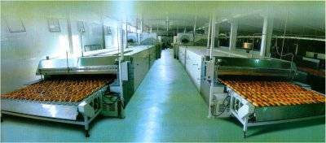
Figure 7. Ekmasan Tunnel Oven, www.ekmasan.com.tr/tunel_firin.php

Process heaters for commercial bakeries, cookie and cracker manufacturing
Blown burners
The blown burner is one option for providing hot air for baking instead of a duct burner or a line burner.
Boilers
Hot water for cleaning and sterilizing; these boilers are not expected to be large enough to warrant tight NO_{x} emissions regulation or the specially designed burners
Duct burners
Hot air for baking in a tunnel oven
If there is a significant increase in flame temperature, the conveyer speed can be increased without any adjustment to the burner.

Infrared burners
Thermal radiation burners, with face temperatures up to 1200°F toast or dry crackers prior to frying and can add a golden crust to breads (reference Energy Solutions Center)
Line burners
Burners for tunnel and other ovens. The pipe burners, in grid, or zigzag, or linear shape, are common in bread and tortilla manufacturing. They are probably the most commonly used burner in this industry.

311823 Dry Pasta Manufacturing
Grain for pasta is milled, then eggs or other ingredients are added and the dough is extruded. After extrusion, pasta is dried with hot air. Temperature and humidity are controlled to prevent over drying and cracking.
Process heaters for dry pasta manufacturing
Blown burners
Blow burners could provide indirect or direct hot air for drying pasta; or the pasta could be vacuum-dried.
Boilers
Hot water for cleaning and sterilizing, and steam for humidity control during pasta drying. The boilers would not be the large ones with stringent emissions regulation, and so are not expected to be the most sensitive Wobbe Number fluctuations.
Duct burners
Duct burners can also provide hot air for drying pasta.

311221 Wet Corn Milling
311230 Breakfast Cereal Manufacturing
Corn is steeped for 30-40 hours at approximately 122°F to remove starch. Then, the steepwater is heated and evaporated to recover the starch, and the starch is washed to remove protein. Starch is then dried in vacuum centrifuges, sometimes with heated air, and packaged. The fiber, gluten, and corn germ are dried and processed for animal feed (reference Corn Refiners Association). Breakfast cereals are each manufactured differently; some require vacuum treatment to puff the product, others require multiple baking cycles. The common thread between them all is the need for some cooking and some drying. Figure 8 shows an example of a cereal manufacturing process.
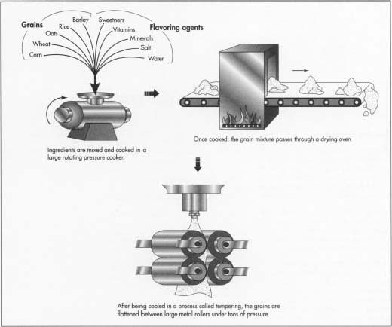
Figure 8. Cereal manufacturing process. www.madehow.com/Volume-3/Cereal.html

Process heaters for wet corn milling and cereal manufacturing
Blown burners
Hot air for drying corn starch or corn germ.
Boilers
Hot water for cleaning and sterilizing, steeping corn, and for washing the starch. These boilers are not likely to have the large low-NO_{x} burners that are most sensitive to fuel Wobbe Number.

Duct burners
Hot air for drying corn starch or corn germ, or for drying cereal products in a tunnel oven.
Infrared burners
Thermal radiation burners, with face temperatures up to 1200°F for toasting or drying.
Line burners
Burners for tunnel and other ovens.

311711 Seafood Canning
Fresh & Frozen Seafood Processing - 311712
Fruit & Vegetable Canning - 311421
Seafood spoils easily, so temperature and humidity are tightly controlled during processing. Canned seafood passes through a retort and is exposed to pressurized steam to be cooked in their sealed cans. Figure 9 shows an old steam retort. Cans are then cooled quickly to prevent overcooking. Fish drying uses electric heat, because nitrosamines formed in the food when it reacts with NO_{X} could poison the food. Frozen seafood is quickly heated for decontamination prior to freezing, or can be cooked. Marine oils are recovered from the fish by conveying them through a steam-heated cooker that reaches 194°F to 203°F. The fish are pressed to recover their liquids, and oil is separated from the water. The remaining liquids are pressed back into the fish and dried to create fishmeal (reference Responsible Fisheries)
Canned fruit and vegetables are also peeled, sterilized, and pressure cooked in retorts, so the process heating equipment for this application is listed here.
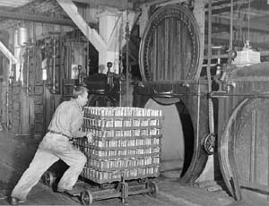
Figure 9. Retort at the Gulf of Georgia Cannery. http://www.goldseal.ca/wildsalmon/salmon_history.asp?article=6

Process heaters for seafood canning, seafood processing, and vegetable canning
Boilers
Steam for pressurized cooking in retorts, for regular cooking, and for flash sterilization

Infrared burners
Thermal radiation burners, with face temperatures up to 1200°F for rapid cooking that seals in meat juices or for drying fishmeal

Fluid Milk Manufacturing - 311511
Milk is decontaminated using one or more heat treatments, including thermisation, Pasteurization, sterilization, and ultra heat treatment. Thermisation holds the product temperature between 135°F and 155°F for 15 seconds. Pasteurization heats milk to 160°F for 15 seconds followed by a rapid cool to 43°F. Sterilization is for filled milk bottles which, after packaging, are conveyed through a steam chamber at 230°F to 266°F for 10-40 minutes. The bottles are also sterilized prior to filling. Finally, ultra heat treatment is a quick sterilization process that heats milk to 284°F for 1-2 seconds and does not destroy milk chemistry. Milk can be processed into standardized whole, semi-skimmed, or skimmed milk. The fat content in whole milk and semi-skimmed milk is standardized by separating the milk into the skim and cream in a centrifuge, and then blending the skim and cream together in specified proportions until the desired composition is achieved (reference Dairy Training and Development Council). It is likely that Pasteurization is done using electric heating.
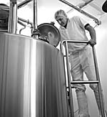
Figure 10. Pasteurization vat at Vermont Butter and Cheese Co. http://www.vtbutterandcheeseco.com/cheesemaking.html

Process heaters for fluid milk manufacturing
Boilers
These provide heat for Pasteurization and sterilization. They are not likely to use the large low-NO_{x} boiler burners that would be the most sensitive to gas Wobbe Number variation.

312 Beverage and Tobacco Product Manufacturing
Beverage and tobacco product manufacturing are both processes that require low heat. All beverage manufacturers must Pasteurize their product, which requires raising product temperature to between 140°F and 170°F for at least 30 seconds. This can be accomplished with a boiler or using electric heating. Wines and beer are held at elevated temperatures for fermentation. In addition to making the product, bottling and other packaging may be done on-site, or bottling facilities for these products may be listed under this NAICS title. Glass applications require high temperatures, and very different manufacturing processes than are used for food. Bottling will be discussed under the subheading “327 Nonmetallic Mineral Products.”

312120 Breweries

312130 Wineries
The steps in beer manufacturing that use process heat are in creating mash, boiling the wort, and fermenting. Grist from the roller mill is mixed with hot water to form mash, which is heated to turn the starch into fermentable and non-fermentable sugars. The clear liquid part of the mash (the wort) is then separated from the solids, boiled, and then cooled to precipitate out the polyphenol and proteins to enhance the clarity of the wort. Once the precipitate is removed, the wort is aerated and fermentation is allowed to start. Additional steps for clarifying and carbonation are performed, then the beer is Pasteurized and bottled (reference Brewer’s Handbook). The fermentation step may use process heat in winemaking.
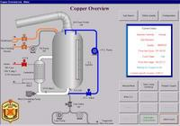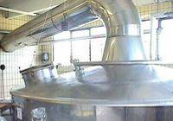
Figure 11. Screen shot of Prodigy HMI SCADA software for automated wort boiling control (reference Tascomp.)

Process heaters for breweries and wineries
Boilers
Steam for Pasteurization, sterilization, fermenting, and boiling. The boiler size would not require a large low-NO_{x} boiler burner, and so these boilers are not expected to be the most sensitive to gas Wobbe Number variability.

3122 Tobacco
Tobacco is cured using indirect heat from burners fired in tubes or against heat exchangers. This is because nitrosamines form in the leaves when they encounter the exhaust NO_{x} from the burners.

Process heaters for tobacco manufacturing
Blown burners
 | Indirect heat for tobacco curing. Heat exchanger lifetime could be reduced if there is flame impingement on its walls from a longer or hotter flame. It is unknown what the effect could be, and a poorly adjusted burner could also create impingement.
Radiant tube burners
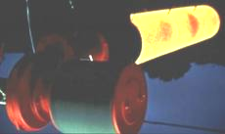 | Indirect heat for tobacco curing. As with the blown burner, one possible issue is the lifetime of the radiant tube.

313 through 316 Textiles, Apparel, Leather
313 Textile Mills
314 Textile Product Mills
315 Apparel
316 Leather and Allied Products
Heating applications for textiles comprise both upstream processing such as cleaning and treatment of fabric, and downstream processing such as dyeing. Hot water or steam are used for cleaning or to heat dyeing baths. Tubes submerged in chemical baths can be used for dyeing, direct or indirect heat can be used to singe stray threads off of the fabric, and duct burners are used to combust volatile effluent for pollution management. Some modern inks are applied as powders, and must pass through infrared ovens with no air flow to set before being heated in convective ovens. Leather processing is chemically intensive, so combustion of volatile compounds is also used, and drying can be by vacuum or by tunnel oven. An example of a tunnel oven is shown in Figure 12, for textile applications, and an example singeing machine is pictured in Figure 13.
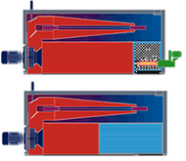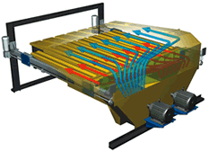
Figure 12. Burner (green object) in an air recirculation drying system from Marshall and Williams. www.tubetex.com/marshall_woven.html

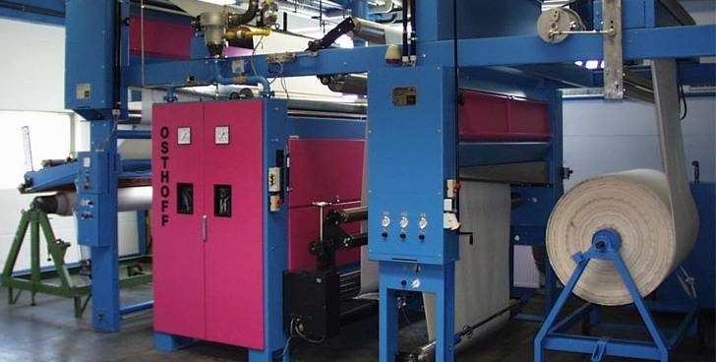
Figure 13. Osthoff-Senge singeing machine
http://www.osthoff-senge.com/en/produkte1.htm

Process heaters for textiles, apparel, and leather manufacturing
Blown burners
All-purpose: can be used for singeing loose strands or fur off of the product, or for firing in tubes to heat chemical solutions for cleaning or dyeing. These burners can also fire into moving air for tunnel heating.
Boilers
Hot water or steam for high temperature cleaning; these burners are not likely to be the Low-NO_{x} boiler burners that are most susceptible to gas quality variability.

Duct burners
Hot air for tunnel drying of fabrics or leather.
Combustion of volatile effluent to reduce pollution.
Infrared burners
Thermal radiation burners, with face temperatures up to 1200°F for setting new powdered dyes. This application is usually electric.

Surface burners
Indirect heating of vats of dyes or cleaning solutions.

321 Wood Products, and 322 Paper
Heating applications for wood products are for drying sawdust for particle board, drying or curing coatings on finished products, and for combusting the effluent vapor from these coatings. Figure 14 shows an oil-fired sawdust dryer. Veneer or other finishes would be cured with radiant tube, thermal radiation, or high-velocity burners. The vapor is a pollutant that would be pulled through a duct and combusted with a duct burner.
BSG-NU has one recycled paper pulp mill in Maine. Paper pulp mills are energy intensive because they require a lot of low-temperature heat during the pulping process, where wood chips are digested in heated chemical solution. For drying, steam heat from boilers heats large “Yankee” roller drums that move the paper, as in Figure 15.
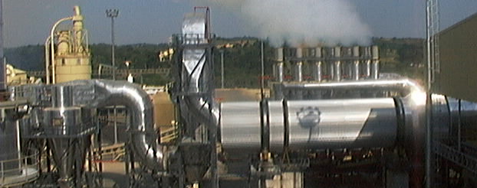
Figure 14. Oil-fired sawdust drying plant for particle board (reference “Particle Board Plants”).

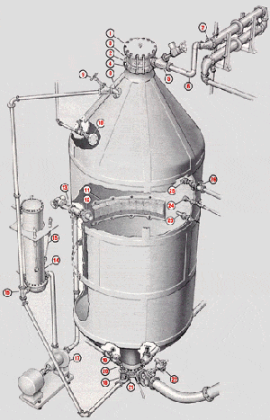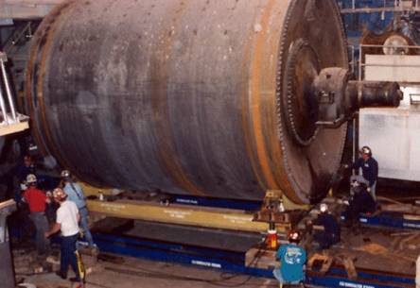
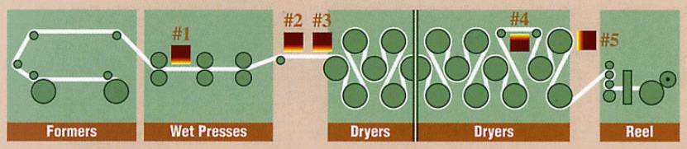
Figure 15. Papermaking equipment: Clockwise from top left: ESCO Batch Digester (reference ESCO); Yankee Dryer, the drying process with IR heaters, drawn as the numbered squares, in place of Yankees.

Process heaters for wood products and paper manufacturing
Blown burners
Indirect heat to dry particleboard particles.
Boilers
Steam or hot water for log treatment prior to peeling veneers and later for pliability. Hot water for pulp digesting, cleaning, and for indirect heat.
These boilers are very large, and are likely to have regulated emissions and low-NO_{x} burners attached. These burners would be sensitive to a change in Wobbe Number and could require three days or a week of a technician’s time to readjust. It should be possible to readjust the burner in a way that it could fire both the AGT system average during 2004-2006, and also the representative LNG compositions up to the suggested NGC+ Whitepaper guideline.

Duct burners
Combust volatile effluents to reduce or eliminate pollution; the burner is downstream of the product manufacturing and will not affect product quality.
Infrared burners
Curing special coatings on the paper and assisting in paper drying. If the flame escapes the porous medium and enters the furnace, it could combust with the volatile effluents that are evaporating from the painted surface.

323 Printing and Related Support
Heaters are used in printing and related support to dry inks and to apply various coatings to papers or other printed materials. When inks are applied dry and heated to a gel, infrared heaters are used to keep from disturbing ink placement. Coated papers can be dried in convection ovens, that can even float the material between opposed jets of hot air, or coatings can be pressed onto the paper as it moves through heated rollers with chemicals on their surface.

Process heaters for printing and related support
Blown burners
Convection ovens to dry inks or float ovens to dry coatings on two sides of the paper.
Duct burners
Combust volatile effluents to reduce or eliminate pollution
In tunnel ovens, to dry inks on paper.

Infrared burners
Curing special inks or dyes on the paper.

324 Petroleum and Coal Products
Asphalt is the heavy residue left over from petroleum refining after the lighter petroleum products are distilled off as fuels. It is usually processed at the refinery, or else transported at 250°F—450°F to a processing plant. Shingles are made by impregnating a fabric with heated asphalt between 250°F and 550°F and rolling it smooth. This temperature is likely maintained through indirect steam heating of asphalt containers, pumps, and conveyers, and possibly direct heating of pipes where the asphalt flows. Details of the asphalt manufacturing process can be found on the CDC website: http://www.cdc.gov/niosh/01-127y.html.
Process heaters for petroleum and coal products
Boilers
Hot water to keep the asphalt flowing. The boilers for this application are not likely the large ones that have low-NO_{x} burners, and are therefore not the most susceptible to gas quality variability.

Duct burners
Combust volatile effluents to reduce or eliminate pollution; the burner is downstream of the product manufacturing and will not affect product quality.

325 Chemical Manufacturing
Chemicals manufacturing is a broad sector that includes petrochemicals, pharmaceuticals, photographic film, fertilizers, soaps, and cosmetics. Petrochemicals manufacturing facilities may fire waste gas from their own processes, or oil, and would not be affected by a change in natural gas quality. Pharmaceuticals manufacturing, on the other hand, could be highly sensitive to furnace temperature. Products are likely heated indirectly, so that they are not affected by combustion exhaust.
Process heaters for chemical manufacturing
Blown burners of all types, including high velocity burners
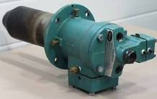 | Indirect heating of all types: melting waxes, heating pills prior to dip coating, or heating soaps, for example. Burners can be fired in tubes or outside of heat exchangers. Also can be used for direct heating to dry and pelletize fertilizers or detergents
Boilers
 |  | Hot water or steam for low temperature, precisely controlled indirect heat. The boilers for this application are not likely the large ones that have low-NO_{x} burners, and are therefore not the most susceptible to gas quality variability.
Duct burners
 |  | Combust volatile effluents to reduce or eliminate pollution; the burner is downstream of the product manufacturing and will not affect product quality.
Line burners
 |  | Pipe heating to keep contents at the proper temperature as they flow around the plant.

327 Nonmetallic Mineral Products
3271 Clay Product and Refractory Manufacturing
3272 Glass and Glass Product Manufacturing
3273 Cement and Concrete Product Manufacturing
Glass and cements are both nonmetallic mineral products. The melting point of glass is between 2550°F and 2900°F, depending on its composition, so glass furnace temperatures must exceed this temperature. Cement manufacturing is also high-temperature, with kiln temperatures exceeding the 2700°F product temperature. Flame sensing is no longer an issue though, because a flammable mixture of fuel and air will automatically burn at these temperatures. At these temperatures, thermal NO_{X} can form, and plant emissions may be regulated. Energy efficiency becomes important because of the amount of fuel used, meaning operators may intentionally reduce the air/fuel ratio so that less excess air is heated. This means there would be a smaller range for Wobbe Number variability before CO emissions would occur. Also, process equipment can be pushed to its operating limit, meaning the maximum blower speed and the maximum firing rate may be used to put the maximum heat into the furnace.
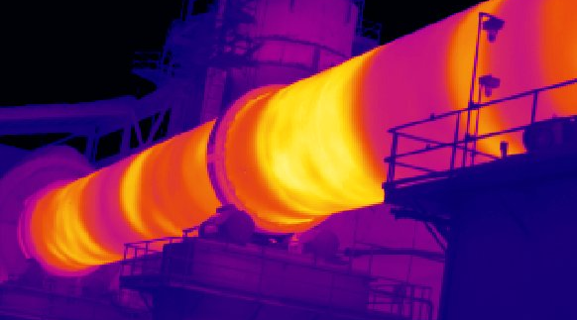 | 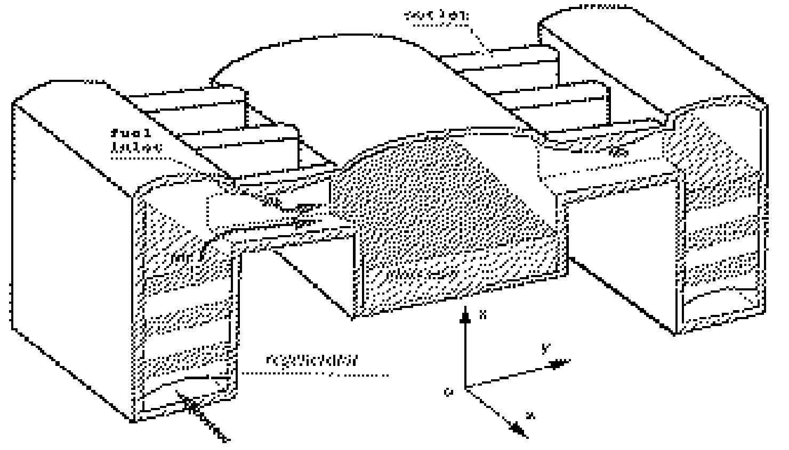
Figure 16. A thermal image of a cement kiln (reference Electrophysics). | Figure 17. Regenerative setup in a glass furnace (reference Song et al 1997).

Process heaters for nonmetallic mineral product manufacturing
High velocity burners
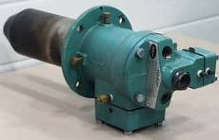 | High heat with convective heat transfer for both glass and cement manufacturing. Cooler applications include the drying line in a gypsum wallboard facility.
Oxygen-fired burners
 |  | These are very common in large glass furnaces. Oxy-fired flames can reach very high temperatures and are thus likely to produce high thermal NO_{x} if the high-Wobbe Number fuel has been conditioned with more than about 1% or 2% nitrogen; the nitrogen content of the AGT historical gas composition is just under 1%.
Regenerative burners
 |  | Glass but not cement heating. The exhaust air must be clean because it will be drawn through the burner for heat recovery. Pressure fluctuations from different combustion product volumes and temperatures may excite some controller oscillation that should be able to be fixed by adjusting the exhaust damper pressure or possibly timing. GTI currently does not believe the changes that could occur, even oscillation, are enough to warrant more than burner adjustment.

3274 Lime and Gypsum Product Manufacturing
Lime and gypsum product manufacturing can also be high-temperature but would not have a clean enough furnace atmosphere for regenerative heating and likely would not use oxygen-fired burners. One very common type of product, wallboard (drywall) is a fire-resistant building material that retains some water in the final product after drying. The drying can be done both with direct firing or with indirect firing, and the atmosphere can be humidity controlled. Emissions regulations, if they exist, are more likely to address product-related emissions than combustion-related emissions.

Process heaters for nonmetallic mineral product manufacturing
High velocity burners
High heat with convective heat transfer for calcining. Cooler applications include the drying line in a gypsum wallboard facility.

Radiant tube burners
Indirect heat gypsum drying.

331. Primary Metal Manufacturing
In primary metal manufacturing, metals are melted and treated to harden them or to change their material properties. The sector includes processing of iron, steel, aluminum, and other nonferrous metals. Because combustion products can oxidize the metal, and also because some chemical treatments are flammable, high-temperature indirect heating is often used. At these high temperatures, the heat exchange medium is often pushed to the limit of its capacity to withstand heat, meaning a small increase in flame temperature or some flame impingement could dramatically shorten equipment lifetime.
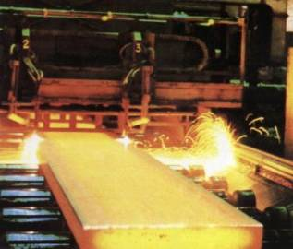 | 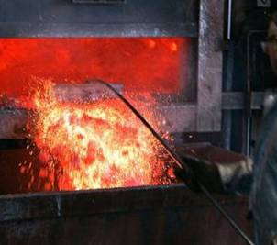
Figure 18. Brno University of Technology, Czechoslovakia, continuous cast slab of steel (http://www-dt.fme.vutbr.cz/cast/Brccm.htm). | Figure 19. Crestwood Metal aluminum recycling in Holbrook, N.Y.((reference Betz, 2006)

Process heaters for primary metal manufacturing
High velocity burners
High heat input and stirring for even temperature in a variety of applications, with a variety of flame shapes. Both indirect and direct heating are possible.
Oxygen-fired burners
Possibly as boosters to increase production given a limited furnace volume, or in some metal applications, but oxidization concerns may not allow their use as 100% of the furnace heat. When oxy-fired burners are used as boosters they are not as likely to create NO_{x}, and NO_{x} will not be a big interchangeability concern in this industry.
Radiant tube burners
Applications such as galvanizing where the combustion exhaust must not contact the product or with a combustible furnace atmosphere. Flame impingement may or may not be an issue; it would be more apparent for u-tubes, a-tubes, p-tubes, trident tubes, or any other tube where the hot gases change direction. GTI records indicate an average tube life for metal tubes of around 10 months.

Regenerative burners
Aluminum melting or other applications where the exhaust air would be clean, because it will be drawn through the burner for heat recovery. These burners are complicated to operate but highly efficient. Pressure fluctuations from different combustion product volumes and temperatures may excite some controller oscillation that should be able to be fixed by adjusting the exhaust damper pressure or possibly timing. GTI currently does not believe the changes that could occur, even oscillation, are enough to warrant more than burner adjustment.

332 Fabricated Metal and 333 Machinery
Fabricated metal manufactured parts can be anything from chains or bolts to decorative fences or light fixtures. The high temperature process heating applications are hardening after machining, and reheating metals for further forming. Low temperature applications include cleaning, paint drying, and combustion of the volatile effluent after painting. Machinery manufacturing is also broad, and includes completely finished machines. Again, paint drying and combustion of volatile effluent are heating applications.
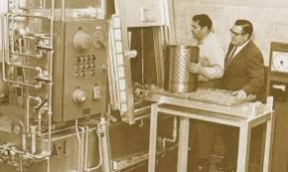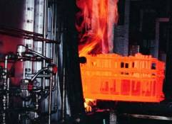
Figure 20. Heat treat furnace at Akron Steel Treating in Ohio.

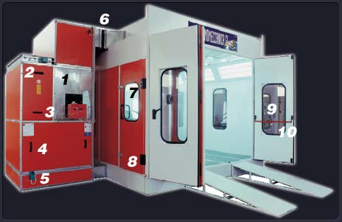
Figure 21. Termomeccanica GL Spray booth (Termomeccanica GL, http://www.spray-booths.org/) . Part #1 houses a heat exchanger to keep combustion products from the paint, and part#3 is a Riello gas/oil dual lfuel burner..

Process heaters for chemical manufacturing
Blown burners of all types, including high velocity burners
High heat input and stirring for even temperature in a variety of applications, with a variety of flame shapes.
Heat parts prior to fluidized dip coating.

Boilers
Hot water or steam for low temperature, precisely controlled indirect heat. These boilers are not expected to be large enough to have a low-NO_{x} burner, meaning any interchangeability issues are not expected to be severe.
Duct burners
Combust volatile effluents to reduce or eliminate pollution; the burner is downstream of the product manufacturing and will not affect product quality.
Infrared burners
Paint drying or other finishing.
Possibly surface heating prior to fluidized dip for coating.

Radiant tube burners
Applications such as hardening where the combustion exhaust must not contact the product. Also, applications with a combustible furnace atmosphere.

334. Computer and Electronic Products and
335. Electrical Equipment, Appliances, and Components
Computer and electronic products that use natural gas heat are likely the shells, the cables, and other plastic parts. Semiconductors and Related Devices (NAICS #34413) require very precise temperature control that can only be achieved by current electric technology. Electrical equipment, appliances, and components include light bulbs, so in addition to requiring thermal radiation burners for thermoforming, the NAICS #335 processes may use intense heat to form glass bulbs.
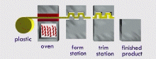
Figure 22. Vacuum thermoforming process. www.plasticpack.com

Process heaters for chemical manufacturing
Duct burners
 |  | Combust volatile effluents to reduce or eliminate pollution; the burner is downstream of the product manufacturing and will not affect product quality.
High velocity burners
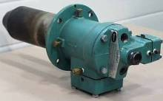 | Heat glass for forming light bulbs.
Infrared burners
Paint drying or other finishing.
Thermoforming plastic parts.

336. Transportation Equipment
Transportation equipment includes car bodies, seats and dashes, headlights, and anything else related to transportation. The process heating applications are heating glass for forming in car lights, drying paint on the car’s exterior, thermoforming plastics for the car’s interior, and combusting the volatile effluents from the painting process.
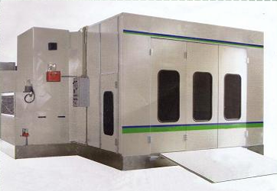 | 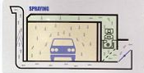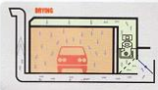
Figure 23. SW-300 spray booth with Riello burner

Process heaters for chemical manufacturing
Duct burners
Combust volatile effluents to reduce or eliminate pollution; the burner is downstream of the product manufacturing and will not affect product quality.
High velocity burners
Heat glass for forming light bulbs
Infrared burners
Paint drying or other finishing.
Thermoforming plastics

337. Furniture and Related Products
Heating applications for furniture and related products include cleaning wood, metal or fabrics, drying paints and varnishes, and combusting effluent vapors to meet emissions regulations. All of these are low-temperature applications.
Process heaters for commercial bakeries, cookie and cracker manufacturing
Blown burners of all types, including high velocity burners
All-purpose: can be used for singeing, or for firing in tubes to heat chemical solutions for cleaning or dyeing.
These burners can also fire into moving air for tunnel heating.
High velocity burners give good circulation in the oven
Boilers
Steam or hot water for cleaning or dyeing fabrics, or possibly to soften woods. These applications are not expected to use the largest boilers, and are therefore also not expected to use the low-NO_{x} burners that are most likely to be susceptible to Wobbe Number variability.
Duct burners
Combust volatile effluents to reduce or eliminate pollution; the burner is downstream of the product manufacturing and will not affect product quality.
Infrared burners
Thermal radiation burners, with face temperatures up to 1200°F for setting new powdered dyes. This application is usually electric.

Surface burners
Indirect heating of vats of dyes or cleaning solutions.

Conclusions and Recommendations
The major interchangeability issues for natural gas-fired process heating equipment fall into five categories: (1) a change in fuel/air ratio, (2) liftoff or other change to interfere with required flame detection for safety, (3) effect on product quality, (4) effect on equipment lifetime, and (5) excursions from permitted emissions limits. The following list briefly summarizes issues for the different heating applications:
End use equipment operates most efficiently when tuned to an unchanging gas composition. In essentially all end use combustion applications, changing the fuel gas requires, at most, a one time adjustment as has been described. However, if gas compositions change regularly, then some combustion systems may need to be tuned non-optimally or slightly de-rated to operate properly over the wider gas composition range. Gas companies can adapt to this concern by supplying gas or different, but narrower, composition ranges to different regions.
- Boilers
  - High risk of excessive CO emissions because of fuel/air deviation:
Low-NO_{X} boilers can run as low as 5% excess air, meaning a 4% change in Wobbe Number (from 1345 to 1400) would bring the fuel/air ratio to nearly no excess air—this is likely to lead to incomplete combustion and unacceptable CO emissions. Boilers that are not designated low-NO_{X} only pose a moderate risk because they are more likely to operate with higher excess air.
  - Moderate risk of loss of flame sight because of pressure and other changes:
Pressure and temperature changes may excite flame instability and cause a loss of flame sight, which will trigger an equipment shutdown. This will be investigated during GTI’s interchangeability tests for the CEC.
  - No risk of reduced product quality:
The water or steam temperature and pressure are carefully controlled, and they indirectly transfer heat to the product. The flame is not in contact with the product.
  - Unlikely risk of increased equipment wear:
A change in flame temperature could increase the number of cycles of firing/not firing, and also increase vibrations and overheat. The degree of change expected is small. This will be investigated during GTI’s interchangeability tests.
  - Moderate risk of deviation from permitted emissions:
Different fuel density will affect the flow pattern, and a different Wobbe Number will change the fuel/air ratio. Together, this and a higher flame temperature could increase NO_{X} emissions. The CO emissions will become a problem only if there is not enough air to consume the fuel—less than maybe 3% excess air or 0.5% O₂ in the exhaust. The amount of increased NO_{X} will be investigated during GTI’s interchangeability tests.
  - Fix:
Adjust the air/fuel ratio. If this does not work, then each burner will require different service and each burner will be different. It is not anticipated that an equipment change will be necessary, but extended service work and analysis may be needed. If it is, then new emissions permits must be negotiated.
  - Cost:
About a day of a service representative’s time to adjust air/fuel ratio, or weeks plus equipment cost for very rare other changes.
- Low-temperature applications
  - Moderate risk of excessive CO emissions because of fuel/air deviation:
These burners are intended to run with 10% to 15% excess air, which is plenty to accommodate a 4% change in Wobbe Number. If blowers are blocked and the fuel/air ratio control is actuated by a cam, then there could be significantly less excess air and high CO emissions, but this is more a maintenance problem than an interchangeability problem.
  - Moderate risk of loss of flame sight because of liftoff:
Liftoff is supposed to be unlikely when the Wobbe Number increases, but some experience at GTI with appliance burners indicates a high nitrogen content in the fuel causes liftoff, regardless of Wobbe Number. This will be investigated during GTI’s interchangeability tests.
  - Moderate risk of reduced product quality:
Increased NO_{X} emissions are likely, which could affect the food chemistry. In some oven applications, temperature is not controlled: instead, a firing setting is fixed and a conveyer speed is selected (reference Miller and Welch 2005). A 4% increase in heat rate (Wobbe Number) is expected to affect the product quality if the conveyer speed and the furnace temperature are both uncontrolled. This is likely to occur in low-tech commercial bakery ovens, pizza ovens, or char-broilers. A retrofit to the conveyer system is impractical, so a temperature controller is recommended if product quality specifications require this. A temperature controller and a motorized valve, plus installation would cost about $1000.
  - Moderate risk of increased equipment wear due to flashback:
Flashback is a possibility in premixed burners when the combustible mixture is ejected at a low speed. The extent of this risk is unknown and will be investigated during GTI’s interchangeability tests.
  - No risk of deviation from permitted emissions:
These applications are not subject to emissions regulation.
  - Fix:
Adjust the air/fuel ratio. Inform employees that the temperature controls for the fixed-time ovens may deviate from their original setting. Monitor food quality, and possibly add automatic control to conveyers.
  - Cost:
The better monitored and instrumented the equipment, the less additional effort must be made. Air/fuel ratio adjustment requires about a day of personnel time. Many of the other suggestions ought to be done already as part of quality assurance. The end-user most likely to be hurt from this are small restaurant owners who have low-tech gas appliances and no real quality assurance program in place.
- High-temperature applications
  - Moderate to high risk of excessive CO emissions because of fuel/air deviation:
These burners are intended to run with 10% to 15% excess air, which is plenty to accommodate a 4% change in Wobbe Number. High energy costs have burner vendors and energy managers openly suggesting to run the burners with less excess air. The excess air does not contribute to heating, and instead simply absorbs energy from the flame. Its only use is as a safety margin to guard against both pressure and temperature changes in the ambient air and fluctuations in gas quality. Energy-conscious manufacturers could be operating with 5% to 10% excess air, which is about on the borderline for incomplete combustion. Oxy-fuel burners fire at lower excess O₂ because the oxygen is expensive too.
  - No risk of loss of flame sight because of liftoff:
Flame sighting is not required for furnace temperatures above 1400°F.
  - Unlikely risk of reduced product quality:
The product just needs to be very hot. The only possible issue is that the lowest possible firing rate of a burner will likely be higher, meaning production will not be able to slow down as much to, for example, accommodate a problem downstream. This could result in more lost batches. It is unclear how often industry uses the lowest firing rate of their burners, and whether the increase in minimum speed (approximately proportional to the % Wobbe increase) would even be noticeable.
  - Moderate risk of increased equipment wear due to control effort:
Regenerative burners in particular have a complex control system that could respond with more activity to an increase in Wobbe Number. Depending on the frequency of the change in gas quality, and on the equipment response to this change (to be determined during GTI’s interchangeability tests) there could be an increase in equipment wear from more frequent actuation.
  - High risk of deviation from permitted emissions:
These applications are often regulated for emissions. The high-temperatures in the furnace are enough to produce thermal NO_{X}, and the increased Wobbe Number fuels are likely to increase the flame temperature, and thus NO_{X} formation. This is particularly an issue for oxy-fuel burners in the gas industry, whose flame temperatures can reach 5400°F, and because they have invested in the oxy-fuel technology partly to reduce NO_{X} emissions.
  - Fix:
When firing traditional pipeline gas, ensure there is at least 2% O₂ in the exhaust. Anticipate the change in emissions and request a different permit from relevant authorities.
  - Cost:
A day or two of personnel time. The cost of deviating from an emissions permit depends on the local laws.

If there are emission regulations for the textiles sector, they may be to restrict the release of volatile effluent that escapes from the dyes or inks, which has nothing to do with the combustion.
“NE” denotes New England: Massachusetts, New Hampshire, and parts of New York.

