IDENTIFICATION
INSTRUCTOR: Christopher Robinson
UNIT TOPIC: Describe Fishing Methods
LESSON TITLE: Demonstrate proper fishing knot tying procedure.
CLASS: Wildlife Recreation & Management DATE BEST TAUGHT: Fall
TEKS: 119.46c 3C

OBJECTIVES (TSWBAT---The student will be able to…)
- Explain in writing the need for proper fishing knots with no errors.
- List 2 rules in writing for proper fishing knot tying with 90% accuracy.
- Perform one common fishing knot with line and sinker with no errors.

TEACHING MATERIALS AND RESOURCES (What do you need to bring?)
- Handouts: Basic rules and knot tying procedures.
- Practice tools: Rope and fake lures (eye hooks in wood blocks).
- Practical assignment: Fishing line and sinkers in envelopes.

TEACHING PROCEDURES---Preparation, Presentation, Application, Evaluation

Preparation (Interest Approach/Motivator) 5 Minutes
Key Points | Methods
Link: recap line test (gauge) & types of lures  Motivation: Q: why are fishing knots important, why are some knots not appropriate, what are some qualities of a good knot?  Overview: Today we will…  Define terms associated with fishing knots  Discuss basic rules that apply to all types of fishing  knots  Practice and perform different types of fishing knots | Teacher led discussion

Presentation (The Meat!) 10 Minutes+5 for each knot
Key Points | Methods
First handout: give to students  Key terms necessary: Eye, standing end, working  end, tag end  Rules to remember: types of knots, lubrication,  tightening, trimming, re-tying, practice  Knots need to be as strong as possible!!!  Knot handouts: give to students as covered  Describe knot qualities and uses  Show quick example  Explain step by step while performing  Demonstrate again before letting students practice | Teacher led discussion  Demonstration

Application (What will they do with what you taught?) 10 Minutes for each knot
Key Points | Methods
Spit class into pairs  Handout practice lures and rope  Allow students to practice the knot  Observe students’ progress helping as necessary | Guided practice

Evaluation/Summary (How do you know they learned it?) 15 Minutes
Key Points | Methods
Review uses and qualities for the knot  Review basic knot tying rules  Practical assignment  Write information on envelopes:  Name, type of knot, qualities of the knot, 2 rules for  Proper knot tying, why fishing knots are important  Using the knot, tie a fishing line to the sinker  Put into envelope and turn in when finished | Oral questions  Handout envelopes

REFERENCES:

http://www.fintalk.com/fishing-knots/

http://www.marinews.com/knot_rigs.php#
Fishing Knots

Terms:

Eye- loop on the hook or lure used to attach the line
Standing End- end of the line that is fixed
Working End- end of the line actively tying the knot
Tag End- the finished unused end of the line

Rules to Remember:

- Be familiar with different types of knots
  - Size and composition of the line
  - Type of lure
- Lubricate the knot
  - Friction and heat
- Tighten slow and gentle but finish firmly
  - Friction and heat
  - Tight knots are stronger
- Trim tag end
  - Neat appearance
  - Less visible
- Re-tie knot until you are satisfied
- Practice often

Bad Knots are Weak Knots!!!
The knot is the weakest point on the line
Strong knots keep 90%or more of the line strength
Weak knots can have less than 50% of the line strength
PALOMAR

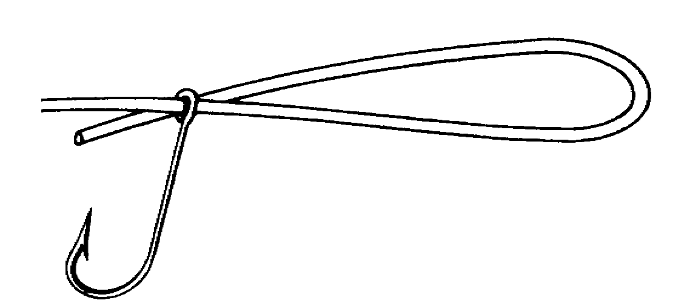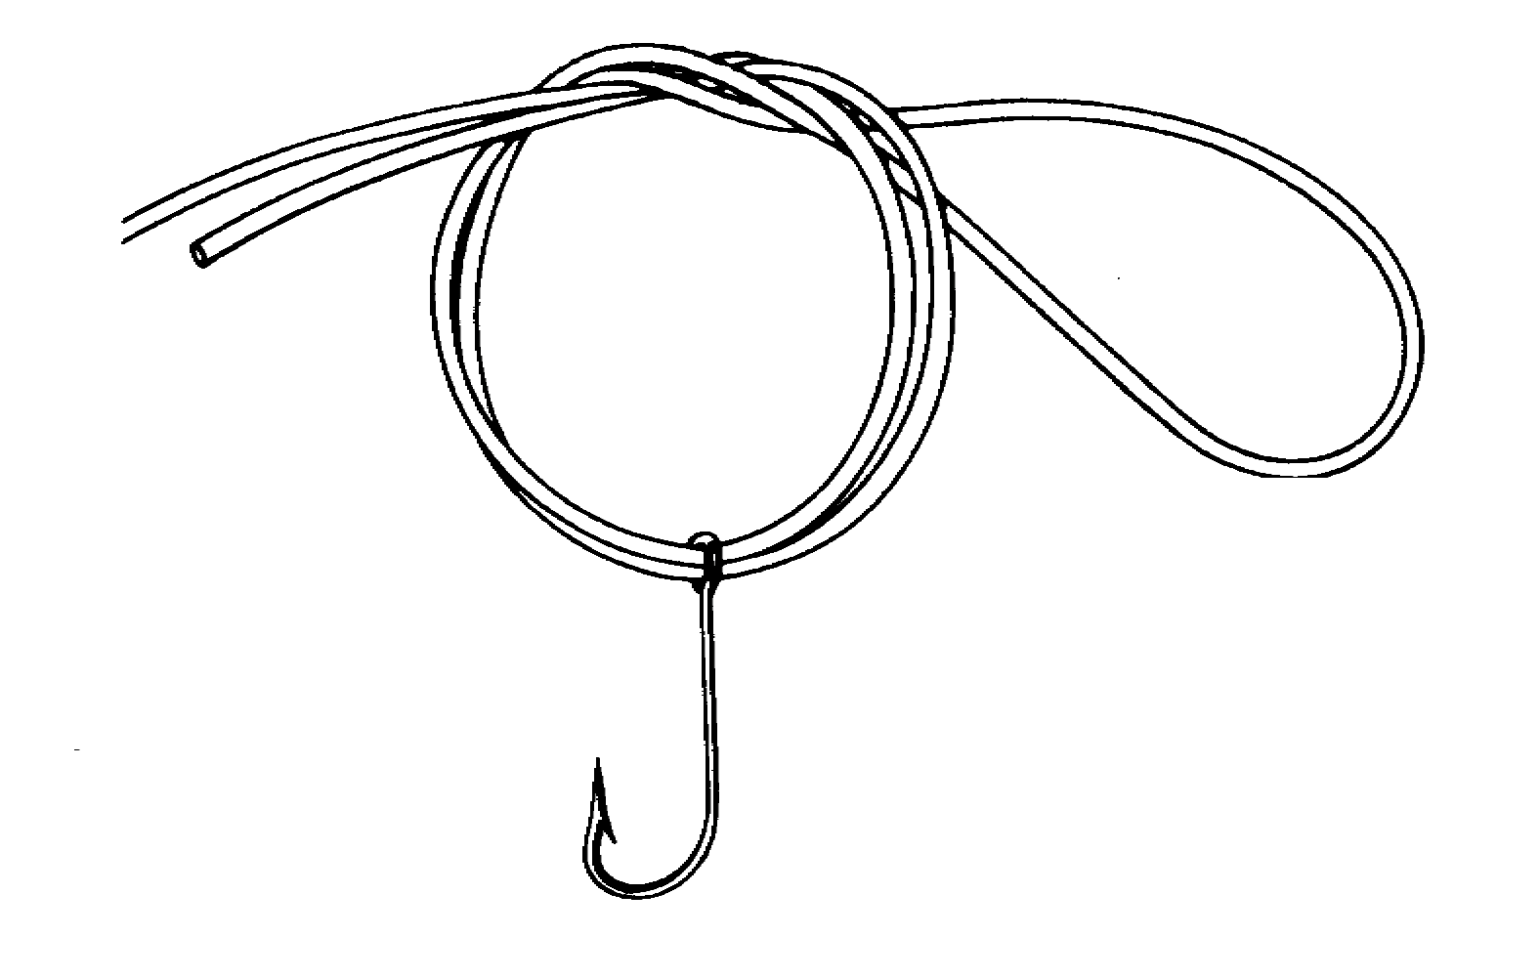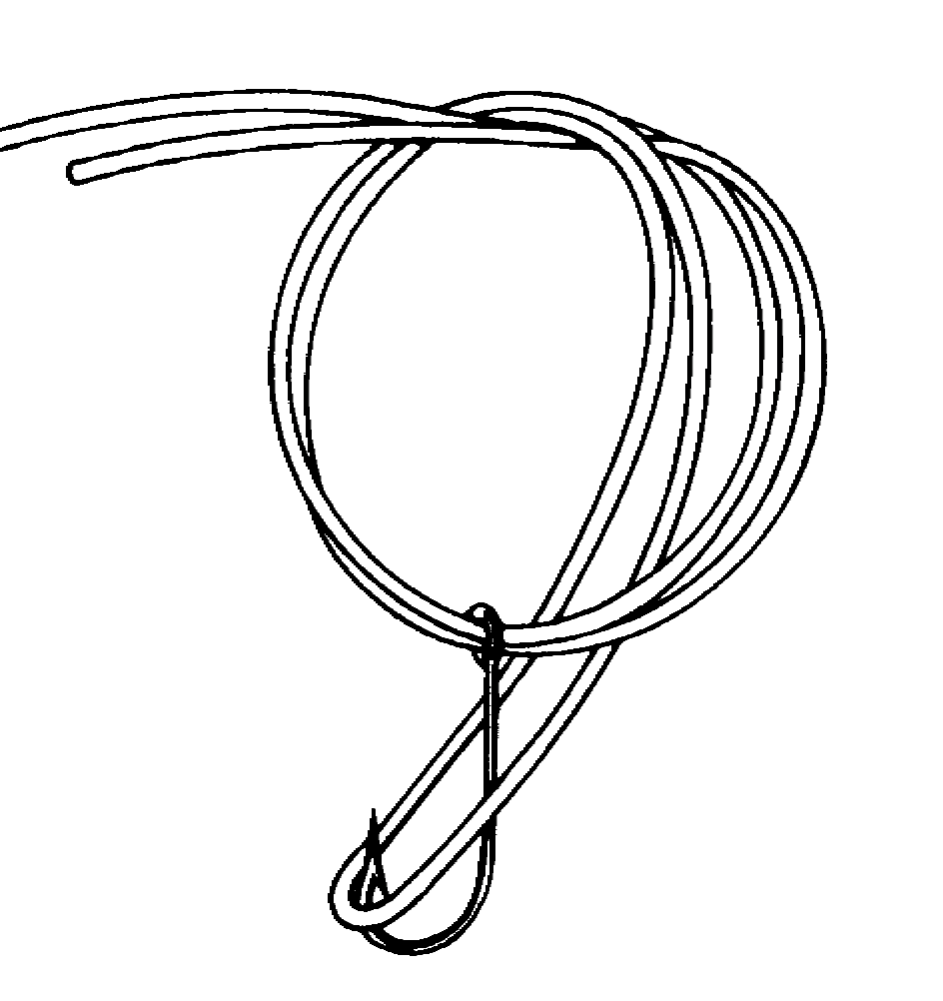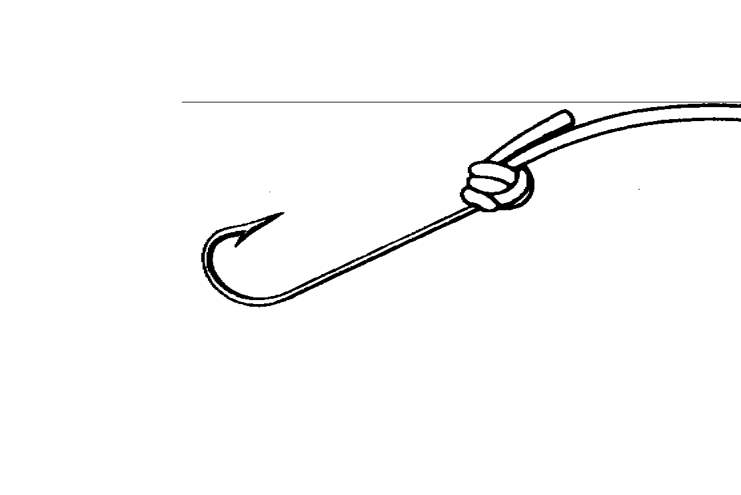

Palomar: very strong, easy to tie, also works with braided lines

- Double line and pass through the eye 4-6 inches.

- With hook or lure hanging from middle, tie overhand knot.

- Pass hanging loop over hook or lure.

- Lubricate.

- Pull standing end and tag end at the same time until tight.

- Clip tag end to ¼ inch.
IMPROVED CLINCH KNOT

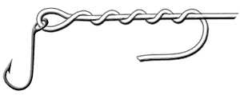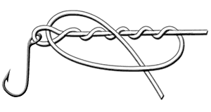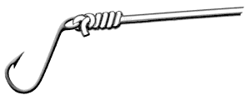

Improved Clinch Knot: very popular, quick, easy, strong, not good for large gauge, use with monofilament only.

- Pass line through eye.

- Wrap 3-5 times around main line depending on gauge.

- Pass working end through gap between eye and first wrap.

- Pass working end through new large loop.

- Lubricate.

- Pull standing end while holding tag end.

- Clip tag end to ¼ inch.

DUNCAN LOOP

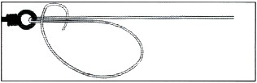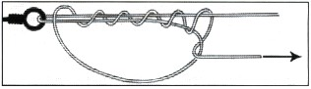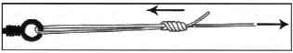

Duncan Loop: Small, compact, adjustable, not very strong, allows movement for flies, plugs and poppers.

- Pass line through eye and double back parallel to standing line.

- Make a loop by laying working end over double line

- Wrap working end around the double line but through the loop 5-6 times depending on gauge.

- Lubricate.

- Pull tag end to tighten knot.

- Slide knot to desired distance from eye.

- Clip tag end to ¼ inch.

