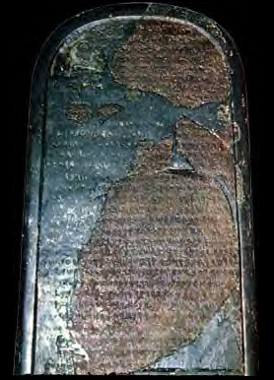
Directions: Based on the text of the Mesha Stele answer the questions below:
- Who is speaking? Where is he from?
- What did Mesha build? Where? Why?
- Who was Omri and who was his son? What did they do to Mesha?
- What did Omri take possession of?
- What do you think Chemosh is? Why is he mentioned so many times in this Stele?
- What did Mesha build?
- What did Mesha do as a sacrifice?
- What city did Mesha fight against? Why? What happened in this fight?
- Who did Mesha take vessels from? What did he do with them? What type of vessels do you think these were?
- What did the King of Israel try to do against Mesha? What happened?
- What city did Mesha build? Describe this city in detail.
- What other cities did Mesha build?
- What kingdom is mentioned at the end of this Stele?
- Below is a Map of Israel at that time, circle all of the cities on this map that are also mentioned in the Mesha Stele and list their names below: http://www.iath.virginia.edu/mls4n/maps.html http://www.biblestudytools.net/OtherResources/BibleMaps/The_Kingdom_Years.html

