Identity Manager 4.4 Performance Evaluation

“Company A” Hardware Proposal
Version 1.0

Tivoli Software
15540 Laguna Canyon Rd
Irvine, CA 92618
 |  | Issue Date: | 7/30/2026 3:38 AM
 |  | Author: | Scott Pierce
 |  | Template version 1.0
Summary of Changes
Date | Author | Purpose
2/20/2003 | Scott Pierce | Document creation

Table of Contents
1. Benchmarking Approach 3
1.1. Performance Benchmarks 3
1.2. Client Usage Profile 3
1.3. Performance Evaluation 4
1.4. Testbed Setup 5
2. Hardware Recommendations 6
2.1. Identity Manager Tiers 6
2.1.1. Application Tier 6
2.1.2. Data Tier 6
2.1.3. Network Tier 7
2.2. Hardware Recommendation Summary 7
2.2.1. Application Tier 7
2.2.2. Data Tier 8
2.2.3. Network Tier 8
2.3. Network Diagram 9
3. Test Results 10
3.1. Change Password Peak Usage Scenario 10
3.2. Standard Client Profile Scenario 10

Table of Contents

The table below contains the summary of changes:

Benchmarking Approach

Performance Benchmarks
This recommendation uses industry benchmarks and capacity planning tools to demonstrate the performance capabilities of IBM Tivoli Identity Manager 4.4 (ITIM). Although good benchmarks are designed to simulate real customer workloads, it is impossible for any single benchmark to simulate every customer environment. Benchmark results are one of many criteria used when determining which platform best fits a client’s needs.
The client stress tool used for this proposal, Segue Performer, delivers stress by simulating actual client behavior. It creates individual threads each simulating a client browser session and performs actions through the ITIM UI exactly as a regular user. This tool can be customized and weighted to adapt to a specific customer environment and traffic patterns, providing tests of the performance and capacity of ITIM suited to specific client requirements.

Client Usage Profile
The client usage profile is the key starting part for determining what resources are needed to run ITIM effectively. A client usage profile is a mix of ITIM transactions that represent the typical usage pattern of a fully implemented client. For example, the profile may include password changes, adding identities, adding accounts, modifying policies, and running reconciliation’s. The standard Client Usage Profile does not include a recon activity, as we find that the majority of our clients prefer to schedule reconciliation’s at night to reduce the impact to the managed resource.
There are several ways to create a client usage profile. The most accurate method is to accumulate client usage data from systems and applications in use at the site. Usage data accumulated over a period of one to several months is the most accurate. This provides a sampling of activities a client completes over hourly, daily, weekly and monthly periods. Samples of activity at small intervals often miss or fail to capture events that happen at regular but infrequent intervals. Once the profile is established, the stress tool scales the concurrent user load to simulate patterns from a single user through hundreds or thousands of users.
For situations where actual client data is absent or unreliable, a standard ITIM Usage Profile is substituted. This profile is a composite of transaction patterns of typical ITIM clients. In addition to the standard ITIM Usage Profile, a peak load performance test was also performed using a “password change” scenario. This scenario simulates every user changing the password of a managed resource in a single day. Thus, there are two types of performance results as a conclusion for this recommendation.

Performance Evaluation
The hardware components chosen, how they are configured, and how they are deployed, can make a tremendous impact in the level of performance ITIM attains. In addition, it is cost-effective to add only those components that will improve performance for your specific environment. For example, a higher speed CPU will boost performance on a server whose performance is hindered by the limitations of its CPU, but will do very little for a system whose performance is limited by its disks. ITIM can be separated into two tiers in its need for resources. The ‘Application’ tier consists of the ITIM application server, which runs on WebSphere Web Application Server using MQSeries for transaction processing. The “Data’ tier consists of DB2 server for ITIM workflow and auditing and IBM Directory Server (LDAP) for storing account information. See Figure1.
Throughput is the most commonly used performance metric for file servers. It is the total bits of data the clients send to a server and a server returns to the clients. Throughput is measured in megabits per second (Mbps).
Average response time is the average time a file server takes to complete all of the different file system and I/O operations a client system requests.
For the testing we will use a fictitious company named “Company A”, which has a user base of 220,000 users. The ultimate target of this performance test was to determine the actual hardware required to support X number of concurrent users. A worst-case scenario would be that every ”Company A” user would change their password in a single day. This results in: 220,000 users X (1 day/8 hr) X (1 hr/60 min) X (1 min/60 sec) = 7.6 transactions/sec, thus if an change password transaction takes 30 seconds to accomplish, the number of concurrent users is: 7.6 transactions/sec X (30 sec/transaction) = 228 concurrent users

Figure 1: ITIM Performance Testbed

Testbed Setup
A performance testbed was setup specifically for the ”Company A” performance evaluation. The setup consisted of three separate AIX servers (see Figure 1), loading of the current ”Company A” user database into ITIM (220,000 user accounts), and tuning of the various software infrastructure components for maximum performance. As mentioned previously, the actual performance testing consisted of running two different types of test inputs against this environment (Password Change and Client Usage Profile). The testbed hardware recommendation will differ from the recommended hardware for several reasons, including:
- Where the performance bottlenecks for maximum throughput are located, changes are made.

- Scaling factors are applied to tune the configuration for a different user environment.
- Hardware extrapolation to support the anticipated ”Company A” production deployment for High Availability is made.

Hardware Recommendations

Hardware Recommendations

Identity Manager Tiers
For scalability and performance, we have found that separation of the processing needs onto separate servers provides a cost effective, secure and performant way of deploying ITIM.

Application Tier
We recommend an application tier with two or more WebSphere application servers joined in a WebSphere Advanced Edition cluster. Each server will run one WebSphere node configured with 2Gb of memory for JAVA. The remainder of the memory is for use by MQSeries, IBM HTTP server, and file cache. Four disks need to be provided for each of the Application tier systems. Three are configured in a RAID1 configuration for use by MQSeries. Testing has shown that the application tier scales as more or faster processors are added. The tier also requires adequate disk system for MQSeries and a small fixed memory size.

Data Tier
We recommend a data tier with one or more servers running two instances of DB2 (includes LDAP). The first instance of DB2 for ITIM requires a minimum 2Gb of memory, a six-disk RAID1 fibre channel volume for data storage, and an additional disk for logging. The second instance of DB2 requires a minimum 4Gb of memory, a six-disk RAID1 fibre channel volume for data, and an additional disk for logging. The remaining memory and disk are used by the OS. Testing has shown that the data tier needs ½ to ⅓ of the processing needs of the application layer but requires a fast disk subsystem to process database and LDAP activities. This tier scales as additional memory and faster IO subsystems are added.

Network Tier
To provide efficient load distribution and failover, we recommend a network load balancer. A hardware load balancer is the best choice for this activity providing security by segmenting the application and data servers from the corporate environment, load balancing choices for efficient network traffic distribution, and complex failover features for ensuring application availability.

Hardware Recommendation Summary

This proposal assumes that client has all required enterprise backup solutions (including tape drives), networking equipment and network bandwidth, and server monitoring tools already in place. The proposal further assumes that ITIM transaction log data will be purged or archived on a 30-day schedule.
This proposal recommends a disk storage subsystem capacity based on the following assumptions:
- 30 day retention period for ITIM audit data on local server (approx 15 day buffer).
- 250,000 identities
- 6 accounts per identity
- 25,000 account transactions per month

Application Tier
To achieve 250 concurrent transactions (0.1% concurrency) against the standard profile using a LDAP population of 250,000 users, we recommend the following hardware:

A typical configuration:
- Two 6-way 1.45Ghz pSeries 650 server running AIX 5.1
- 3 GB RAM per server
- Internal RAID of 3x18.2Gb Disks for MQSeries and 1x18.2Gb Disk for AIX OS

Data Tier

A typical configuration:
- Two 4-way 1.45Ghz pSeries 650 server running AIX 5.1
- 8 GB RAM per server
-
One FASTt500 Storage array with 14x18.2 15k Fibre Channel drives

Network Tier
- One Alteon 180e Web switch/load balancer (or equivalent)

Network Diagram
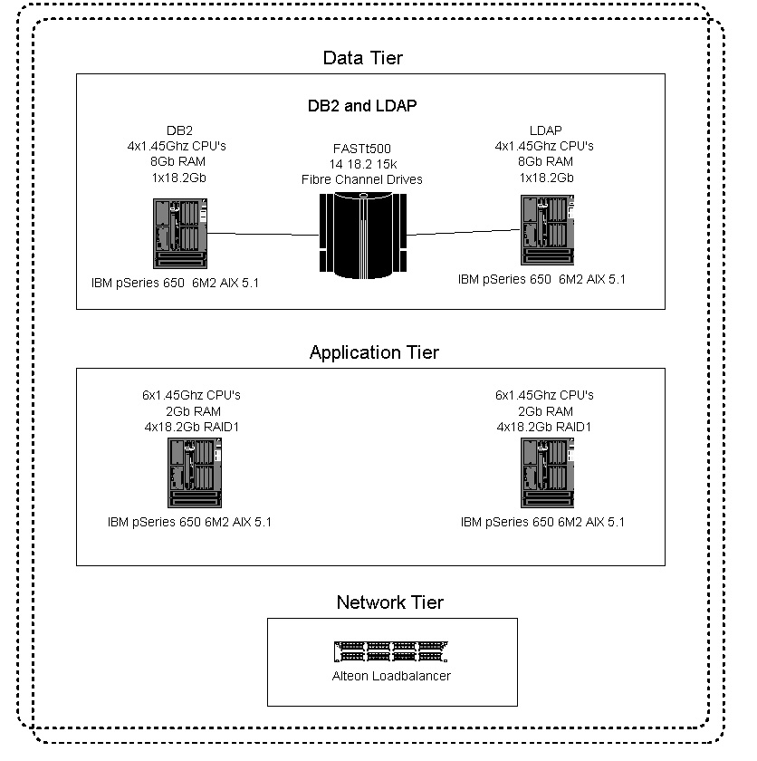

Test Results

Change Password Peak Usage Scenario
11,172 change passwords were completed in one hour. 65 concurrent connections were applied with an average page response time of 0.71 seconds. The Application servers were at 30% CPU utilization, 162,292K free memory and 1,500K free memory and an average of 60% of disk wait time.
Conclusion – We are disk bound on the data tier that, when relieved, should allow us to process up to 100% more transactions achieving 22,324 transactions/hr or 6.2 transactions/sec. The hardware recommendation, specified in Section 2 of this proposal, is two times that of the tested configuration and we should achieve 12.4 transaction/sec.
Example: the proposed system, properly tuned, will support 250,000 users each changing one passwords in a day. This is 8.7 transactions/sec (250000 users / 8hrs /60 min /60 seconds) and would reach 372 concurrent users (30 seconds a transaction * 12.4).

Standard Client Profile Scenario
2,472 transactions composed of 39 Add users, 1,821 Change password, 75 Change Organizational Role, 49 Change Provisioning Policy, 64 Change User Status, 11 Delete users, 141 Forget Password and 272 Search were completed in one hour. 33 concurrent connections were applied with an average page response time of 1.56 seconds. The Application servers were at 30% CPU utilization, 100,000K free memory and an average 5% of disk wait time. The Data server was at 17% CPU utilization, 3,513K free memory and an average of 52% of disk wait time.
Conclusion – We are disk bound on the data tier, that when relieved should allow us to processes 200% more transactions achieving 4,944 transactions/hr or 1.373 transactions/sec. The hardware recommendation, specified in Section 2 of this proposal, is two times that of the tested configuration and we should achieve 2.74 transaction/sec.
Example: the proposed system, properly tuned, will support an update operation on 20% of the 250,000 users on a daily basis. This is 1.74 transactions (250000 users / 8hrs /60 min /60 seconds * 20%) and would reach 164 concurrent users (60 seconds a transaction * 2.74).

