Anne’s links
You can activate the links by left-clicking on the link while holding down the Ctrl-key.
You can add links to a document by copying the address and inserting it in the document. Here I use click with the right mouse button.
Copy: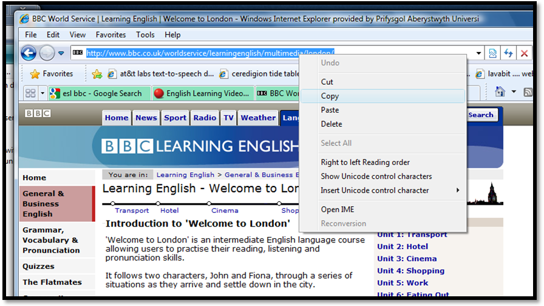
Paste:
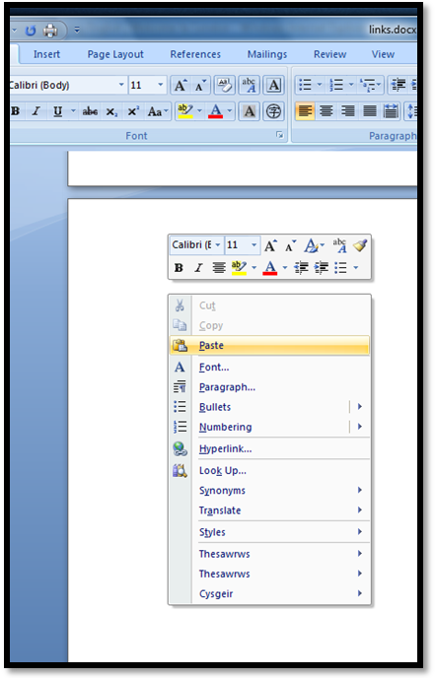

Text to speech etc.
http://www.naturalreaders.com/ Natural Reader. Programme for installation on the computer. The free version works but do not have the “good” voices.
http://www.research.att.com/~ttsweb/tts/demo.php AT&T. Online demo. You can paste a limited amount of text and have it read aloud.
http://udltechtoolkit.wikispaces.com/ UDL. About digital tools for the classroom. Some of them are free.

Large collections of links
http://iteslj.org/links/ All kinds of stuff – grammar, jokes, conversation questions...
http://www.manythings.org/ Very much like the above. It’s here you find the audio files of jokes: http://www.manythings.org/jokes/. Can be downloaded and burned to a disk or carried on a memorystick.

Audio, transcript and exercises together
http://www.esl-lab.com/ Randall’s. Organized by level.
http://www.cdlponline.org/ California Distance Learning Project. Organized by topic. New and old news. Unfortunately not organized by level (it varies a lot) or date.
“Couple says they are guilty” is one of my favourites.... http://www.cdlponline.org/index.cfm?fuseaction=activity1&topicID=2&storyID=172
http://www.rong-chang.com/qa2/index.html Rong Chang. Yep - Chinese guy. Everything is read slowly.
http://www.mansioningles.com/listening00.htm Site by some Spanish person.

Grammar and spelling
http://web2.uvcs.uvic.ca/elc/studyzone/ The ESL pages for students at Victoria University. I’ve used this one a lot. Grammar plus texts with exercises.
http://eolf.univ-fcomte.fr/index.php?page=magic-e-spelling-pronunciation-rule Spelling.
http://eslus.com/LESSONS/SPELL/SPELL.HTM Dictations.

Mixed bag
http://www.bbc.co.uk/worldservice/learningenglish/ BBC’s ESL pages. Kath already showed us this site – the one we couldn’t find was “Beyond the postcard” which takes you around Britain: http://www.bbc.co.uk/worldservice/learningenglish/multimedia/btp/index.shtml .
“Welcome to London” is a story that will take you around London: http://www.bbc.co.uk/worldservice/learningenglish/multimedia/london/

http://www.esldiscussions.com/ Questions organized by topic.
http://mes-english.com/ Flash-card generator.
http://www.senteacher.org/Print/ Printables (clocks, post cards plus more).
http://www.teflmaster.org/exercises/view-1720.html Make your own exercises – or let the student make exercises for each other.
http://themoonlitroad.com/ Moonlit road. Traditional horror stories. My favourite is “I don’t feel dead yet” (usually read in connection with Halloween) http://themoonlitroad.com/i-dont-feel-dead-yet/. Not really ESL – it’s for advanced students. No exercises.
http://www.voanews.com/specialenglish/american-stories.cfm Voice of America. Very ... American. Some of the fiction is really good – and there’s audio (no exercises). I’ve used “The law of life” http://www.voanews.com/specialenglish/archive/2006-08/2006-09-11-voa4.cfm

