Secretariat Group | One U.N. Plaza, Rm. DC1-775  New York, N.Y. 10017  Tel [1-212] 963-4149  or [1-212] 963-8279  Fax [1-212] 963-3121  Email – unwg@un.org  Website – www.un.org/unwg
Newsletter
June 2004 Issue

UNWG Secretariat Group Activities –– March 2003 to February 2004

In <month> 2003, the Secretariat Group held a workshop for members and invited as speakers, Dr. Michael “Take Away the Pain Doctor” Ebbro, Chiropractor, and Mr. Ernesto Ramos, Nutritionist and Iridologist (the science of reading the pupil to pinpoint problem areas, i.e., the heart, the kidneys, etc.).
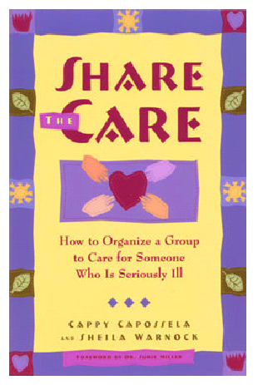
On 13 January 2003, the Group invited Ms. Sheila Warnock, Founder of Share the Care, to speak on “How to Organize a Group to Care for Someone who is Seriously Ill”; and Ms. Mari Lifrieri, Hypno-therapist and Reiki Master, to speak on treatment by hypnosis. In the same occasion, Ms. Haydee Britton provided information on a UNDP staff’s project in the Congo with the street children/child soldiers of "LES PETITS OKAPIS".

The Secretariat Group was asked by the UN Staff Union to assist in an International Food Bazaar for Staff Day 2003. There was a contest and a Group member, Ms. Kanthi Jayawickrema, won in the presentation of the best appetizer. We gratefully acknowledge the cooperation of Nubia Soto, Maggie Caban, Alicia Zanelli, Blanca Bugallo, Kanthi Jayawickrema, Zoila Poire, and Friedda Radovic, as well as other the other Group members who came during their lunch hour to assist in the Bazaar.

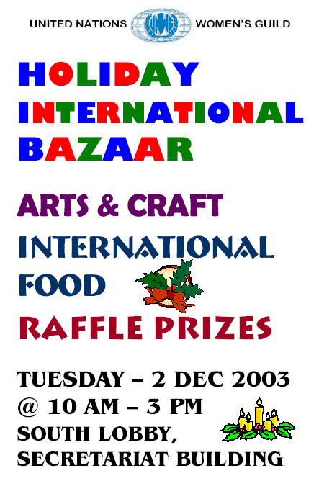
The Secretariat Group was responsible for the design and reproduction as well as subsequent distribution of the flyers used in the International Holiday Bazaar, i.e. the Bazaar announcement, raffle prizes, silent auction, list of participating Missions and prize winners. The Group also assisted the President in the formatting and faxing the letters announcing the Bazaar to all the Permanent Missions of the United Nations. A second mailing had to be undertaken as the Permanent Mission of Russia took exception to Chechnya being mentioned in the 2003 Projects List and a new list had to be mailed to all the Permanent Missions. The Group also provided the stationery and envelopes used, and gratefully acknowledge the efforts, expertise and cooperation of Ms. Terri Olvida.

The Group is also instrumental in the publication efforts of the second edition of the book of children’s stories entitled “Ride The Sun”. We gratefully acknowledge leadership and coordination of Ms. Fabiola Knight in this endeavour.

The Group manned the UNWG Gift Shop on Saturdays and Sundays until September 2003. We gratefully acknowledge the contribution of Elsa Wurfl for making this possible. The 2004 Calendar towels were sold by various Secretariat Group members in the DC1 3rd Floor and we gratefully acknowledge the cooperation of Amelia Charles in this endeavor. The Secretariat Group had a toy drive for a children’s project in Appalachia in late December. We gratefully acknowledge Sandy Stim for her efforts in making this event a success.

Throughout the year, the Secretariat Group met to discuss the issues being discussed in the Board, i.e., Projects Review Committee and Issuance of Tax Deductible letters by individual groups, among other things.

DirectorElsa WURFLAssistant DirectorBlanca BUGALLOBoard RepresentativeEdna DUVIVIERSecretaryDiane LINTreasurerMaggie CABANProjects CommitteeHedy MATULACSales CommitteeDina SIMONProgramsNewsletter / PublicityGenoveva WALLACHPublicityAlicia ZANELLIStaff Union and AFICS RepresentativeAmelia CHARLES

