- Marching Squares:
Draw the marching squares and where the contour line would go for the given data (x,y,c), for the case c = 10:

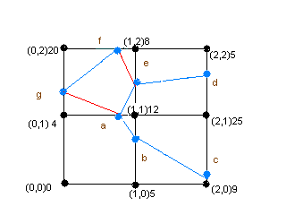

No | Point | Intersection between P1 & P2
1 | a-(0.75, 1) | (0,1) & (1,1)
2 | b-(1,0.714) | (1,1) & (1,0)
3 | c-(2,0.0625) | (2,0) & (2,1)
4 | d-(2,1.75) | (2,1) & (2,2)
5 | e-(1,1.75) | (1,2) & (1,1)
6 | f-(0.83,2) | (1,2) & (0,2)
7 | g-(0,1.38) | (0,2) & (0,1)

Sample Calculation for point 1 (a)
Intersection between (0,1) & (1,1) for c=10.
C(t)= c₁ +(c₂-c₁)t
10=4 + (12-4) t
t=0.75.

X(t)= x₁ +(x₂-x₁)t
X(0.75)= 0 +(0.75)t
Y(t)=1
Intersection point a = (0.75,1)

Similarly points for b, c, d, e, f, g can be obtained as tabulated in the table above.
2) Marching Cube:
Draw the triangle in a marching cube to indicate the surface for the given data (x,y,z,c)
for the case c = 10:

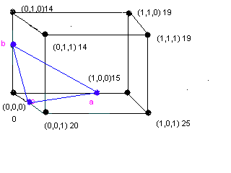

No | Point | Intersection between P1 & P2
1 | a-(0.66,0,0) | (0,0,0) & (1,0,0)
2 | b-(0,0.71,0) | (0,0,0) & (0,1,0)
3 | c-(0,0,0.5) | (0,0,0) & (0,0,1)

Sample Calculation for point 1 (a)
Intersection between (0,0,0) & (1,0,0) for c=10.

C(t)= c₁ +(c₂-c₁)t
10 = 0 + (15)t
t = 10/15

X(t)= x₁ +(x₂-x₁)t
X(t)= 0+(1-0)10/15
X(t)= 0.66
Y(t)= 0
Z(t)= 0
Intersection point a = (0.66,0,0)

Similarly points for b, c can be obtained as tabulated in the table above.
3) Marching Cube Application:
Find a practical application on the web that has used Marching cubes.

♠Application Domain

Advanced medical techniques frequently require geometric representations, rather than 2D photographic images, of human organs. These geometric models, either simulated or physical, can be used for analyses of physical problems, as well as visualization of organs for diagnosis, education, guided surgery, and other purposes.
To create a volume mesh of organs from the medical images, a set of medical images, such as cryosection images are used for segmenting. Surface boundary meshes are created from these segmented outlines for organs of interest. Finally solid volume meshes are created bounded by the surface meshes generated earlier. The flow chart for this procedure is shown in figure1.

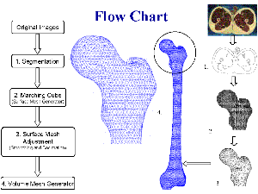
Figure 1. Flow Chart for Creation of Solid Volume Meshes Based on 2D Medical Images

Medical images contain a significant amount of information besides the region of interests (ROIs), or more explicitly, the boundaries delineating these regions. In order to create three dimensional surfaces and volume meshes of ROIs we need to segment the original images, i.e., to outline each region of interest such that the enclosed area of the image can be flooded with a unique intensity value.

The regions were manually segmented to represent boundaries of different materials. A unique pair of material IDs was assigned to each contour as in figure3.

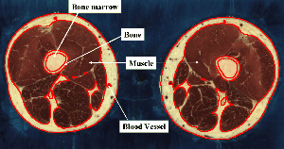
Figure 2. Manual Segmentation of Color Cryosections from the Visible Male

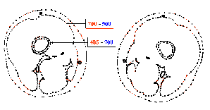
Figure 3.

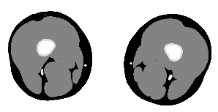
Figure 4. Segmented Image of the Original Cryosection Presented in figure2
A computationally efficient line-crossing algorithm was employed to classify each pixel within the image based on the segmented outline information only. Figure 4 shows a segmented image.

♠Iso-values used to extract the surface

Each Boundary Line Segment is Assigned Two Material IDs Corresponding to Its Two Adjacent Materials, Ex: Fat=900, Muscle=888, Femur Bone=485

♠Extracted Surface represents a left femur model created from VHP dataset.
Slices 1851-2343 were located in the left femur region.

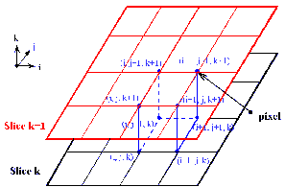
Figure 5. Illustration of Marching Cube Algorithm

♠Triangles in the Extracted Object:

Direct output of Marching cube program for Left Femur gave a node count of 3220 and surface triangle is 70.

♠Screen Visualization of the object:

Surface models were generated by utilizing a Marching Cube algorithm. A virtual cube, as in figure 5, was used to march through pairs of adjacent segmented images in a set. The material information of cube’s vertices was obtained directly from the two-segmented images. If a vertex has a different material ID from its neighboring vertices, a boundary surface should exist between it and the others in order to separate different materials. There are 256 different combinations of material IDs that a cube’s vertices could have.
These combinations can be reduced to 15 situations with the use of
Symmetry. The surface generation process was extremely fast due to the direct triangulation from the look-up-table properties of the marching cube routine.

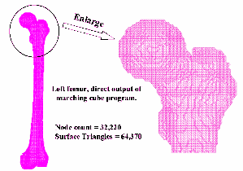
Figure 6. Surface Mesh of Femur Created from Segmented Images

♠Visible artifacts in the rendered image:

The surface model created by the Marching Cube algorithm has stair-step shaped surfaces, which do not represent the natural surface curvature. The model also contains too many nodes and triangle surfaces, which severely hinder the computational efficiency if used directly for volume mesh generation.

Solutions to the drawbacks:
Two main procedures to improve the quality and efficiency of the existing surface model --- smoothing and decimation.
Smoothing is a technique that adjusts the node coordinates to improve the appearance of a mesh, and/or improve the shape of surface triangles.
Decimation algorithm reduces the total number of surface triangles, while maintaining a good approximation to the original geometry.

A smoothed and decimated surface model of femur is shown.

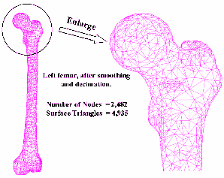
Figure 8. Smoothed and Decimated Femur Surface Mesh

Summary:
→Application Domain used is Images of Color Cryosection.
→Iso-values used to obtain the surface-: Fat=900, Muscle=888, Femur
Bone=485.
→Extracted surface represented is Left Femur bone.
→Number of triangles in the extracted object is 64370.
→Disc memory space to store the surface data is 20KB.
→Visible artifacts in the rendered object was that the surface model created
by the Marching Cube algorithm had stair-step shaped surfaces, which
did not represent the natural surface curvature. The model also contained
too many nodes and triangle surfaces.

http://www.nlm.nih.gov/research/visible/vhpconf2000/AUTHORS/SULLIVAN/IMAGINDX.HTM

