Case Study #2
Group T - Part II

November 27, 2001

Group Members:
James Morton
Minhchau Nguyen
Mariela Passarelli
Shaun Riley
Urhoy Tarzi
Nhi Tran
Hoa Vu

Molecular Structure and Protein Binding Data for Twenty Drugs

The molecular structures for the drugs were taken from ChemFinder (ref. 1). The protein binding data was taken from the Remington (ref. 2) and Clinical Pharmacology 2000 (ref. 3).

TABLE 1. Twenty Drugs with Protein Binding Data
Generic  Name | Protein Binding (%) | Molecular  Structure
1  Verapamil | 90 | 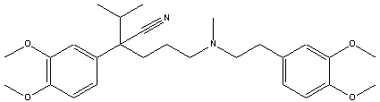
2  Amlodipine  Besylate | 97 | 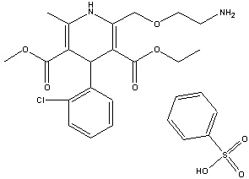
3  Indapamide | 75 | 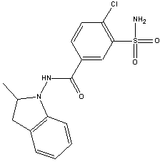
4  Metolazone | 95 | 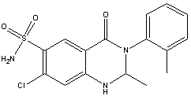

TABLE 1. Twenty Drugs with Protein Binding Data (Cont.)
Generic  Name | Protein Binding (%) | Molecular  Structure
5  Phenobarbital | 48 | 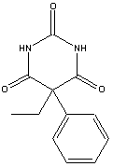
6  Carbamazepine | 67 | 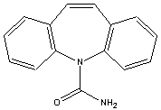
7  Felbamate | 24 | 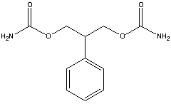
8  Salicylamide | 48 | 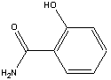
9  Methotrexate | 50 | 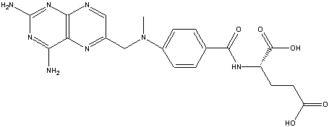

TABLE 1. Twenty Drugs with Protein Binding Data (Cont.)
Generic  Name | Protein Binding (%) | Molecular  Structure
10  Sulfisoxazole | 86 | 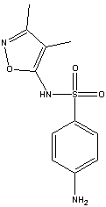
11  Nizatidine | 35 | 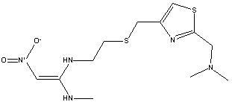
12  Tetracycline | 65 | 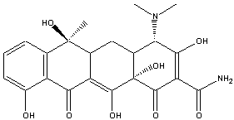
13  Oxaprozin | 99.9 | 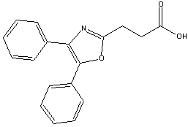

TABLE 1. Twenty Drugs with Protein Binding Data (Cont.)
Generic  Name | Protein Binding (%) | Molecular  Structure
14  Acyclovir | 21 | 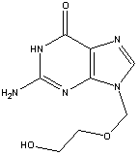
15  Diazepam | 99 | 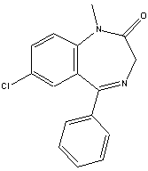
16  Minocycline | 75 | 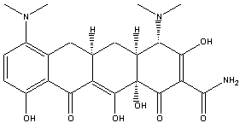
17  Nifedipine | 72 | 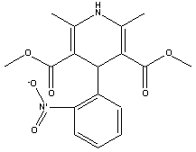

TABLE 1. Twenty Drugs with Protein Binding Data (Cont.)
Generic  Name | Protein Binding (%) | Molecular  Structure
18  Diltiazem | 75 | 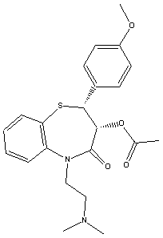
19  Propranolol  HCl | 93 | 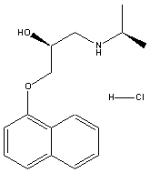
20  Nitrofurantoin | 40 | 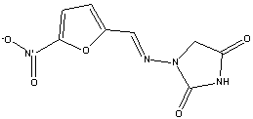

Correlations Between Three Molecular Properties and Protein Binding for Twenty Drugs

Association Between Log P and Protein Binding
The graph showing the relationship between log P and protein binding is located in Figure 1. The overall trend of the data shows that the higher the log P results the more protein binding is expected. Partition coefficients indicate, at equilibrium, the concentration of drug in hydrophobic medium (i.e., plasma membrane) divided by the concentration of drug in water. Therefore, a large log P means that the concentration of drug in the hydrophobic environment is much larger than that in water. Because partition coefficients are determined at equilibrium, a relatively large log P indicates that the drug is energetically more stable in hydrophobic environments than hydrophilic environments, such as water. Although albumin usually binds hydrophilically, the driving force of protein interaction is increasing entropy (at a given temperature, ↑ΔS will ↓ΔG, causing the system to become energetically more stable since ΔG = ΔH - TΔS). According to Martin, “Hydrophobic interaction is favored thermodynamically because of an increased disorder or entropy of the water molecules that accompanies the association of the nonpolar molecules, which squeeze out the water (ref. 4).” In the situation where nonpolar drug molecule are in the hydrophilic environment of blood, the drug molecules will “find” the most thermodynamically stable environment by binding to blood proteins (i.e., albumin). The association of drug molecules with albumin is thermodynamically favorable because of breaking the water cage around the drug molecules, which yields a less ordered arrangement and an overall entropy increase of the system (ref. 4). It is not the drug molecule’s “desire” to associate with albumin that drives protein binding; rather, it is the drug molecules “unhappiness” with being surrounded by water (or other hydrophilic molecules). Drugs with relatively low (i.e., negative) log P value are much more hydrophilic and better able to dissolve in water. Again, although albumin can bind hydrophilically, the more hydrophilic drugs will dissolve in water because relative to the albumin, the surrounding environment is more hydrophilic. These drug molecules will more readily dissolve in blood than they will bind the blood proteins, such as albumin, thereby yielding the observed lower protein binding in Figure 1.
Association Between Nitrogen + Oxygen Fraction and Protein Binding
The graph showing the relationship between nitrogen + oxygen fraction and protein binding is located in Figure 2. Goodman and Gillman (ref. 5) explains that albumin contains 9500 amino acids and has large hydrophobic pockets. Albumin also has the tendency to bind acidic drugs, while alpha-1 acid glycoproteins coordinate with the basic functional groups of drug molecules (ref.6).

Drugs with a low ratio of nitrogen + oxygen to carbon, like verapamil (protein binding (PB) = 90%), bind significantly to the hydrophobic pockets of albumin. This interaction is thermodynamically driven. Filling the hydrophobic pockets with molecules that contain large hydrophobic backbones is thermodynamically more favored than filling the pockets with the aqueous plasma. Drugs with a high N+O/carbon ratio, like acyclovir (protein binding 21%), are somewhat hydrophilic. Therefore, these molecules are solvated with the plasma and interactions with the plasma proteins are decreased.

Several drugs deviate significantly from the linear regression. Felbamate with a ratio of 0.545 would have a predicted PB = 62%. However, lacking a carbon backbone it must rely chiefly on its ester and amine functionality for plasma protein association. This leads to a protein binding significantly lower than would be anticipated. Nitrofurantion has a higher binding than would be anticipated for a molecule with a N+O fraction of 1.125. The cyclic arrangement of the nitrogen and oxygen atoms lessens the molecule’s solvation with plasma. This makes the molecule move available for binding with protein. Addtionally, the -NO₂ is available for interaction with the side chains of albumin. Finally, phenobarbital and salicylamide (PB = 48%) have 40% less protein binding than would be anticipated given their N+O ratio of approximately 0.43. The protein binding is lowered as a result of the carbons in these molecules being primarily aliphatic. Thus the drugs must rely on side chain interactions for binding.
Association Between Carbon Fraction and Protein Binding
The graph showing the relationship between Carbon fraction and protein binding is located in Figure 3. Carbon fraction is simply the portion of the molecular weight due carbon atoms divided by the total molecular weight of the molecule. The carbon fraction appears to serve as a surrogate of the quantity of hydrophobicity. Our graph between carbon fraction and protein binding shows a increase in protein binding when the carbon fraction increases with a calculated 0.3075 correlation coefficient. The best explanation for this phenomenon is the van der Waal forces between hydrophobic regions of the drug and the albumin protein, which is induced by a change in entropy caused by the disorder of water molecules in the environment. As the drug gets close to albumin all the water molecules are in an ordered position around albumin and the drug, but as they get closer hydrophobic interactions between the drug and albumin cause both to come in close contact. This is not driven by hydrophobic interactions, but instead, by the water molecules becoming more disordered. An increase in disorder means an increase in entropy, which in turn means a decrease in free energy of the system, which overall indicates a favorable reaction. Remember that the more negative the free energy, the more likely the reaction will occur. It is known that albumin is more likely to bind to hydrophilic molecules than hydrophobic ones, and therefore you would mistakenly conclude that our graph would have a decreasing slope. On the contrary, our graph has an increasing slope due to the fact that even though albumin prefers binding with hydrophilic molecules, it will bind hydrophobic ones when other surrounding molecules have a greater affinity to hydrophilic binding than albumin itself. This explains why slope in Figure 3 is positive as the carbon fraction of the drug increases.
Prediction of Protein Binding of Representatives of Five β-Lactam Antibiotic Classes

The linear regression curves generated from the graphs in Figures 1 – 3 are summarized in Table 2. Note that the correlation coefficients are reasonable high for these sorts of associations, ranging from 0.3075 to 0.4916.

TABLE 2. Linear Regression Data
Figure | Independent Variable (1) | Regression Equation | Linearity (r²)
1 | Log P | y = 10.181x + 55.841 | 0.4735
2 | N + O Fraction | y = -71.241x + 100.57 | 0.4916
3 | C Fraction | y = 1.4537x – 16.123 | 0.3075
(1) x = independent variable (horizontal axis); y = dependent variable (protein binding, vertical axis).

Protein binding was predicted for a single antibiotic in each of five different classes of β-lactam antibiotics by utilizing the regression equations in Table 2 above. The five β-lactam antibiotics along with associated information are found in Table 3, while the resulting predicted protein binding data (along with the literature values) are stated in Table 4.

TABLE 3. β-Lactam Antibiotics and Associated Information
Generic  Name | Antibiotic  Class | Molecular  Formula | Molecular  Weight | Log P | N+O  Fraction | C  Fraction
Penicillin G | Penicillin | C₁₆H₁₈N₂O₄S | 334.39 | 1.83 | 0.375 | 57.5
Amoxicillin | Aminopenicillin | C₁₆H₁₉N₃O₅S | 365.40 | 0.87 | 0.500 | 52.6
Cefaclor | Cephalosporin | C₁₅H₁₄ClN₃O₄S | 367.81 | 0.35 | 0.467 | 49.0
Aztreonam | Monobactam | C₁₃H₁₉N₅O₈S₂ | 437.44 | -6.19 | 1.000 | 35.7
Imipenem | Carbapenem | C₁₂H₁₇N₃O₄S | 299.34 | -1.17 | 0.583 | 48.1

TABLE 4. Protein Binding Data for β-Lactam Antibiotics
Name | Protein Binding (%)
Name | Literature (1) | Log P | N+O Fraction | C Fraction
Penicillin G | 50 – 65 | 74.5 | 73.9 | 67.5
Amoxicillin | 17 | 64.7 | 64.9 | 60.3
Cefaclor | 25 | 59.4 | 67.3 | 55.1
Aztreonam | 56 | -7.18 | 29.3 | 35.8
Imipenem | 20 | 43.9 | 59.0 | 52.8
(1) The literature protein binding data were found in references 2 and 3.

Amoxicillin
The protein binding data for two of the antibiotics identified in Tables 3 and 4 will now be discussed. One is the antibiotic that has already been chosen (Part #1 of this case study), amoxicillin, while the second one is penicillin G. From literature, it is known that the percentage of amoxicillin bound to serum proteins is relatively low (17%). However, the predicted protein binding results for amoxicillin estimated from Figures 1 – 3 (see Table 4) were much higher than the literature value (60 – 65%). One possible explanation of this dramatic deviation is the ionization state of amoxicillin in serum. The pH of serum is approximately 7.4. In Part #1 of this case study, the carboxylic acid was found to have a pK_{a} = 2.87; the amine was found to have a pK_{a} = 7.28. Therefore, at serum pH of 7.4, a large portion of the amine is deprotonated and uncharged, while the carboxylic acid will be almost completely deprotonated and negatively charged. The negative charge of the carboxylic acid will therefore dominate the minor positive charged of the amine making the overall charge negative. The result of having an overall negative charge is greater solubility in water. The hydrophilic nature of charged amoxicillin allows it to readily associate with water, increasing its solubility. Hydrophobic interaction, which is the most important “driving force” of protein binding, has a lesser effect on molecules that are hydrophilic.

A drug included in Figures 1 – 3, felbamate, has similar literature protein binding as amoxicillin and also dramatically deviates from the best-fit linear regression line. Felbamate has protein binding of 24%, which is similar to the amoxicillin’s literature value of 17% and makes it an extreme outlier in all three graphs. From the example of felbamate (and several other obvious outliers), it becomes clear that the three chosen properties (log P, N+O fraction and C fraction) only have margin utility in predicting protein binding. One important characteristic that does not get captured in Figures 1 – 3 is ionization, which is dependent on pH of the environment. Ionized groups would dramatically change the molecule’s hydrophobicity (decreasing it). This one reason could account for much of the scatter (i.e., non-linearity) observed and also for the poor prediction of amoxicillin protein binding.

Penicillin G
The experimental percentage protein binding data found for Penicillin G was 50-65%. Our calculated predictions for protein binding were close to the experimental, only being slightly higher. In the association between Log P and protein binding, we saw that the higher value for Log P-estimated value resulted in higher percent protein binding. Our calculated protein binding for Penicillin G was 74.5%. Although this predicted value is higher than the experimental, the difference is less than 10%. Our calculation for protein binding based upon the N+O fraction gave a similar result to that of Log P. Using the equation for the N+O fraction, the calculated percentage of protein binding was 73.9%. The association between the Carbon fraction and percentage protein binding gave us the best prediction for percentage protein binding for Penicillin, 67.5%. This result was the closest to the experimental data found for Penicillin G.

The lower experimental value for protein binding describes penicillin as a molecule that is more hydrophilic than was predicted by the models in Figures 1-3. As stated before, hydrophilic molecules do not bind as well to plasma proteins because of the “more” hydrophilic nature of the surrounding plasma.

As previously mentioned, estimated protein binding based on log P is higher than the experimental value. This is due to the fact that we used the log P value for the non-salt form of Penicillin G (logP=1.83), but obtained the experimental protein binding data from the salt form of penicillin (logP=-3.01). The salt form will be in the ionic state in the plasma and therefore, have a more hydrophilic character. As a result, the protein binding would be much less than that predicted in our models.

The estimated protein binding based on the ratio of nitrogen and oxygen to carbon was also higher than expected. This was due to the data used to develop the linear regression model. The data was highly skewed. Our data points clustered around a lower ratio of nitrogen and oxygen to carbon. Based on our data, penicillin has a low ratio of 0.375 and might yield a false high estimate.

The estimated protein binding based on percent carbon weight to total molecular weight is a good predictor and yields an estimated percent similar to the experimental value. This is due to the fact the heteroatoms in penicillin G do not play a major role in making the molecule more hydrophilic. Although, the heteroatoms make up 62.5% of the molecule, the structure of penicillin reduces the hydrogen bonding power of the free electrons on the nitrogen atoms. The free electron pairs are delocalized into the cyclic amide structure and the carbonyl group of the other amide bond.
The fact that our estimated values are higher than the experimental value is also due largely to the fact that there are many other factors that determine protein binding. Taking our predictors separately to predict protein binding is not thorough and therefore not extremely accurate. Also, the linear regression models that we used for log P, nitrogen and oxygen fraction, and carbon fraction have low R² values. The R² values for our predictors were 0.4735, 0.4916, and 0.3075 respectively, which means that there is not a strong linear relationship. Therefore, the lower the R² values, the more scattered our data exhibit and the results would be less reliable. This is why we mentioned that our results were actually not good predictors.

Summary Comments
The protein binding for all five drugs will depend upon several factors. As previously discussed, a hydrophobic drug will be the thermodynamically driven from the aqueous plasma to bind with plasma proteins. A hydrophilic drug is less likely to interact with the plasma proteins. A hydrophilic drug is solvated and stabilized in the aqueous plasma. Additionally, these drugs will have varying affinity for the polar/charged side chains of the plasma proteins. The charge of a molecule will influence protein binding. A charge may induce protein binding or it may keep the drug in the aqueous plasma. Finally, the spatial arrangement of the molecule will be a major determinant of drug-protein molecular interactions.

References

- ChemFinder (www.chemfinder.com).

- Remingtion: The Science and Practice of Pharmacy, 19th edition. Mack Publishing Company: Easton, PA (1995).

- Clinical Pharmacology 2000, on-line version (www.cp.gsm.com).

- Martin, A. Chapter 11: Complexation and Protein Binding, p. 266. Physical Pharmacy: Physical Chemical Principles in the pharmaceutical Sciences, 4th edition. Lea & Febiger: Philadelphia (1993).

- Goodman & Gilman's The Pharmacological Basis of Therapeutics, 9th Edition (1996).

- Benet, L.Z., Kroetz, D.L. and Sheiner, L.B. Pharmacokinetics - The dynamics of drug absorption, distribution, and elimination (Chapter 1).

