How to Play VCD
In DVD Player
A Note on VCD’s
* If you get any type of error when inserting the disk in the DVD player, then it is incompatible with VCD’s. On average 80% of DVD Players are compatible*
Use your DVD remote’s track changing buttons {|<<or>>|} to change tracks.

In PC
- ) Load Windows Media Player (Any Version will work)
- ) Go to File -> Open
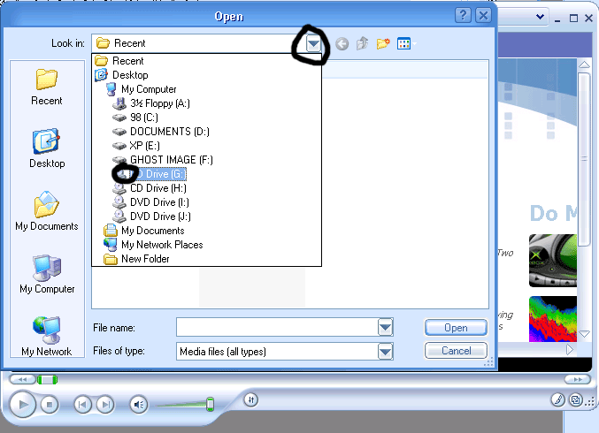

- Select your CD Rom Drive
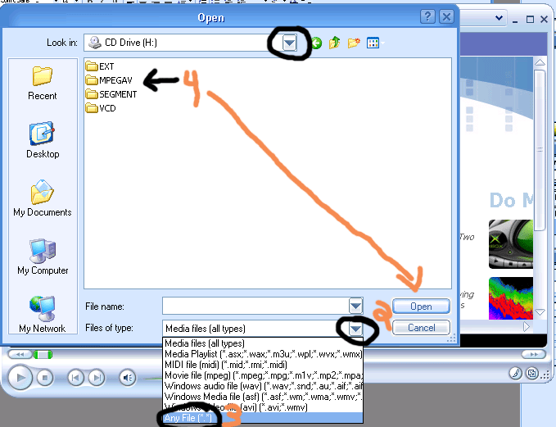
- After Opening the folder, select the movie you want to watch
(Note: My screen looks different from yours but it will work. If the icons don’t look the same, or the .dat is not there, it will still work)
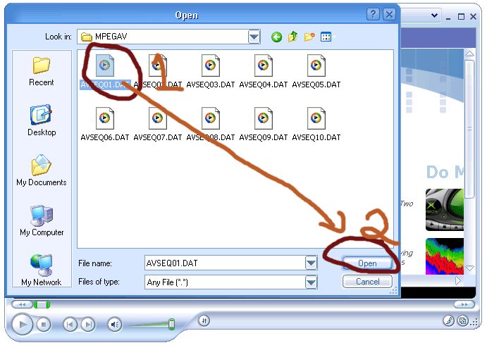

What the files mean
AVSEQ01.DAT Audioslave – Like a Stone (Video)
AVSEQ02.DAT Audioslave – Cochise (Video)
AVSEQ03.DAT Audioslave – Cochise (Live on Letterman)
AVSEQ04.DAT Audioslave – Gasoline (Live)
AVSEQ05.DAT Audioslave – Like a Stone (Live)
AVSEQ06.DAT Audioslave – Set it off (Live)
AVSEQ07.DAT Soundgarden – Black Hole Sun
AVSEQ08.DAT Soundgarden – Blow Up The outside world
AVSEQ09.DAT Soundgarden – Rusty Cage
AVSEQ10.DAT Soundgarden – The Day I Tried To Live
- Watching the VCD
It might take a few seconds, but be patient. It will load and you should see this: 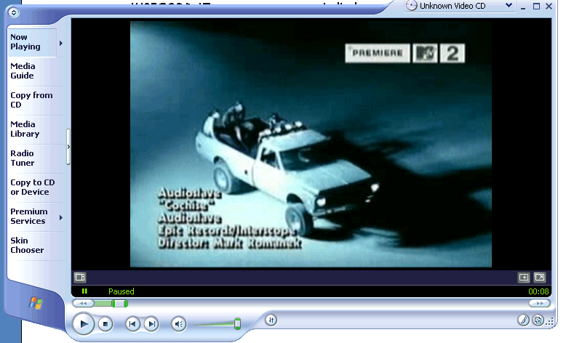
You need to do this every time in order to play the disk. If you have any questions send me an email at ushker@softhome.net with the subject “VCD Help”

Created 05-10-03

