Graphing Calculator Software Instructions

First Things First:

What you Need:
Windows 95-XP
Link Cable (USB or Serial)
Supported Calculator
MEMORY

A note on Memory:
In today’s world computers have gigabytes of memory, but for calculators they have kilobytes. An average computer has a 20 Gigabyte hard drive has 2,097,152Kb and my TI – 83 only has 24Kb. What this means is that you can only hold so much on your calculator at once. You also need to keep enough memory for the calculator to run. I was once taking a math test and when I wanted to use a scientific number I received an out of memory error.

Installing Games / Apps

Step 1: Installing The Link Software

Go to My Computer and Find the CD-Rom Drive that the disk is in. The Drive should say Linksw. Click on this and you see that everything is neatly organized. Then click on the TI Connect Software folder. Then run the installation application inside the folder. After that is complete, you must restart your PC.

Step 2: Getting Games

Go back to my computer and open the CD up. The following operations require a program like WinZip or WinRAR. If you have windows XP, there should be no problem. For my examples, I will use WinZip, which can be gathered free at www.winzip.com.
- Go to my computer and open up the CD that says LINKSW or if you have Auto play this will occur automatically.
- Select the folder corresponding to your calculator
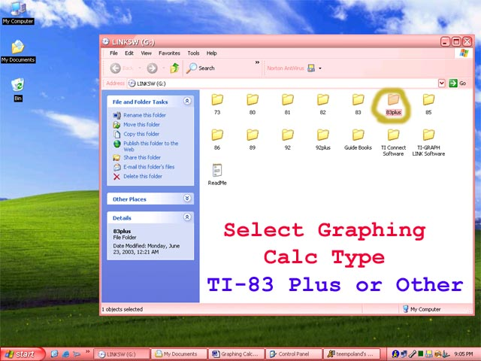

Then open the folder (I have selected the 83plus folder)
- then you select what type of application you want (asm, basic, flash)
- Then select a category. (For this I will go to 83plus -> asm -> games)
- When you open up a category, there will usually be a .Zip file called allfiles.
- Open that up and you get a list of every file in that directory.
- Select which file you want. ( for this I will select Tetris )
- Then you “drag and drop” the file on to the desktop
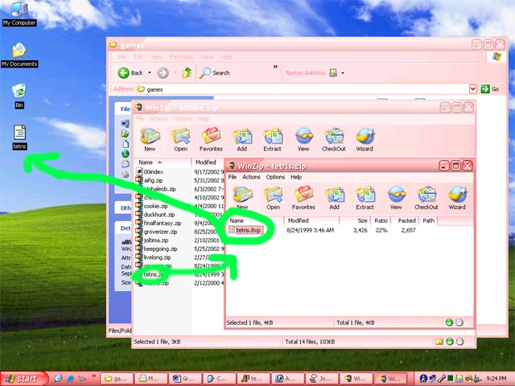

Step 3: Installing Games
- Load the TI Connect application on the desktop
- then select TI Device Explorer
- Make sure your calculator is plugged in and is on
- Your screen should look like mine with many branches.
- To install the program, “ drag & drop” the application to the window

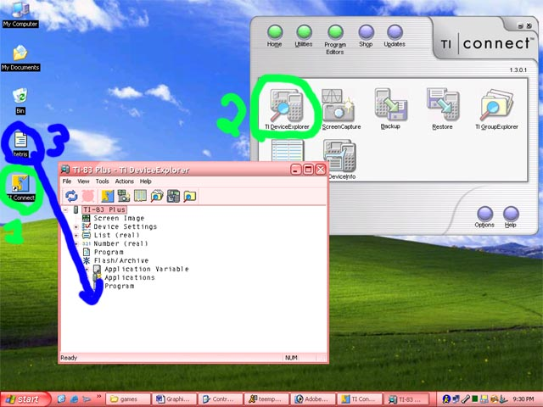

When the file transfer is complete, go to your calculator and select the PRGM button to play the game. If you get an error, then you need an operating system like MirageOS. MirageOS is like Windows XP and the TI’s OS is like DOS.

If you have any questions, please email me at ushker@softhome.net

