It Is Time To Celebrate Our Biggest Cultural Event

THE GUJARATI SAMAJ

PRESENTS

NAVRATRI RAAS GARBA

MUSIC BY NEWLY FORMED

COMPRISING OF BEST TALENTS IN TOWN

GARBA MUSIC GROUP
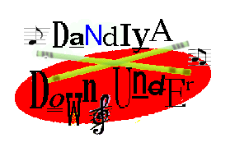

12TH OCT SATURDAY TIME: 7.00PM – 11PM
(ARTI AT 10.00PM)
20TH OCT SUNDAY TIME: 4.00PM-8.00PM (ARTI AT 7.00PM)

ANNE CLARK NETBALL CENTRE
CHURCH STREET, LIDCOME

ADMISSION: $3.00 PER PERSON FOR MEMBERS
$5.00 FOR NON-MEMBERS
(KIDS UNDER 5 YRS ARE FREE)

- MEMBERS, Please Bring Your Membership Card To Avoid Delay At The Door
- Yummy Food/Drinks Available At The Hall
- New Or Renewal Of Membership At The Door

Main Sponsor - DESSPACE TRAVEL

AN IDEAL OPPORTUNITY FOR BUSINESSES TO ADVERTISE THEIR PRODUCTS & SERVICES BY DISPLAYING THEIR BANNERS

CONTACT

PARESH PANDYA - 04 0823 4742

FOR ADVERTISING DETAILS

