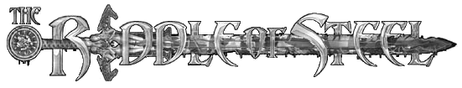
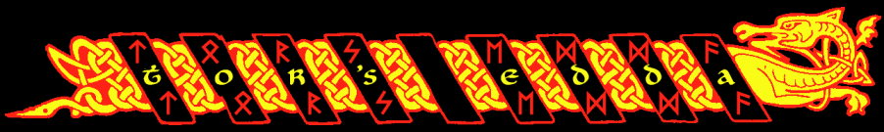
Armour

ArmourAVCP -Covers____________________________________________________________________________________________________________________________________________________________________________________
I
I
II
II
III
IV
IV
V
VI
XIII
XII
XI
X
IX
VIII
VII
Arms Swing
XIV
Arms Thrust
Pools
___________________

___________________

___________________

___________________

WoundsLocationTypeBLPainLocationTypeBLPain

PenaltiesPain
Blood Loss
Fatigue

Attributes
ST |  | EN |  | WP |  | SO
AG |  | HT |  | WT |  | PR
TO |  |  |  | MA

Proficiencies

Melee Weapons
Weapon | Length | DTN | CTN | C DM | ThTN | Th DM | Notes

Missile Weapons
Weapon | Prep | ATN | ST | DM | PB | Shrt | Med | Long | Ext

Derived Attributes
RX |  | K/o
Aim |  | MV
K/dn

Character Information
Insight

Spiritual Attributes

Attributes
Strength |  | Will Power
Agility |  | Wits
Toughness |  | Mental Aptitude
Endurance |  | Social
Health |  | Perception

Skills
□□□
□□□
□□□
□□□
□□□
□□□
□□□
□□□
□□□
□□□
□□□
□□□
□□□
□□□
□□□
□□□
□□□
□□□
□□□
□□□
□□□
□□□
□□□
□□□
□□□

Derived Attributes
Reflex
Aim
Knockdown
Knockout
Move

Gifts

Flaws

Gear. Equipment. Loot!!

