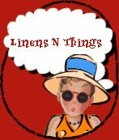 Vintage ~ Nouvelle

where the old becomes new again…

Linens n Things

Home

About Us

Artisan Products

Jewelry

Sterling Reproductions

Dress Up

Pillows Plush

Linens N Things

For Baby

For Him

Wedding Bells

Skincare

Pampered Pets

Garden Party

Tea Time

Travel’s with V

V’s Products

Or own V line

V’s Recipes

V’s Fun Page for kids

Contact Us

Policy & Info

Your Order

Wanted

Copyright All rights reserved. 1992-2002
vintagenouvelle@aol.com
Vintage Nouvelle
PO BOX 29902
Thornton, CO 80229

