What is a macro?
Put simply, macros automate common tasks. For example, let's say when you print out a particular document, you always have to print 5 copies. You always need to go to the File/Print menu, select 5 copies, and choose OK to print. Wouldn't it be nice if you could just press a keyboard shortcut or choose a button on the toolbar and have Word automatically print 5 copies? That's what macros do. Macros allow you to assign a keyboard shortcut or create a button on the toolbar for tasks you commonly perform and can save you oodles of time. Macros are written in Visual Basic for Applications (VBA), but are easily created in Word with no knowledge of VBA. The code is written for you!
A macro can be created for virtually any task that you perform in Word. The amount of steps is irrelevant. You can even create a macro that automatically places certain text in a document with as many attributes as you'd like! This is great if you need to place things like legal statements or disclaimers in a document.
Macros are created with a recording device similar to a common tape recorder. Once you start recording your macro, a toolbar pops up with standard stop and pause buttons. Let's use our example of creating a macro that automatically prints 5 copies of a document, and make one!
Creating a Macro
- Open a blank document or open the document in which you would like to add a macro. You can assign the macro to either be available to all documents, or just the document you currently have open.
- From the Tools menu, choose Macro and Record New Macro. The Record Macro dialog box is displayed as shown below.
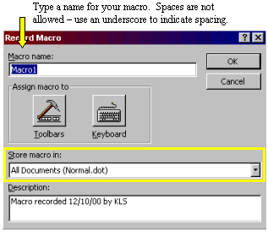
- Type a name for your macro as indicated above, and choose where to store your macro. The drop down arrow will allow you to choose a document that you have open to store your macro in, or you can make it available to all documents by storing it in the Normal template.
- Add a Description if you would like - this is helpful if you are creating a lot of macros and need to keep everything organized. I usually just make the macro name something I can recognize, and leave the description as the default text.

