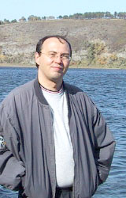
GENERAL
Name: Serge V. Moschnegootz
Date of birth: 14/03-1966
Citizenship: Russian Federation
e-mail: ceti@mail.ru
Web: http://www.geocities.com/voutz/

EDUCATION
Secondary school finished in 1983 with the Gold Medal.
1983 - 1989: studying in the Kemerovo State Medical Institute, graduated with the Red Diploma.
Scientific degree in medicine received in 2001.

POSITIONS
2009-present: radiologist at the department of radiology
of Kemerovo Regional Hospital (Siemens SOMATOM Definition AS+ spiral CT scanner).
1995 - 2009: radiologist at the department of radiology
of Kemerovo Cardiological Centre (Siemens MAGNETOM Open and Concerto 0.2T MRI scanners).
1992 - 1995: angioradiologist at the department of
radiology of Kemerovo Cardiological Centre.
1989 - 1991: general surgeon.

PROFESSIONAL INTERESTS
Three-dimensional visualization and digital image processing.

PUBLICATIONS
See list of publications page (in Russian).

