2002-2003 Calendar
_______________ FALL _______________
October
Haunt House
November
Food Sales
Thanksgiving Homeless Dinner
December
Union Gospel Mission Volunteer
X-mas Gift X-change
______________ WINTER _____________
January
Tet Festival [Lunar New Year]
February
Valentine Hearts Sales
Candies Sales
March
Food Sales
High School Visitations
_____________ SPRING ______________
April
Spring Picnic
Car Wash
Food Sales
May
Miss International [in propose]
VSA-SCC Dance
June
Car Wash
Members’ Retreat
For a more updated calendar, please visit VSA online at http://www.geocities.com/vsascc. If you have suggestions or comments, please forward them to our activity coordinator, Thao Ngo ( lienthao@hotmail.com ).

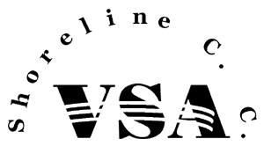

Vietnamese Students Association
16101 Greenwood Avenue North
Shoreline, Washington 98133
2002 - 2003

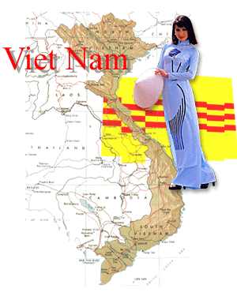

http://www.geocities.com/vsascc

Where is it?
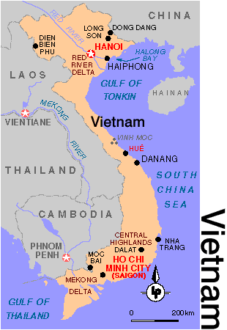
http://www.lonelyplanet.com/mapshells/south_east_asia/vietnam/vietnam.htm

Vietnam
Viet is an ethnic term, of unknown linguistic origin, that dates from well before the Christian era. In its Chinese form it could mean either "beyond," i.e., the peoples beyond the boundary (outsiders), or "hatchet," perhaps referring to a farm implement common to the region. Nam is a Chinese word meaning "south." The early Chinese histories refer to a kingdom called Nam Viet, the southernmost of Viets; there were also eastern Viets and several other Viets. But in general, “nguoi viet” would be a good term for these people.
http://www.askasia.org/frclasrm/readings/r000189.htm#h
Working together to make a difference...

Learning in diversities

http://www.geocities.com/SoHo/Den/5908/

Vietnamese students association
The Vietnamese Students Association, a.k.a. VSA, provides a support group for Vietnamese students making the transition to academic life at Shoreline Community College and a means for all students to learn about Vietnamese culture. In 2001-02, the VSA promoted a year long calendar which included social activities such as bowling, home visitation, dining out and campus activities like dance, food, and candies sales. VSA members are also involved with community projects such as the Union Gospel Mission during the holidays. As part of the Vietnamese Student Association of Washington, member schools meet once a month to exchange ideas and to build network with affiliated universities and colleges. This year, they are working with VSAWA to promote the Nam Thanh Lich, a male pageant, on January 11, 2003. At the end of the year, VSA members look forward to the Members Retreat which can be in state or out of state.

2002-2003 Officers

President Huu Au
gokhuu@msn.com
Vice President Nga Nguyen
tnga06235@yahoo.com
Secretary/Treasury Thanh Pham
therese_2001@yahoo.com
Activity Coordinator Thao Ngo
lienthao@hotmail.com
Internal Coordinator Ha Nguyen
thnn05@hotmail.com
External Coordinator Be Truong
wutizluv@hotmail.com
Publicity Nguyen Vu
win_vu@hotmail.com
Co-Advisor Lan Luu
vickilanluu@yahoo.com
Advisor Jen Cauffman
jcauffma@ctc.edu
(206) 546-5821

The Vietnamese Student Association meets every other week. These General Meetings are held on campus to allow members to meet the officers and to be update with current activities. Meeting time and location are generally email to members, but occasionally, posters are also posted by the PUB entrance. If you are interested in attending one of our meetings or thinking about becoming a member, please contact one of the officers.
The VSA Officers welcome you!

(206) 546-4654

