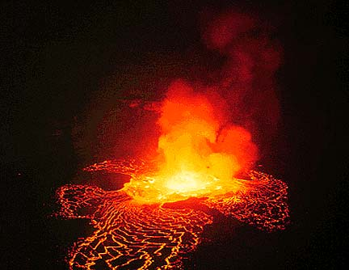
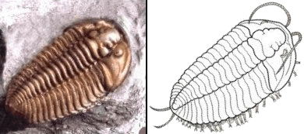

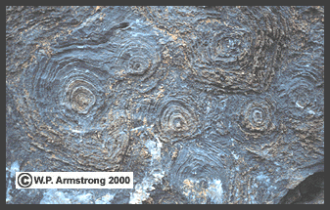
One billion-year-old stromatolites embedded in limestone along Going-To-The-Sun Road in Glacier National Park, Montana, USA. The concentric rings represent calcareous layers of limestone where ancient colonies of cyanobacteria once thrived in shallow seas.



