 |   No product really has to be a commodity. The trick is to know what services your customers want—and to charge more.
John E. Forsyth, Alok Gupta, Sudeep Haldar, and Michael V. Marn
The McKinsey Quarterly, 2000 Number 4
Companies that sell soap, perfume, candy bars, and other consumer products are expert at "decommoditizing" them: finding and capturing the value of intangible benefits and building strong brand names that can provide a kind of differentiation in the minds of consumers. But companies that sell products such as bulk chemicals, paper, and steel to businesses tend to be unsophisticated in these matters. Burdened by corporate cultures that emphasize operations and sales over marketing, many of these companies constantly strive to churn out more and more product more and more cheaply and then to sell as much of it as possible at the market price. Viewing themselves as commodity producers, they are particularly likely to overlook the nonfunctional features of their products—delivery speeds, after-sales service, and so on.
As a result of this mentality, such companies leave large amounts of money on the table. They would be far better off if they took a page from the playbooks of marketing-oriented businesses and embraced the—to them, unlikely—notion that buyers care not only about the price of a product but also about the way it is sold to them, the services that accompany it, and the nature of their relationship with the seller. If these manufacturers were to take that approach, they would find themselves thinking about their customer base not as they have traditionally segmented it—large and small, based in France or Germany, and so forth—but as composed of businesses that want (and are willing to pay for) quite different things. This would in turn help manufacturers focus on the segments whose business they can win and retain most profitably: the segments seeking product or service attributes that correspond to their strengths.
The managers of one industrial-resin manufacturer, for example, believed that its product was simply a commodity. Their customers, they thought, could just as easily use one supplier's resin as another's, so the manufacturer could compete only on price, which gave it limited leeway, commodity margins being low. But a systematic analysis of the preferences of the manufacturer's customers showed that for one of the biggest of them, 70 percent of the purchasing decision was based not on price but on quality and service (Exhibit 1). When the manufacturer undertook a full "needs analysis" of its main customers by using a process called conjoint analysis along with detailed, qualitative, one-on-one interviews, it discovered three distinct segments. As Exhibit 2 indicates, about one-fifth of its customer base cared most about technical support and the ability to get hold of a sales representative quickly. A third focused on the supplier's product range and product development strengths. The remaining group—less than half—cared most about price and on-time delivery.
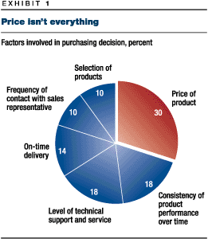
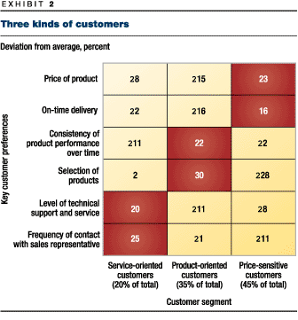
At this point, the resin manufacturer began to change the way it served the different segments. In addition to identifying the needs of each, it focused on other identifiers, such as the kinds of customers its customers served and how its customers' businesses operated. As a result, the company was able to slot prospective customers into a needs-based segmentation scheme without having to interview them all. The company managed to increase its sales by 15 percent in a single year by determining which important attributes it was best at providing and focusing on the buyers that valued them most.

Conjoint analysis and needs-based segmentation
So many companies segment their customers by size and other such criteria because this approach is easy to carry out, and the companies falling into these gross categories do tend to have similar needs. But to have a truly actionable segmentation scheme, you must divide your customers into much more precise groupings based specifically on their needs.
In the business-to-consumer (B2C) market, this kind of segmentation is often quite hard to undertake because the obvious differences among customers—age, income, geography, and so on—usually don't correspond to their preferences for, say, shampoos, books, or even clothing. To solve this problem, consumer goods companies have developed elaborate statistical mechanisms, such as dual-objective segmentation.¹ But because these complicated algorithms are not typically used by business-to-business (B2B) suppliers, those companies divide their world by weak identifiers such as size and geography.
The good news is that B2B companies don't necessarily need to use elaborate and sophisticated methods; only a large consumer goods customer base—often comprising millions of individuals—demands them. In many B2B markets, 25, 15, or even just 10 customers account for 80 percent of sales. By taking them through a conjoint analysis and interviewing their managers in person, B2B companies can gather most of the information needed to determine exactly which customers really care only about price and which features other customers would be willing to pay more to get.
Conjoint analysis asks a decision maker to specify which of two characteristics is more valuable and then uses the answer to assess how important all of the characteristics might be if all of them were present to a greater or lesser extent. These trade-offs elicit a customer's specific needs. The views of customers on the capabilities of each seller in their market help quantify how well each competitor fulfills those needs.
A bulk-chemical manufacturer, in one instance, interviewed the purchasing and plant managers of its current and potential customers. The managers were asked to make "forced choices" among many different scenarios—the hallmark of conjoint analysis. One scenario involved a supplier with 90 percent product consistency, little willingness to tailor the composition of its chemicals to the needs of its customers, and a nearly perfect record of on-time delivery. Another supplier achieved 100 percent product consistency and was much more willing to customize, but only 95 percent of its deliveries arrived on time.
Actual and prospective customers were asked which alternative they preferred. In a subsequent round of questions, the price was varied against the other decision variables, which themselves were varied, allowing the chemicals manufacturer to determine how sensitive in relative terms its customers were to price. Finally, in wide-ranging interviews, customers were invited to discuss which suppliers they perceived to be best and worst at meeting various needs.
The result of the conjoint analysis was a series of weightings of each product or service attribute according to its importance in a particular customer's decision-making process. The customers were then segmented on the basis of these weightings. This procedure yielded a reliable, brand-new segmentation scheme that the company could use to organize its business.
Getting close to your customers
In many B2B markets, as much as two-thirds of a customer's buying decision might be based on nonprice factors. The interviews conducted by one B2B electricity retailer, for example, helped it identify a segment of "predictability seekers," who cared more about a contract's duration (and, thus, insurance against price swings) than about absolute price levels. Another segment comprised "high-inertia buyers," who were more interested in doing business with a supplier that had a proven track record than in paying a low price. In fact, we have found very few situations in which price was the primary concern for a majority of a company's customers.
Actually sitting down with your customers yields more information than general insights about what kind of customer prefers service to price and what kind cares about long-term relationships. Often, the conjoint-analysis process—coupled with detailed interviews that elicit information such as customers' perceptions of different suppliers—identifies some valuable attributes that the supplier, and perhaps even the customers, hadn't focused on previously.
One printing company, for example, generally won new orders by offering price discounts. The interviews it conducted uncovered an important segment that cared much more about how long it took to turn orders around. Since the printing company had never realized that improving its existing 15-day cycle time would allow it to raise prices, it had never made the fairly modest technological investment needed to do so.
Conjoint analysis also makes it possible for a company to develop a "vulnerability assessment" of any of its customers in the face of offers from its competitors. Exhibit 3 applies the different weighted preferences that one customer gave the resin company's interviewer to yield a "value-against-a-competitor" reading. The analysis shows that by providing a number of options that the customer didn't much care about but that drove up the price, the resin company placed itself at a competitive disadvantage. The framework outlined in Exhibit 4 makes it possible to take the data on each customer's vulnerability to offers from competitors and to map these data against that customer's profitability. This approach allowed the resin company to organize its customers into four groups, ranging from profitable and loyal to unprofitable and at risk, with obvious implications for how to proceed.
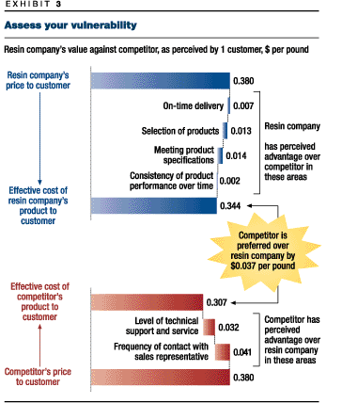
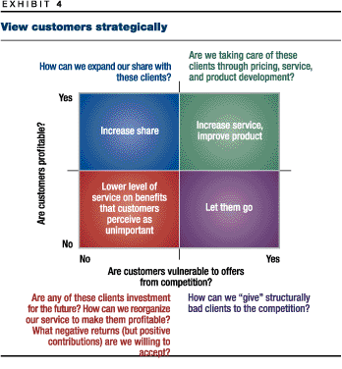
Notes:
¹ See John Forsyth, Sunil Gupta, Sudeep Haldar, Anil Kaul, and Keith Kettle, "A segmentation you can act on," The McKinsey Quarterly, 1999 Number 3, pp. 6–15.
Paying such close attention to your customers yields something else. Once you have channeled your current customers into value-based segments, you will be able to step back and observe their characteristics. Do the members of each segment have common organizational structures, business processes, purchasing patterns, or types of customers? To the extent that they do, you will be able to make educated guesses about the needs of potential customers if you have at least some information about them.
The ability to make such guesses may be especially useful if you have many midsize customers rather than 15 or 20 big ones, since conducting conjoint analyses of many companies and interviewing 100 or 150 people may be impractical. Not surprisingly, companies find little overlap between the traits they have traditionally used to segment their markets and the observable traits that actually help them categorize unanalyzed customers and prospects.
Turning knowledge into strategy
In general, taking the analysis this far and applying its results to the way you deal with customers adds a few percentage points to the bottom line—perhaps doubling your profits, given the typical margins on so-called commodities. Yet at this point, you won’t even have begun to make strategic choices based on the new market segmentation. Once you have done a good job of assigning customers and prospects to segments, you are bound to find that your company isn’t well suited to serving them all.
One obvious response is to focus on segments that place a high value on the service you are uniquely good at providing and, specifically, on the businesses within those segments that currently buy from other suppliers. You could then charge a premium that corresponds to the probable intensity of their preferences. (You could of course try to undersell the competition, but the whole point of our approach is to avoid that trap.)
Alternatively, you may wish to improve your product’s service attributes as a way of appealing to a few large segments whose needs you don’t adequately serve at present. When Dow Chemical, for instance, standardized its computer workstations all over the world, its engineers became available to customers 24 hours a day, with all of the necessary customer and product information immediately at hand. Together with the transformation of the company’s transaction-oriented sales force into a more technically skilled and consultative one, the redesign of the engineering force turned Dow into a power in one high-value segment that it had identified.²
Looking beyond frontline beliefs
You might think that a company’s sales force would be ideally equipped to detect customers’ hidden needs. In fact, it is often the sales force that is most taken by surprise by a new, needs-based segmentation scheme and most skeptical that customers might view the product as something more than a commodity.
We once asked the salespeople at a manufacturer of refractory bricks (the heat-resistant chunks of ceramic that line the ladles used to pour molten metal in steel mills) to fill out a forced-choice questionnaire. When we ran it through a conjoint analysis, we found that the salespeople regarded price as the most important dimension by far in determining their customers’ choice of products. But when the steelmakers—the customers for refractory bricks—answered the same questionnaire, all sorts of other things they wanted help with emerged: Could the vendor advise them on how to reduce throughput? Were longer-lasting bricks obtainable? Could bricks be delivered in different lot sizes? And so on.

For all practical purposes, the B2B market has no commodities. Sometimes customers attach importance to functional distinctions that suppliers don’t even know about. More important, customers always value servicelike features, such as consulting services, maintenance, and "conditions of sale" (for instance, the duration of contracts and time to delivery).
To realize the value in these noncommodity pieces of the business requires the kind of customer-focused marketing strategy that most B2B companies have never had to adopt. In particular, to use the process we recommend, you must base a well-informed segmentation scheme for current and potential customers on the particular noncommodity product or service features they value most highly. Developing such a segmentation scheme requires empirical research, because suppliers—and sometimes even buyers—don’t necessarily know beforehand what those features will be or how much they will be valued.
Sound like hard work? It certainly can be. But the alternative is simply to sell an industrial commodity. Where is the money in that?
Notes:
John Forsyth is a principal in McKinsey’s Stamford office; Alok Gupta is a consultant in the New York office; Sudeep Haldar is a consultant in the Chicago office; Mike Marn is a principal in the Cleveland office.
² See Bruce Caldwell and Mary E. Thyfault, "IT makes commodities hot," Information Week, September 7, 1998. For a discussion of the differences between transactional and consultative selling, see John R. DeVincentis and Neil Rackham, "Breadth of a salesman," The McKinsey Quarterly, 1998 Number 4, pp. 32–43

