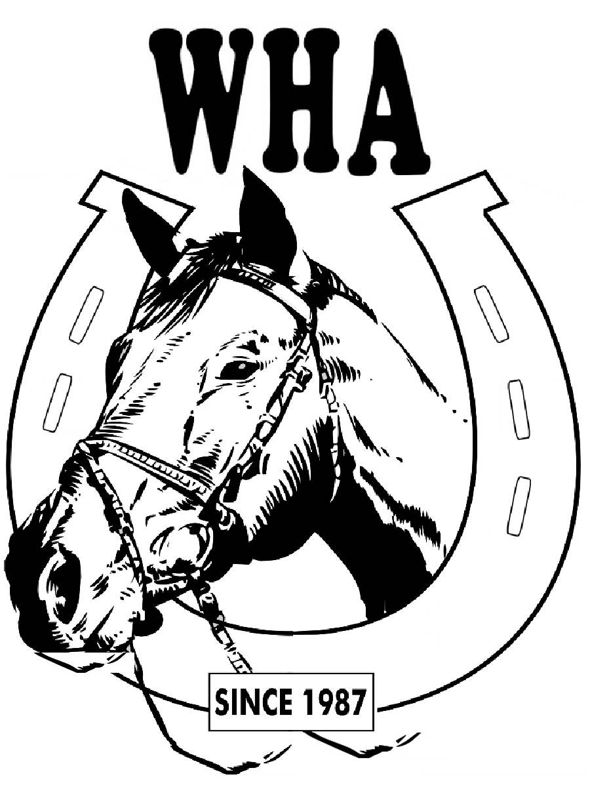
SCHOOLING SHOW SCHEDULE OCT. 11, 2009
LAKEVIEW STABLES (480-4963)
7585 78th Avenue North, Pinellas Park, FL 33781
Show Manager: Joanne Butler 560-3739

All Classes: $6.00 ea. (Members $5.00) - All Day: $35.00 (Members $30.00)
Gates Open: 8:00AM - Registration: 8:15 - Show Begins: 9:00
Judge: Karen Iverson
All exhibitors must show proof of (current) negative Coggins for their horse & sign Release Waiver at the registration desk. Exhibitors must wear boots. All exhibitors ages 18 & under must wear HELMETS in Halter & costume classes, show ring & show grounds (loaners available), No Smoking or Alcoholic beverages on show grounds. Management reserves the right to have unruly horses, exhibitors, handlers or spectators removed from the show grounds, with NO REFUNDS given. Classes may be combined or split.

Youth: 10 & under, Junior: 11-15, Senior: 16 & over

IMPORTANT - Riders may only walk their horses, unless in the warm-up ring or the show ring. No trotting, jogging, cantering, loping or galloping outside of the rings. You will be required to leave the show (without a refund) if this rule is broken WHA Show Staff and Lakeview Stable Mgmt., have the authority of enforcement.
CLASSES: SPONSORS:
1. Grooming & Conditioning Largo Feed 581-8743
2. Fillies & Mares Equifilms - For All Your Video Needs 391-1994
3. Colts & Geldings
4. Color Class Park Feed 546-7503
Grand & Reserve Halter Champion (No Fee) 1st & 2nd from classes 1, 2, 3 & 4

5. Showmanship at Halter ALL AGES
6. Trail Class (TIME WILL BE POSTED FOR THIS CLASS)
7. Youth Walk/Trot English Pleasure (1&3)
8. Youth Walk/Trot English Equitation (1&3) Art Attack (Doug Rohloff) 518-7848
9. Jr. & Sr. Walk/Trot English Pleasure (1&3)
10. Jr. & Sr. Walk/Trot English Equitation (1&3)
11. Open Schooling English Pleasure (2)
12. Youth English Pleasure *
13. Youth English Equitation * Devine Designs Jewelry 934-6387
14. Junior English Pleasure *
15. Junior English Equitation * Horsemaniac.com
16. Senior English Pleasure*
17. Senior English Equitation * Horse & Paw Pet Sitting (Tracy Hobbs) 804-1694
18. Open English Pleasure
19. Open English Equitation Len’s A/C & Refrigeration & Repair 588-9200
20. NOVICE English Pleasure (3)
21. NOVICE English Equitation (3) Riding Lessons@www.pinellashorse.com
22. Open Saddle Seat Pleasure Amber Glen Equestrian/Amber Glen Feed Depot 547-8495
23. Open Hunter Hack over 18” Fences (2)(WALK/TROT ONLY)(1&4) Practice in warm-up ring only
23-A. Youth Hunter Hack over 18" Fences (2) Practice jumps in warm-up ring only
23-B. Junior Hunter Hack over 18" Fences (2) Practice jumps in warm-up ring only
23-C. Senior Hunter Hack over over 18" Fences (2) Practice jumps warm-up ring only
24-A. Youth Open Schooling Hunter Over 2’ Fences (4) Practice jumps in warm-up ring only
24-B. Junior Open Schooling Hunter Over 2’Fences (4) Practice jumps in warm-up ring only
24-C. Senior Open Schooling Hunter Over 2’Fences (4 ) Practice jumps in warm-up ring only

Break – 30 Minutes (TIME PERMITTING) Concessions on Show Grounds

!!! COSTUME CONTEST DURING BREAK !!!

PATTERNS WILL BE POSTED FOR ALL EQUITATION CLASSES

Western riders - 2 handed if riding with Ring type Snaffle bit only, 1 hand if riding with Tom Thumb, curb, port or other bits. Youth riders may use crops in western classes.

25. Obedience
26. Youth Lead Line IN MEMORY OF TRACIE BRINK
27. Walk - Pleasure (English/Western)
28. Walk - Equitation (English/Western)
29. Bareback Equitation Horse & Paw Pet Sitting (Tracy Gould) 804-1694
30. Double Bareback Equitation
31. Youth Walk/Trot Western Pleasure (1&3) Equifilms - For All Your Video Needs 391-1994
32. Youth Walk/Trot Western Equitation (1&3)
33. Jr. & Sr. Walk/Trot Western Pleasure (1&3)
34. Jr. & Sr. Walk/Trot Western Equitation (1&3)
35. Open Schooling Western Pleasure (2)
36. Youth Western Pleasure * Largo Feed 581-8743
37. Youth Western Equitation *
38. Junior Western Pleasure *
39. Junior Western Equitation *
40. Senior Western Pleasure * Roofing By S.E. Spicer 527-2500
41. Senior Western Equitation *
42. Open Western Pleasure
43. Open Western Equitation
44 NOVICE Western Pleasure (3)
45. NOVICE Western Equitation (3)

PATTERNS WILL BE POSTED FOR ALL EQUITATION CLASSES
-------------------------------------------------------------------------------------------------------------------

Please patronize our sponsors. Thank you!

(1) - Horse/ rider combination may not have shown in any canter classes, but may show in schooling classes
(2) - May use training equipment
(3) - Novice horse/rider- has not won 3 blue ribbons in these classes.
* - Counts toward highpoint (English & Western Highpoint Awarded to Youth, Junior & Senior)
Tie breaker Equitation rider only.

IMPORTANT - Riders may only walk their horses, unless in the warm-up ring or the show ring. No trotting, jogging, cantering, loping or galloping outside of the rings. You will be required to leave the show (without a refund) if this rule is broken. WHA Show Staff and Lakeview Stable Management have the authority of enforcement.

!!! SPONSORS NEEDED!!!

$10.00 1/ Show $30.00/4 Shows $50.00/6 Shows

Bring in $50 or more of Sponsorships and show free all day.

Call Joanne (560-3739) or Sandy (391-1994) for forms. Or visit: www.geocities.com/walsinghamhorsemansassoc

Updated 10-8-09

