Kif sa nitghallem nghix?

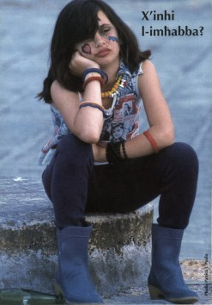
Saqsi b’genwinita`

…u ibqa` fittex sa ma ssib dak li
tixtieq. Meta tghejja
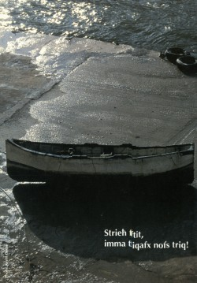

Tghallem
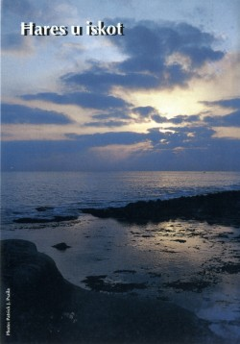

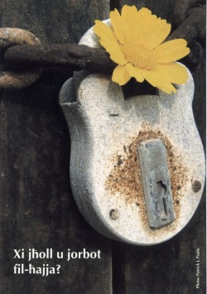
Fittex

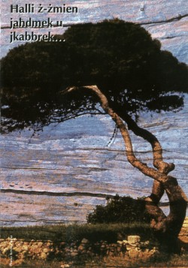

bhal ma kabbar iz-zerriegha sakemm saret sigra li fiha setghu jistkennu l-ghasafar.
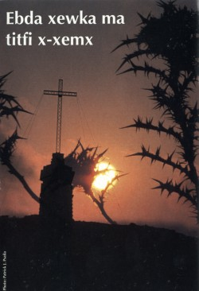

U min ifittex isib u min ihabbat
jifthulu. M’hemmx ghalfejn nghidlek,
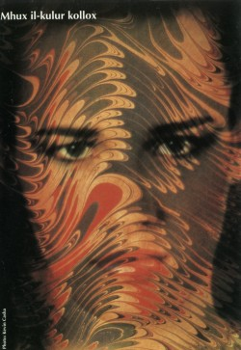

Fl-ahhar, wara hafna zmien tkun tista` thares lura u tghid li hajtek saret
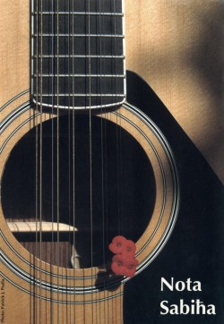

li ssebbah l-ambjent tal-madwar

Il-mistoqsija ahharija hija
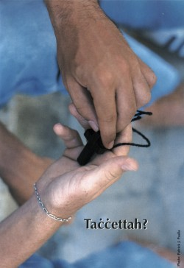

My Secret is simple, I pray – Mother Theresa

stampi mħeudin minn Djarju Ħabib 1997

