Lesson Plan
Name: Teri Warner

Grade level: 7-12

Subject unit: Diagramming Sentences

Materials needed:

Day 1
Sentence Type I Exercise
Reed-Kellogg Diagram Poster (need to make)
Phrase Marker Diagram Poster (need to make)
Day 2
Sentence Type II Exercise
Reed-Kellogg Diagram Poster (need to make)
Phrase Marker Diagram Poster (need to make)
Day 3
Sentence Type III Exercise
Reed-Kellogg Diagram Poster (need to make)
Phrase Marker Diagram Poster (need to make)
Day 4
Sentence Type IV Exercise
Reed-Kellogg Diagram Poster (need to make)
Phrase Marker Diagram Poster (need to make)
Day 5
Sentence Type V Exercise
Reed-Kellogg Diagram Poster (need to make)
Phrase Marker Diagram Poster (need to make)
Day 6 (no Lesson Plan)
Final Exam to be given on this day

Theory:

Most students do not like to be taught grammar in the upper grades. If they did not grasp the basics in the lower grades, it becomes more difficult. In order to improve their sentence structuring ability as well as increase their self esteem of their ability to create sentences well, the teacher must begin at an elementary level using a method which can be visualized by the student.

Objectives:

The student will be able to:
- identify parts of speech
- build a basic understanding of sentence structure
- increase their ability to develop good sentences

Day 1

Materials needed:
Sentence Type I Exercise
Reed-Kellogg Diagram Poster (need to be made)
Phrase Marker Diagram Poster (need to be made)

Introductions:

Explain the importance of good sentence structure.
In order to write a good story, you need to be able to put together good sentences. Without a good sentence structure, the reader may not understand the meaning.

Explain two people, Thomas P. Klammer and Muriel R. Schultz, developed a system called sentence types. These types are broken into five types that describe the sentence pattern that almost all sentences of English carry.

We will begin by learning the simplest sentence type. We will use two types of diagramming tools to ensure we have a stable structure.

Procedures:

Using the Reed-Kellogg Diagram Poster, explain the basic parts of the diagram for a Type I sentence.
Where the subject is placed.
Where the verb is placed.
Where the article is placed.

Using the Phrase Marker Diagram Poster, explain the basic parts of the diagram.
Where the subject is placed.
Where the verb is placed.
Where the article is placed.

Explain Sentence Type I is Intransitive.
It contains a subject and an intransitive verb.
Find out if they know what an intransitive verb is.
A verb that does not need a direct object to complete its meaning. It expresses an action that does not have a receiver. (i.e., The dog ran.)

Demonstrate and explain how to diagram a Type I sentence using a Reed-Kellogg diagram.
The dog ran.

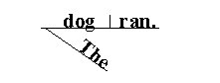
Show a more complicated example. Explain the difference (“in New York” is a prepositional phrase and not a direct object).

John Lennon died in New York.

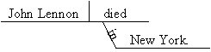

Now diagram the sentences using Phrase Marker diagrams.

The dog ran.

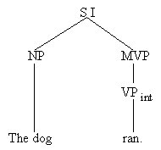

John Lennon died in New York.

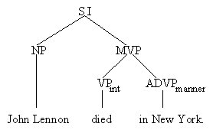

Closure/Evaluation:

Handout Sentence Type I Exercise. Explain the instructions.

Repeat that a Type I Sentence contains a subject and an intransitive verb.
And an intransitive verb is a verb that does not need a direct object to complete its meaning. It expresses an action that does not have a receiver. (i.e., The dog ran.)

- Were they able to grasp the concept of sentence types?
- Did any of the students have difficulties with the exercise? What were the issues regarding their difficulties?

Lesson Analysis:

- If they had any difficulties, what were they? How should this lesson plan be improved to accommodate that difficulty?
- Was there active participation from the students while diagramming?

Day 2

Materials needed:
Sentence Type II Exercise
Reed-Kellogg Diagram Poster (need to be made)
Phrase Marker Diagram Poster (need to be made)

Introductions:

Review Type I sentence diagramming.
A Type I sentence contains a subject and an intransitive verb.

Take 10 volunteers to put their diagram (either the Reed-Kellogg or Phrase Marker) on the board. Review for accuracy. Answer any questions.

Procedures:

Now that they have grasped the most simplest sentence, have them begin with the next more difficult.

Using the Reed-Kellogg Diagram Poster, explain the basic parts of the diagram for a Type II sentence.
Where the subject is placed.
Where the linking verb is placed.
Where the adverbial phrase is placed.

Using the Phrase Marker Diagram Poster, explain the basic parts of the diagram.
Where the subject is placed.
Where the linking verb is placed.
Where the adverbial phrase is placed.

Explain Sentence Type II contains a subject, linking verb, and an adverbial phrase related to time/place/manner.
Find out if they know what a linking verb is.
A verb that tells that the subject is, was, or will be something.
(i.e., Our meeting is tomorrow.)

Demonstrate and explain how to diagram a Type II sentence using a Reed-Kellogg diagram.
Our meeting is tomorrow.

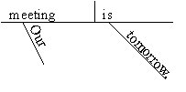
Show a more complicated example.

That plant has been by the door for years.

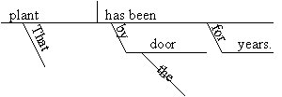

Now diagram the sentences using Phrase Marker diagrams.

Our meeting is tomorrow.

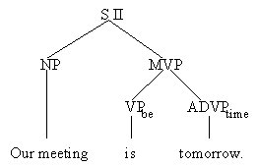

That plant has been by the door for years.

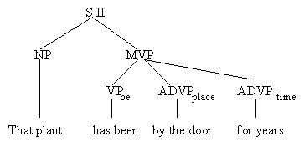

Closure/Evaluation:

Handout Sentence Type II Exercise.

- Ask them what a Type I sentence is? (subject and intransitive verb)
- Ask them what a Type II sentence is? (subject, linking verb and an adverbial phrase that describes time/place/manner)

- Did they remember what a Type I sentence was?
- Were they able to grasp a Type II sentence?
- Did any of the students have difficulties with the exercise? What were the issues regarding their difficulties?

Lesson Analysis:

- If they had any difficulties, what were they? How should this lesson plan be improved to accommodate that difficulty?
- Was there active participation from the students while diagramming?

Day 3

Materials needed:
Sentence Type III Exercise
Reed-Kellogg Diagram Poster (need to be made)
Phrase Marker Diagram Poster (need to be made)

Introductions:

Review Type III sentence diagramming.

Take 10 volunteers to put their diagram (either the Reed-Kellogg or Phrase Marker) on the board. Review for accuracy. Answer any questions.

Procedures: (Includes modeling, structured practice, guided practice-independent work)

Using the Reed-Kellogg Diagram Poster, explain the basic parts of the diagram for a Type III sentence.
Where the subject is placed.
Where the linking verb is placed.
Where the adjectival phrase is placed.
Point out the slanted line indicating a adjective is on the other side.

Using the Phrase Marker Diagram Poster, explain the basic parts of the diagram.
Where the subject is placed.
Where the linking verb is placed.
Where the adjectival phrase is placed.

Explain Sentence Type III contains a subject, a linking verb, and an adjectival phrase.
Find out if they know what a linking verb is.
A verb that tells that the subject is, was, or will be something.
(i.e., My daughter looks angelic.)

Demonstrate and explain how to diagram a Type III sentence using a Reed-Kellogg diagram.
My daughter looks angelic.

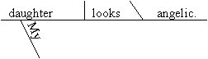

Now diagram the sentences using Phrase Marker diagrams.

My daughter looks angelic.

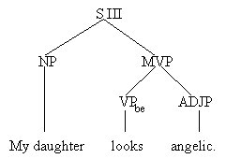

Show a more complicated example. Explain that the adverbial phrase is an extra phrase that is not needed.

The grapes looked ripe enough to pick last week.

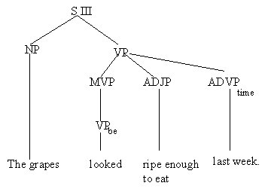

Closure/Evaluation:

Handout Sentence Type III Exercise.

- Ask them what a Type I sentence is? (subject and intransitive verb)
- Ask them what a Type II sentence is? (subject, a linking verb and an adverbial phrase that describes time/place/manner)
- Ask them what a Type III sentence is? (subject, linking verb and an adjectival phrase)

- Did they remember what a Type I sentence was?
- Did they remember what a Type II sentence was?
- Were they able to grasp a Type III sentence?
- Did any of the students have difficulties with the exercise? What were the issues regarding their difficulties?

Lesson Analysis:

- If they had any difficulties, what were they? How should this lesson plan be improved to accommodate that difficulty?
- Was there active participation from the students while diagramming?

Day 4

Materials needed:
Sentence Type IV Exercise
Reed-Kellogg Diagram Poster (need to be made)
Phrase Marker Diagram Poster (need to be made)

Introductions:

Review Type IV sentence diagramming and explanation.

Procedures: (Includes modeling, structured practice, guided practice-independent work)

Using the Reed-Kellogg Diagram Poster, explain the basic parts of the diagram for a Type IV sentence.
Where the subject is placed.
Where the linking verb is placed.
Where the noun phrase is placed. Point out the straight line designating a noun.

Using the Phrase Marker Diagram Poster, explain the basic parts of the diagram.
Where the subject is placed.
Where the linking verb is placed.
Where the noun phrase is placed.

Explain Sentence Type IV contains a subject, a linking verb, and a noun phrase.
Find out if they know what a linking verb is.
A verb that tells that the subject is, was, or will be something.
(i.e., The D-Day invasion was General Eisenhower’s greatest triumph.)

Demonstrate and explain how to diagram a Type IV sentence using a Reed-Kellogg diagram.
The D-Day invasion was General Eisenhower’s greatest triumph.

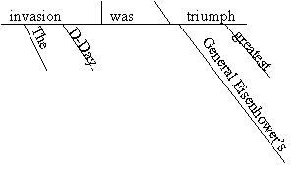
Show another example.

“Death by Chocolate” is the best dessert.

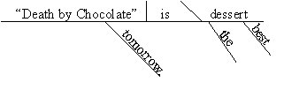

Now diagram the sentences using Phrase Marker diagrams.

The D-Day invasion was General Eisenhower’s greatest triumph.

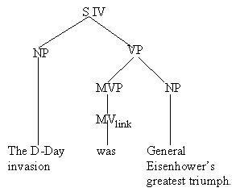

“Death by Chocolate” is the best dessert.

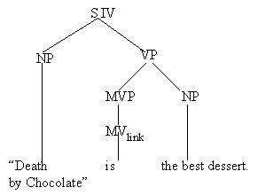

Closure/Evaluation:

Handout Sentence Type IV Exercise.

- Ask them what a Type I sentence is? (subject and intransitive verb)
- Ask them what a Type II sentence is? (subject, a linking verb and an adverbial phrase that describes time/place/manner)
- Ask them what a Type III sentence is? (subject, linking verb and an adjectival phrase)
- Ask them what a Type IV sentence is? (subject, linking verb and a noun phrase)

- Did they remember what a Type I sentence was?
- Did they remember what a Type II sentence was?
- Did they remember what a Type III sentence was?
- Were they able to grasp a Type IV sentence?
- Did any of the students have difficulties with the exercise? What were the issues regarding their difficulties?

Lesson Analysis:

- If they had any difficulties, what were they? How should this lesson plan be improved to accommodate that difficulty?
- Was there active participation from the students while diagramming?

Day 5

Materials needed:
Sentence Type V Exercise
Reed-Kellogg Diagram Poster (need to be made)
Phrase Marker Diagram Poster (need to be made)

Introductions:

Review Type V sentence diagramming and explanation.

Procedures: (Includes modeling, structured practice, guided practice-independent work)

Using the Reed-Kellogg Diagram Poster, explain the basic parts of the diagram for a Type V sentence.
Where the subject is placed.
Where the transitive verb is placed.
Where the direct object is placed.

Using the Phrase Marker Diagram Poster, explain the basic parts of the diagram.
Where the subject is placed.
Where the transitive verb is placed.
Where the direct object is placed.

Explain Sentence Type V contains a subject, a transitive verb, and a direct object.
Find out if they know what a transitive verb is.
A transitive verb needs a direct object to complete its meaning. It expresses an action that passes across (transits) from a doer (the subject) to a receiver (the direct object).
Find out if they know what a direct object is.
A direct object is a noun (or pronoun) that tells whom or what after an action verb. (i.e., The group has checked its luggage.)

Demonstrate and explain how to diagram a Type V sentence using a Reed-Kellogg diagram.
The group has checked its luggage.

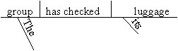

Show a more complicated example.

Their team won its last three games.

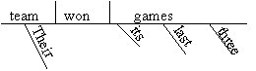

Now diagram the sentences using Phrase Marker diagrams.

The group has checked its luggage.

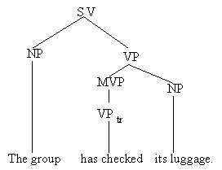

Their team won its last three games.

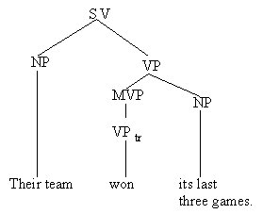

Closure/Evaluation:

Handout Sentence Type V Exercise.

- Ask them what a Type I sentence is? (subject and intransitive verb)
- Ask them what a Type II sentence is? (subject, a linking verb and an adverbial phrase that describes time/place/manner)
- Ask them what a Type III sentence is? (subject, linking verb and an adjectival phrase)
- Ask them what a Type IV sentence is? (subject, linking verb and a noun phrase)
- Ask them what a Type V sentence is? (subject, transitive verb and a direct object)

- Did they remember what a Type I sentence was?
- Did they remember what a Type II sentence was?
- Did they remember what a Type III sentence was?
- Did they remember what a Type IV sentence was?
- Were they able to grasp a Type V sentence?
- Did any of the students have difficulties with the exercise? What were the issues regarding their difficulties?

Lesson Analysis:

- If they had any difficulties, what were they? How should this lesson plan be improved to accommodate that difficulty?
- Was there active participation from the students while diagramming?

SENTENCE TYPE I EXERCISE
Remember a Type I sentence is a sentence that contains a subject and an intransitive verb. An intransitive verb is a verb that can stand alone (without a direct object). For the sentences below, diagram each using a Reed-Kellogg diagram and a Phrase Marker diagram.

- The president sleeps.
- Eddie’s dog sleeps.
- Some cookies are baking.
- A sudden storm appeared.
- Three police cars stopped on the bridge.

SENTENCE TYPE II EXERCISE
Remember a Type II sentence is a sentence that contains a subject, a linking verb, and an adverbial phrase that describes time/place/manner. For the sentences below, diagram each using a Reed-Kellogg diagram and a Phrase Marker diagram.

- The computer disks were in his desk drawer.
- The wedding reception was outside in the garden.
- Jessie is outside.
- The concert will be next week.
- Her job interviews were yesterday.

SENTENCE TYPE III EXERCISE
Remember a Type III sentence is a sentence that contains a subject, a linking verb, and an adjectival phrase. For the sentences below, diagram each using a Reed-Kellogg diagram and a Phrase Marker diagram.

- This lemonade tastes sour.
- The children are being difficult.
- The ocean seemed warm to the visiting Norwegians.
- Francie’s yellow corvette was very clean last night.
- The milk tastes sweet.

SENTENCE TYPE IV EXERCISE
Remember a Type IV sentence is a sentence that contains a subject, linking verb, and a noun phrase. For the sentences below, diagram each using a Reed-Kellogg diagram and a Phrase Marker diagram.

- The Eiffel Tower is a famous landmark.
- The Tadpoles became an overnight success.
- Roger and Marylou became friends in college.
- Walt remained a bigger eater.
- Our child’s room is a mess.

SENTENCE TYPE V EXERCISE
Remember a Type V sentence is a sentence that contains a subject and a transitive verb. A transitive verb is a verb that needs a direct object to complete its meaning (it passes across (transits) from a doer (the subject) to a receiver (the direct object). For the sentences below, diagram each using a Reed-Kellogg diagram and a Phrase Marker diagram.
- Gerald’s summer adventures tested his courage with unexpected rigor.
- Barbie left the house this morning.
- John hit Bill.
- Sam prefers popcorn.
- Three minnows nibbled her toes.

SENTENCE TYPE FINAL EXAM

For the sentences below, diagram each using a Reed-Kellogg diagram and a Phrase Marker diagram.
- Our office is becoming a jungle.
- A telephone rang.
- John hit Bill.
- Sheila is beautiful.
- The concert will be next week.

Answer Key:

SENTENCE TYPE I EXERCISE
- The president sleeps.
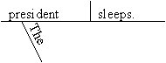 | 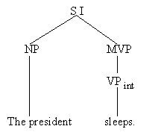

- Eddie’s dog sleeps.
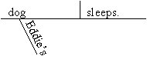 | 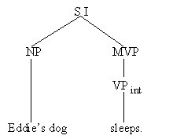

- Some cookies are baking.
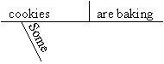 | 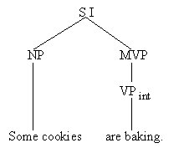

- A sudden storm appeared.
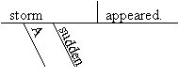 | 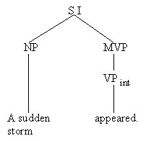

- Three police cars stopped on the bridge.
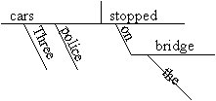 | 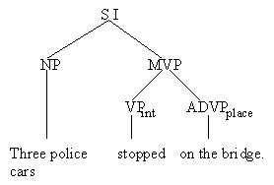

SENTENCE TYPE II EXERCISE

- The computer disks were in his desk drawer.
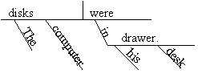 | 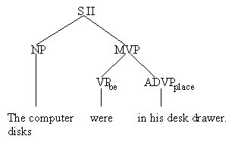

- The wedding reception was outside in the garden.
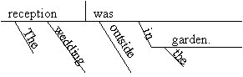 | 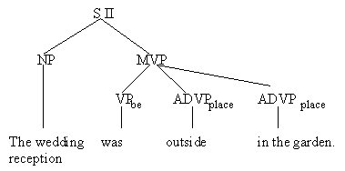

- Jessie is outside.
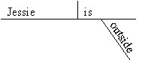 | 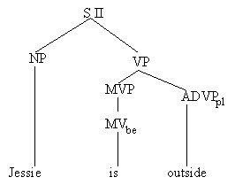

- The concert will be next week.
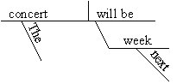 | 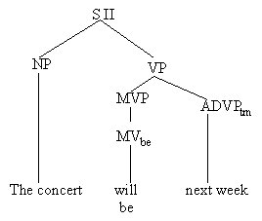

- Her job interviews were yesterday.
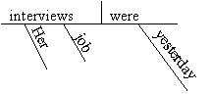 | 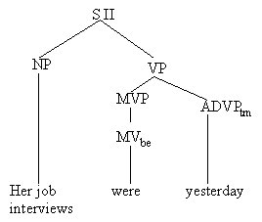

SENTENCE TYPE III EXERCISE

- This lemonade tastes sour.
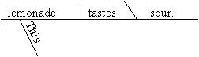 | 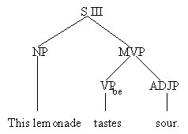

- The children are being difficult.
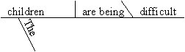 | 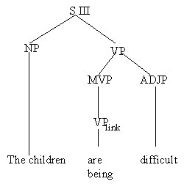

- The ocean seemed warm to the visiting Norwegians.
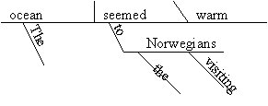 | 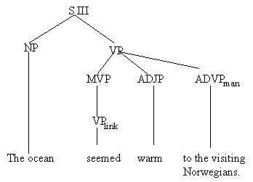

- Francie’s yellow corvette was very clean last night.
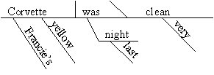 | 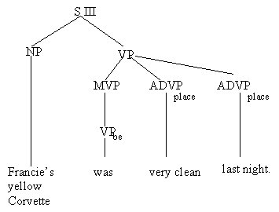

- The milk tastes sweet.
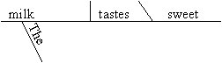 | 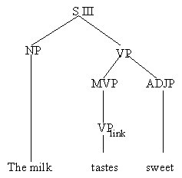

SENTENCE TYPE IV EXERCISE

- The Eiffel Tower is a famous landmark
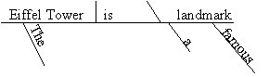 | 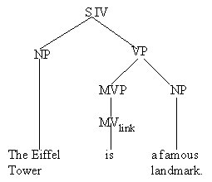

- The Tadpoles became an overnight success.
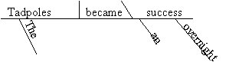 | 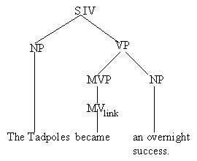

- Roger and Marylou became friends in college.
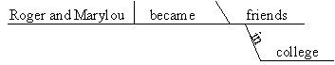 | 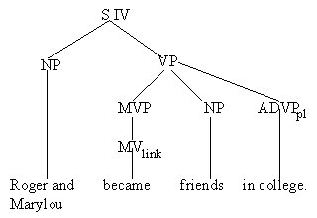

- Walt remained a big eater.
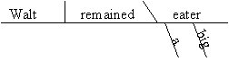 | 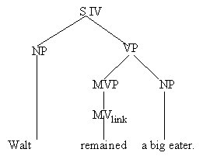

- Our child’s room is a mess.
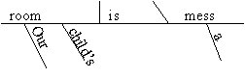 | 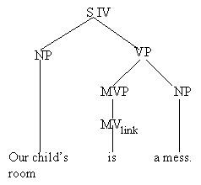

SENTENCE TYPE V EXERCISE

- Gerald’s summer adventures tested his courage with unexpected rigor.
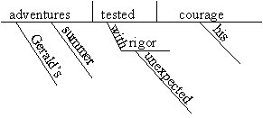 | 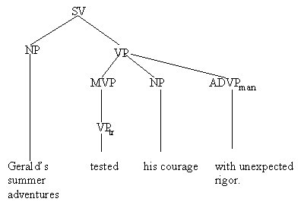

- Barbie left the house this morning.
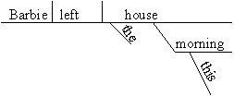 | 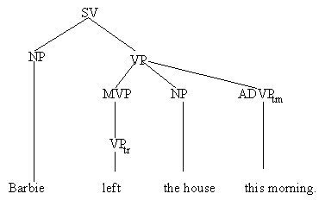

- John hit Bill.
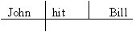 | 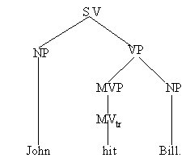

- Sam prefers popcorn.
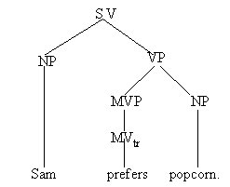

- Three minnows nibbled her toes.
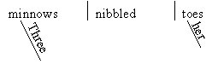 | 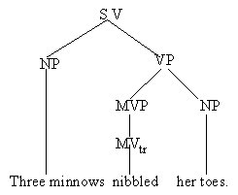

SENTENCE TYPE FINAL EXAM
- Our office is becoming a jungle.
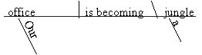 | 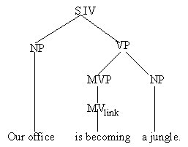

- A telephone rang.
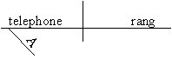 | 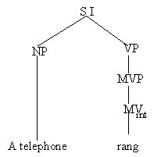

- John hit Bill.

- Sheila is beautiful.
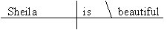 | 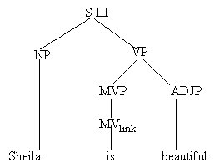

- The concert will be next week.

