ARIZONA STATE RIFLE & PISTOL ASSOCIATION

HIGH POWER RIFLE DIVISION PRESENTS

116TH WASHINGTON’S BIRTHDAY MATCH

SUNDAY, FEBRUARY 17, 2008
Hosted by the Desert Sharpshooters Rifle Club

Big changes to the range this year! ASRPA volunteers spent all summer reconditioning the High Power range to allow for larger matches, we now have enough space for 75 teams! That’s 67% more than last year! 300 shooters if we can find that many, tell your friends! With more firing points we can take more shooters so we will allow more types of rifles including M4-type rifles with iron or optical sights! Good news for shooters new to competition!

The weekend includes:
- Beginner’s Clinic & Practice for experienced shooters Saturday & Lunch available.
- Opening Ceremony Sunday morning.
- 4-relay, 50-shot Main Match Sunday with Lunch & T-shirt Available.
- Shooter’s Swap meet & Displays all day Sunday
- A Sudden Elimination Shoot Off match after the main match
- The annual fund-raising raffle for an M1 Rifle and other prizes

The Washington’s Birthday Match is held on Sunday at Ben Avery’s High Power Range, 200 yd line. This is the 116th year! Saturday the day before the match, February 16, experienced High Power coaches and shooters are conducting a “Beginners Clinic” in the activities center followed by some practice time on the range.

Supporters of the Arizona State Junior Rifle Team are serving lunch both days!!! You can pre-pay for your lunch with your entry! The profit goes right into sending the team to Camp Perry! We are having commemorative T-shirts again this year! $10. You must order your shirt with your entry!

Other match day events:

Opening Ceremony: Like at Camp Perry Cannon Shot & flag raising.

Shoot-off! The top shooters, those shooting Master class scores, are firing a sudden elimination format shoot-off match in the standing position. This is serious competition for them and some entertainment for everyone else. It makes shooting more of a spectator sport. This will be right after the main match, during that down-time while the stat office compiles the team scores, stay right behind the line and cheer, jeer, and applaud the sudden-elimination round!

Swap meet! Bring your spare equipment, older shooting gear; reloading supplies you don’t need anymore, whatever… bring a table or some money, we are holding a shooter’s swap meet in a designated area behind the line. (To allow room for food, spectators and swap meet, shooters should plan on parking at the 300 yd line).

Come out and shoot with us! Get a group of friends, co-workers, or hunting buddies together! Wear a team uniform! Wear a classic side-arm (empty chamber)! Maybe try something fun like have the whole team all shoot the same type of antique or unusual military rifle, even dress the team in surplus uniforms appropriate to your exotic rifles!

Enclosed is the match program and an entry form. Also enclosed is a flyer on the fund raising raffle to send the State Junior Team to the National Championships and information on Arizona High Power shooting schedules. Check the http://arizona.rifleshooting.com & http://www.geocities.com/washbday/ websites for updates! Tell your friends! Post this bulletin where other shooters will see it!

See you on February 16 & 17!

Bill Poole - ASRPA High Power Rifle Division Director - washbday@gmail.com or bill@poole.com

Arizona State Rifle and Pistol Association
116TH WASHINGTON’S BIRTHDAY MATCH

SUNDAY, FEBRUARY 17, 2008
Hosted by the Desert Sharpshooters Rifle Club

- PURPOSE OF THIS MATCH:
  - To uphold the century-old tradition of Arizona shooting teams.
  - To provide a match that encourages and fosters new civilian shooters, both Junior and Adults.
  - To conduct the most prestigious High Power Match in Arizona
  - To act as an enhancement of the goals of the CMP program.
- LOCATION: The Ben Avery Shooting Facility High Power Rifle Range, Phoenix, AZ, ½ mile west of the junction of SR 74 (Carefree Highway) and I-17 (Exit 223). Park at 300 yd line.
- FIRING TIME: Firing commences at 0800 hours. (Be on the line by 0700).
- TEAM CAPTAINS: A Team Captain (TC) must be designated for each team and may be a firing member. Team Captains report upon arrival for firing point assignments. Team Captains should study this program and the NRA High Power Rifle Rules prior to reporting. It shall be the TC’ s responsibility to assure that all equipment used by his/her team meets the spirit and intent of the match and that team members comply with the rules.
- RULES: Current NRA High Power Rifle Rules, except as noted in this program.
- ELIGIBILITY: Only Arizona residents are eligible for awards. Non-residents may participate for bragging rights if space is available.
- CLASSIFICATIONS: NRA High Power Rifle Classifications will NOT BE USED. (EX, MA, HM and Distinguished Riflemen using optical sights (or their teams) not eligible for awards)
- TEAM COMPOSITION: Each team consists of four firing members. Partial teams and individual entries are squadded together by the match registrar to fill the team to 4 shooters. All 4 team members’ scores are summed to the team score. Teams of fewer than 4 shooters are allowed to participate but may be assigned additional shooters.
- TEAM CATAGORIES: Team categories are determined by the status of the four firing members. However, for individual awards, each shooter keeps his/her own category.
- Adult – Not a junior team
- Junior – ALL FOUR shooters will be junior per NRA definition.
- INDIVIDUAL CATEGORIES: Civilian, Junior, Woman, Senior, Police or Service. An individual can win an award in only one category. Other awards to be announced
- ENTRIES: Teams of 4 should submit an entry on the enclosed Registration/Entry form with email contact, accompanied by the proper fees, (made payable to Bill Poole). Mail to: Bill Poole, Washington’s Birthday Match c/o PRGC 915 W. Olney Dr, Phoenix, AZ 85041, 602-405-0717. Fees of teams unable to attend will be refunded in full upon request, providing cancellation is made prior to February 12, 2008. Individuals and partial teams may submit an entry using the same form, pick-up squadding will be at random.
- ENTRIES CLOSE: Entries CLOSE at 1700 hours, February 12, 2008. Late entries may be accepted after that date only to fill vacancies. Late entries are charged a $20 late fee.
- ENTRY LIMIT: Entries are limited to 45 teams, (180 individuals).
- FEES: Entry fees are $80.00 per Adult team, $40.00 per Junior team of 4. payable to Bill Poole
- SQUADDING: Firing point assignments are posted at the range on the day of the match.
- TARGET SERVICE: Each team must provide a target puller (may be a firing team member). Pullers are to report to the pits AFTER the opening ceremony and announcements. There is one pit-change (schedule posted and announced prior to firing) so a firing member of the team can be assigned to pull targets during the alternate relay. Teams may bring a volunteer or hired target puller. Target puller MUST be experienced at pulling targets or have attended the clinic the day before. Pullers reporting to the Pits must identify themselves as to the team and target number they represent. The Pit Officer has the authority to change target assignments. Any team not performing satisfactory target service will be disqualified. Shooters who are participating in the shoot-off are excused from pit duty at that time.
- SCORING: Teams must provide a scorer for another team as assigned (may be a firing team member). Team Captains are responsible for verifying the entry of scores and correctness of totals.
- RIFLES: (8mm or less centerfire):
- US service rifle (AR-15, M14/M1A, M1 per NRA/CMP)
- Vintage Military Bolt Rifle (Springfield, Mauser, Enfield, Mosin-Nagant etc in as issued condition)
- John C Garand (M1 rifle or M1 Carbine per CMP rules)
- Foreign Service Rifle (AK, HK, FAL etc in as issued condition)
- M4-gery (action or tactical weight and style semi-auto carbine/rifle, OPTICS permitted!) (no “space gun” match rifles)
- Other Rifles may be approved by match director.
- SHOOTING EQUIPMENT: NRA/CMP service rifle slings, gloves, coats, mats and equipment may be used Except for M4 and Hunting rifle categories may not use shooting coats and gloves, only street, military, tactical or hunting clothing must be worn. No sandbags or bipods.
- AMMUNITION: Competitors must supply their own safe ammo. No tracer or incendiary permitted. Point rifle at the impact area when loading and closing the bolt.
- SIGHTING SHOTS: Each team member may fire three (optional) sighter shots, in any position, as part of the standing stage.
- COURSE OF FIRE: National Match Course, 50-shot, all firing at 200 yards on the appropriate reduced targets. 10-shots standing, 10 sitting/kneeling rapid, 10 prone rapid, and 20 prone slow fire. Shooters start in position in rapid fire.
- ALIBIS: There are NO alibis or re-fires, except for range alibis (NRA Rule 9.25).
- TEAM AWARDS: The winning team will win an award, the top junior team lesser awards to be announced.
- INDIVIDUAL AWARDS: High Individual in the match and High Competitor in each category may win ONE Individual Award. Winner of the shoot-off also wins an award.
- RESULTS BULLETIN: NO Results Bulletin will be mailed. Results will be posted on the web if possible.

Opening Ceremony: An opening ceremony will precede the match.

Shoot OFF: There will be a shoot-off immediately after the match (while the results are being tallied). All shooters who fire a Master Class score (470) or higher will participate. It will be a sudden-elimination format fired from the standing position at the SR target. After a preparation and sighter period, a single shots taken by all shooters then scored and displayed together, repeating shot by shot, with those scoring the lowest score eliminated in each round until only one shooter remains. (bring enough ammo!) There will be a separate award for the shoot-off winner. All other match participants are strongly encouraged to participate as spectators during the shoot off. Applause is appreciated.

SWAP MEET: Open to all participants, any appropriate shooting related items. All laws to be obeyed. It is recommended that valuables not be left unattended. Competitors should do their buying and selling to before and after the match and lunch break.

PARKING: Parking at 300 yd line to allow room for spectators, swap meet, awards ceremonies. Unloading/loading or limited parking at 200 yds by prior arrangement.

AWARD CEREMONY & RAFFLE: All shooters are strongly encouraged to stay for the entire duration of the event. To cheer the shoot off and award and raffle winners. Shooting awards & minor raffle prizes must be present to win. M1 Rifle Raffle prize need not be present to win, but a $20 delivery penalty charge will be imposed if the winner is present but leaves early.

ENTRIES: Entries accepted starting 1-Jan-08. Priority on entries given to named team entries of 4 named shooters, paid in full, with email contact for the team captain. Teams are encouraged to pre-order shirts and lunches with their entry. Two or more teams applying together with all fees may be squadded together if practical. Partial team and individual entries will be squadded into random groupings for teams. If no email address is provided for contact, no confirmation of entry will be provided or guaranteed.

Shooters are strongly encouraged to form teams of special interest, such as their home club, forum group, a specific rifle type, employee clubs etc.

Beginners Clinic: There is a Beginners Clinic on Saturday, 16-February-08. The classroom instruction phase is held in the Activity Center at Ben Avery Shooting Facility starting at 8:00 AM. The clinic is conducted by a volunteer group of Arizona High Power Coaches and Shooters . Among the clinic instructors are several NRA appointed coaches, Distinguished Rifleman’s Badge holders, Master Class high power rifle shooters, and member of the Arizona State High Power Rifle Team.
  - TOPICS COVERED: Safety, match procedure and range commands, sight alignment, trigger control, shooting positions, use of the sling and equipment, etc.
  - FIRING PRACTICE (Beginners): Firing practice for beginners is the 2nd part of the beginner’s clinic. Shooting at the 200 yd line of the High Power Range immediately following the classroom session. Approximately 40 shots will be fired. 200yd target.
  - Clinic/Practice Fee: The clinic fee is $25 for adults and $10 for juniors. This covers both the classroom and range sessions.
  - OPEN: The clinic is open to everyone, with priority given to Juniors and non-classified shooters who intend to shoot the Match on Sunday.
  - Target Puller training: New paid/volunteer target pullers planning to work Sunday should participate in the pits during sessions Saturday in order to gain experience.

Firing Practice for EXPERIENCED SHOOTERS: Firing practice session during the Saturday afternoon firing session of clinic. $10 fee, payable at the range.
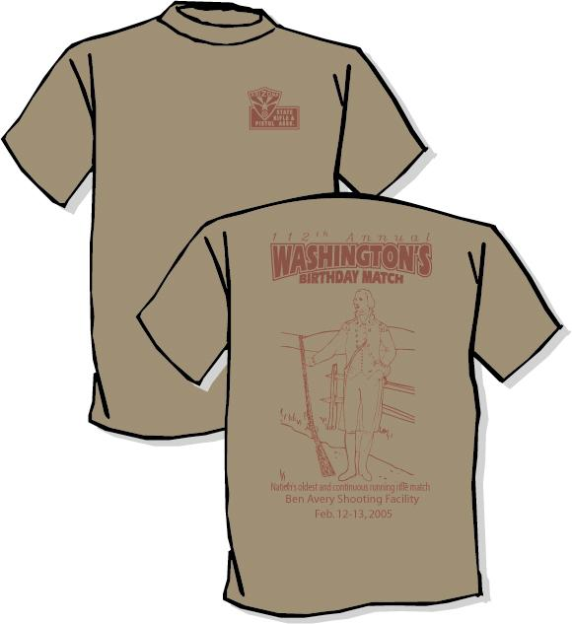
Lunch available on the line,
order your lunch & raffle tickets
Special T-shirt Available, order with your entry, $10.

with your entry.

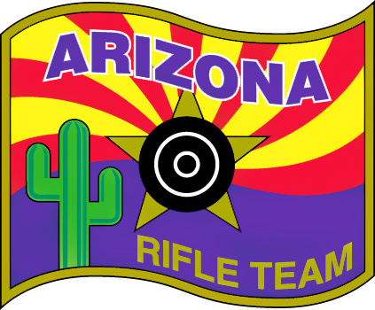

Arizona Junior Highpower Rifle Team http://members.cox.net/azjrhp/
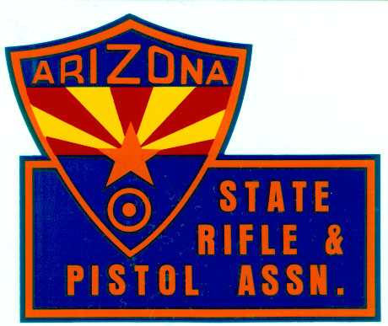
The Arizona Junior Highpower Rifle Team is sponsored by the Arizona State Rifle & Pistol Association and local clubs. The team is open to Arizona youth between the ages of 14 and 20. Team members shoot local matches during the season (Sept - May), practice like crazy June & July, and participate at the National Championship Rifle Matches at Camp Perry, Ohio in August. Most equipment including AR-15 rifles, ammunition components and match fees, are provided to team members free of charge. The Washington’s Birthday Match is a big fund-raiser for the team! If you know a teenager who is motivated, well-behaved and who would like to join the team, have him or her see the team and their coaches at the match!
Arizona State Rifle & Pistol Association
ASRPA
P.O. Box 40962,
Mesa, AZ 85274-0962
http://www.asrpa.com

The ASRPA does legislative work, education, training, match sponsorship, Ben Avery partnering and publishes a great little e-newsletter about competition, ranges, shooting and legislation specifically in Arizona. Find out what matches are shot where, what Arizonan is winning championships, read articles about matches, events and shooters in YOUR state! Only $20/yr ($5 juniors). Join NRA, ASRPA, USA Shooting and your local club!

ASRPA Fund-Raising Raffle
Proceeds fund the Arizona State Junior Rifle Team to the
2008 National Championships at Camp Perry, OH.

Tickets: $2 each, 3 for $5 –

See any of the staff at the Match or mail your order with entry
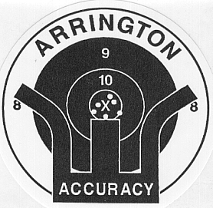
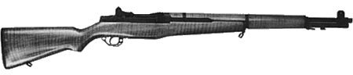

US CMP M1 Garand Rifle - New walnut stock and handguards. New parkerizing. New .30-06 barrel, Hand fitted issue sights, National Match tuned chamber, action and trigger job. Set up to meet rules for NRA/CMP Service Rifle or CMP John C. Garand Match.

Custom Assembled for this fund raiser by
Arrington Accuracy Works
Phoenix, AZ - 623-582-5066 http:// www.arringtonaccuracy.com

Check out the http://arizona.rifleshooting.com website for info on competition shooting in AZ!

