WASHINGTON’S BIRTHDAY 116thANNUAL RIFLE MATCH
16/17-Feb-2008
Ben Avery Range, Phoenix, AZ
I-17 & Carefree Hwy High Power Range
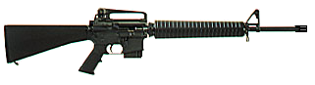
Since 1893!
The longest running annual rifle match in the country
and the largest (300 shooters) High Power Rifle Match in AZ!

This match is a 4-person team match, using the NRA/CMP 50-shot (plus sighters) High Power Rifle course of fire, AR-15, M1, M14, Vintage military bolt action and foreign service rifles, new for 2008: M4-type (optics or irons) style rifles permitted. All firing at 200 yds.

Saturday 16-Feb-08, 8am, Beginner’s Training & Practice
- Beginner’s Clinic Saturday Morning (Ben Avery Activity Center)
- Shooting Practice for beginners & experienced shooters Saturday (High Power Range)
- Lunch available
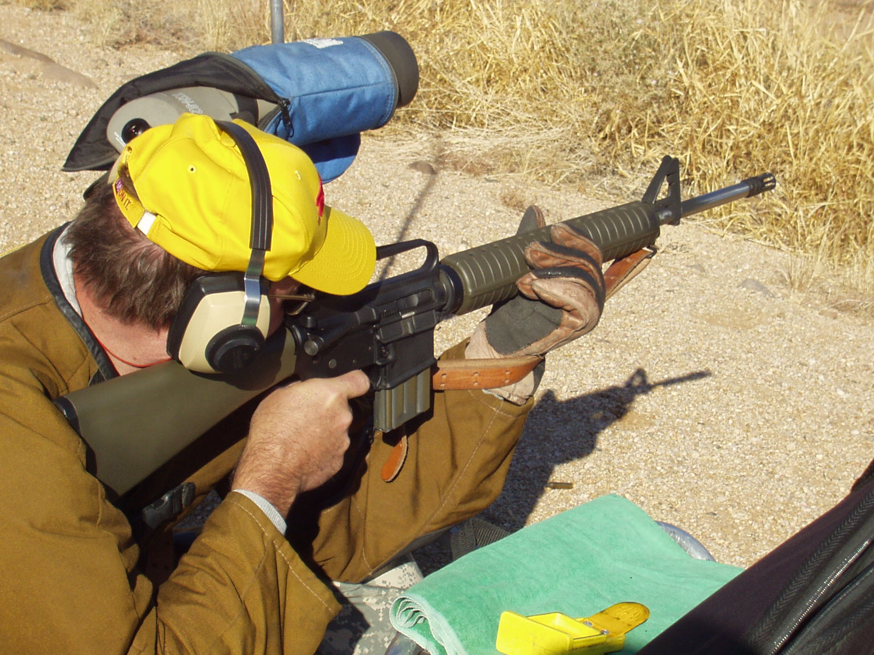
Sunday 17-Feb-08, 7am, MATCH DAY!
- Opening Ceremony Sunday morning
- 4-relay, 50-shot Main Match 7am Sunday
- Break for lunch –grill behind the firing line
- Shooter’s Swap meet & displays all day Sunday
- A Sudden Elimination Shoot Off match after the main match
- Award Ceremony after Sunday’s match, awards for Top Adult and Junior Teams, Top individual shooter plus top junior, woman, senior, police, military & shoot-off winner
- Commemorative T-shirt available (order with entry)
- New shooters Welcome!
- Spectators Welcome! Bring eye & ear protection, binoculars. Park at 300 yd line!
- Raffle for custom re-built M1 Rifle & more, tickets at the match or order with entry.

Fees:
- $80 team of four shooters
- $25 Beginner’s training class
- $10 commemorative T-shirt
- Raffle Tickets $2 or 3 for $5
- Lunch $6, if ordered with entry
For 2008 we have more range capacity!
300 shooters - 75 teams!!!!!

More information, including entry forms, can be found on these sites or by mail:
- http://arizona.rifleshooting.com/
- http://www.geocities.com/washbday/
- email: washbday@yahoo.com
- write: Washington’s Birthday Match,
915 W. Olney
Phoenix, AZ 85041

Subject to change, Dec-07

