How To Log Onto The Member Directory

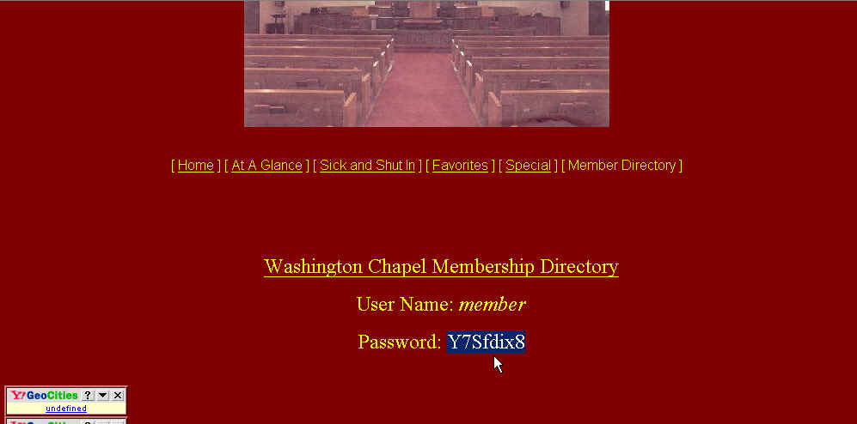

Highlight the password and copy the highlighted area. A quick way is to hold down the Ctrl key and press “C” at the same time.

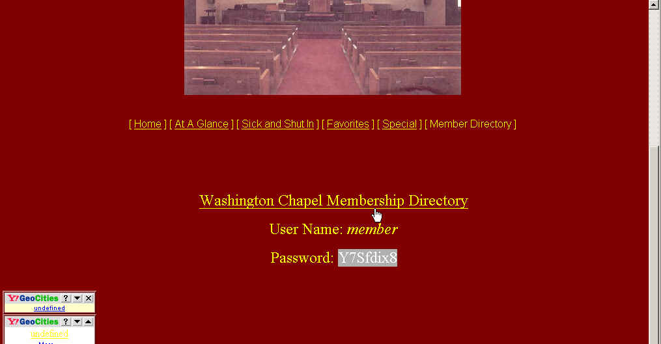

Now, click on the link to the Membership Directory.

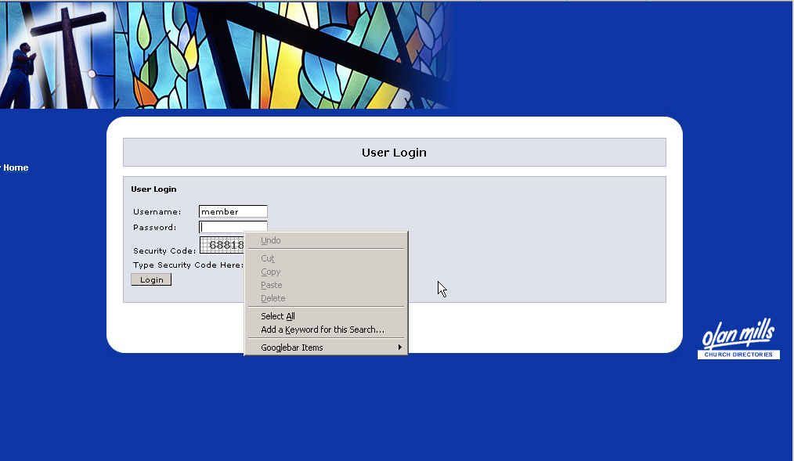

Type “member” in the Username box. Make sure you use lower case. Position your cursor in the Password box. Right-click your mouse and select “Paste”.

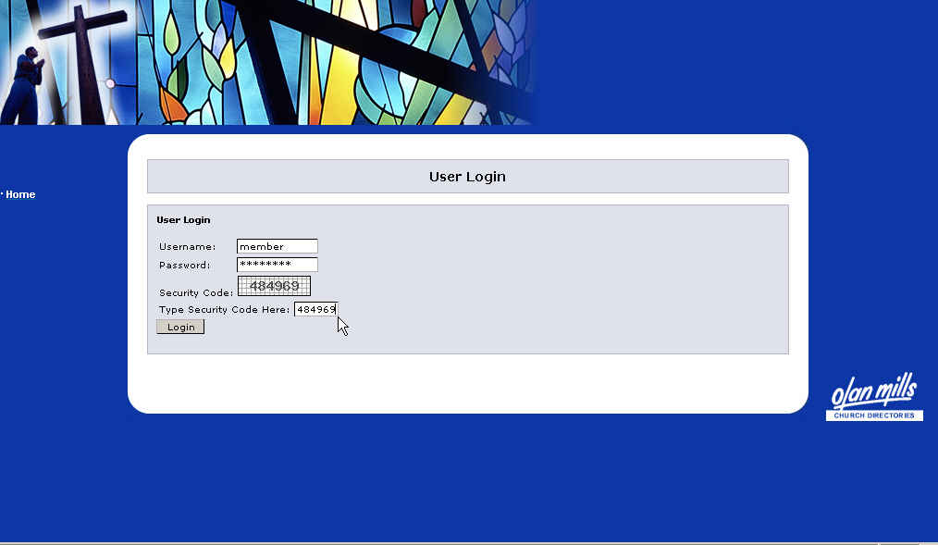

Next, type the security code in the security code dialog box. Type it exactly as you see it displayed.

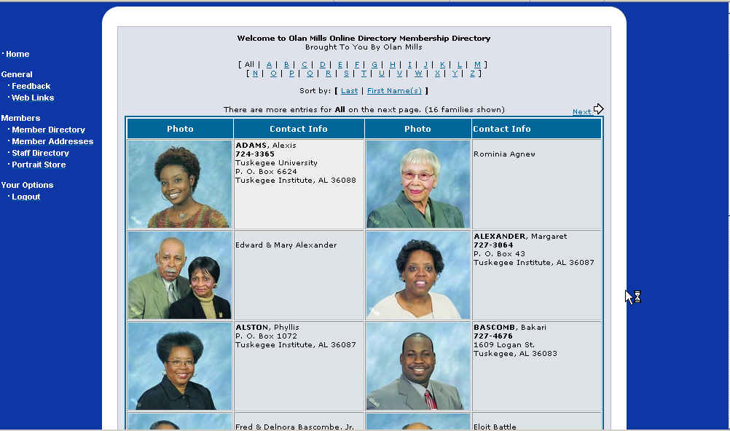

If you did everything correctly, you will see the Membership Directory.

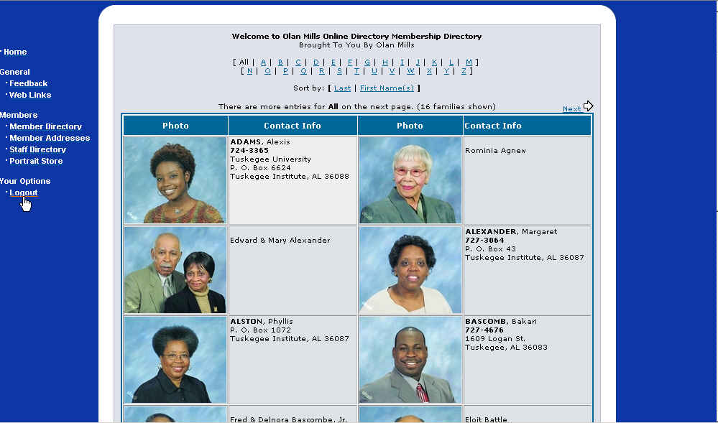

When you wish to log off, select the last choice on the left-hand side; Logout.

