Online Business

Report & new business research

Prepared by Renee Deguara Feb 2002

Contents

Title Page

Contents

Intention Statement

Asia Demographics

Asia Internet Population Demographics & Usage

Introduction to Digital Delivery E-Commerce

Travel Introduction & Online market summary

Case Study - Expedia.com

Case Study - Orbitz.com

Lifestyle Introduction & Online market summary

Case Study - Cooks Illustrated

Case Study - EDiets.com

Case Study - Globalfitness.com

Music Introduction & Online market summary

Case Study - Emusic.com

Case Study - Pressplay

Finance Introduction & Online market summary

Case Study – PayPal

Summary

Introduction

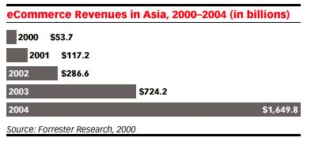
The Internet is quickly becoming a cost-effective platform for businesses to disseminate product information, buy and sell products and services, and to provide customer service. The Internet also allows businesses to reach beyond domestic markets. As a result, Asia is experiencing a rapid development in online commerce relative to the rest of the world. Asia’s e-commerce revenues have grown dramatically over the past year. Forrester paints an extremely optimistic picture of this region, they believe that Asia

will experience phenomenal growth in e-commerce

during the next few years.

But while total Asian e-commerce revenues will increase substantially over the next few years, the region, as a whole will account for a fraction of the total revenues on a worldwide basis, Although it accounts for a much larger share of the population. This is where we find the opportunity for new online business in Asia

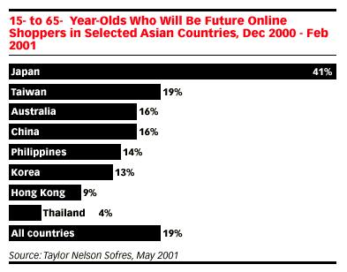

A key factor that will continue to drive Asia’s e-commerce growth will be cheaper telecommunications services. As Internet access becomes more affordable, Internet usage will increase in both the consumer and business segments.

The Asia population is there, the shopping enthusiastic population is there, and the technological opportunity for digital delivery and international services is there. All these elements now need to be matched together to find e-commerce sites outside Asia who are thriving, but missing out on a huge customer base in Asia.

Asia Demographics

Population

Asia is by far the most populous region in the world. Of the approximately 6.1 billion people worldwide, more than half are currently living in this region.

Population Spread

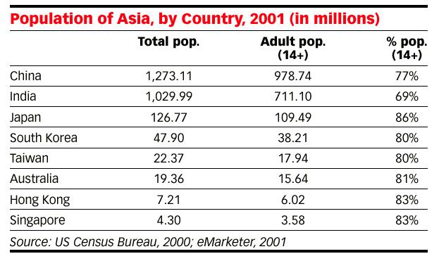China and India, accounting for over two-thirds of Asia’s population will be the biggest consumer markets for computers as the Internet continues to mature. Although Japan comes third in terms of population, it is currently Asia’s largest Internet market due to high per capita GDP, high standards of education and a population with a penchant for adopting high-tech gadgetry. As with South Korea, at fourth, it is a flourishing Internet market with a strong preference for broadband access backed by a proactive government that heavily promotes the Internet as a medium for economic growth.

Internet Population

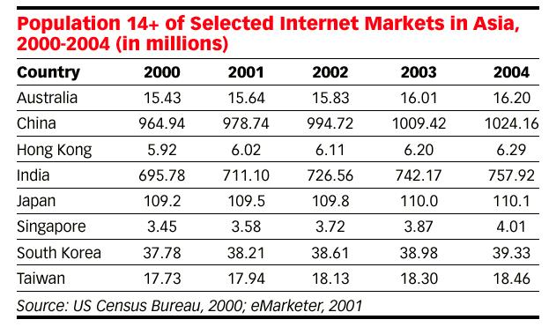
Here we define Internet users as those aged 14 and over (not the total population) going online at least once a week for at least 1 hour per week. Using this definition, the total number of Internet users in Asia is set to grow dramatically over the next several years. According to eMarketer, the total number of active adult Internet users in Asia will rise to 63.8 million in 2001. The number of online users will jump to 173 million by the end of 2004. The latest data from the ITU showed that South Korea, Australia and Singapore are among the Asian countries that rank in the top 10 in terms of Internet penetration on a worldwide basis.

Asia Internet Population Demographics

Gender

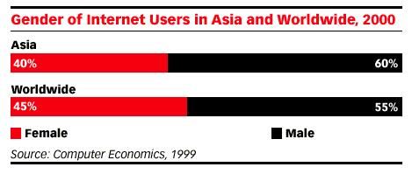
In Asia, men make up the majority of online users. However, this number is changing; according to a recent survey conducted by Internet Metrix, one out of three women are now surfing the internet in South Korea, which seems a trend throughout Asia. It is likely that the gender imbalance that characterized the early

development of internet users in Asia will, as is happening with many other regions, gradually give way to increasing gender parity.

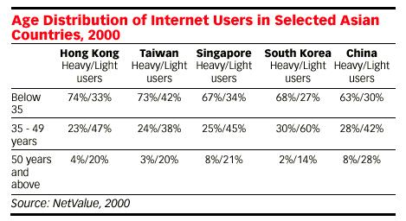

Age and Occupations

Data from the market research firm NetValue point to a strong correlation between intensity of use and age among Asian internet users. Heavy users tend to be under the age of 35. Of the five countries surveyed, Hong Kong, at 74%, has the highest percentage of heavy users under the age of 35. Meanwhile, internet users over 50 years of age in all five countries tend to surf only occasionally.
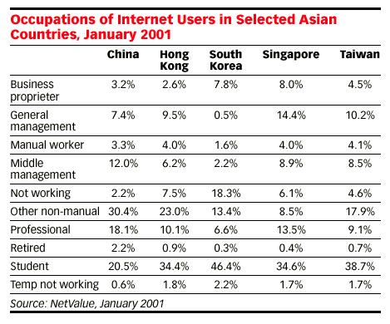

Furthermore, the data also found that internet usage tends to be dominated by students. The high percentage of young internet surfers in Asia points to the tremendous popularity of online games and chatrooms in Asia.

Usage Patterns

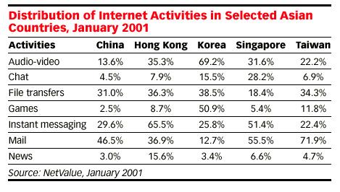
Internet usage patterns were found to directly relate to a country’s users’ level of sophistication as well as the technology currently available. For instance, e-mail is the most popular activity among Internet users in China. Streaming audio-video and online games, which depend largely on broadband access to create a satisfactory experience, rank relatively low with Chinese users. On the other hand, South Koreans are recognized to be among the most sophisticated web users in the world, and broadband access is also widely available in the country. Thus, streaming audio-video and online games are among the most popular form of online activities in that nation.

Digital Delivery E-Commerce

Simply establishing a presence on the Internet does not guarantee that a business will succeed. Building brand awareness through advertising and marketing is critical to success in a new and rapidly evolving market, particularly on the Internet where consumers have the choice of spending their time and money at thousands of different sites. This brand awareness now needs to learn to reach across the globe as digital delivery products and services become more predominant in the online marketplace. This is something many digital businesses have not yet realized their products potential to do, and the potential international market that awaits them.

Developments in digital delivery products (& services) not only dissolve storage and distribution costs by making a business and it products completely digital, they make them available to anyone around the world connected to the Internet. The possibilities of a digital delivery product mean the consumers the world over can access their product in the same way online, so businesses are able to service customers worldwide. If technology and consumer preference continues to evolve so that consumers can access and navigate the Internet faster, more efficiently and more conveniently, the only final barrier for digital delivery commerce is consumer confidence. This will come with more human like interfaces, simpler operating systems and greater IT coherence within communities. Many (especially older) consumers still are grappling with the idea of “Nothing to take home, hold, feel, where’s the value, for the money they have given?” Then again with a completely digital service, they will pay in “digital money” (or using a credit card/ online billing system). So do they still feel the value in loosing that as much as hanging over cash at a regular store?

Basically, the technology is available in most instances but most consumers are not yet ready to make that leap into a completely digital medium. (And some businesses have not yet recognized some of those consumers who ARE ready to). Even with such possibilities within their medium and a willing consumer group, most businesses are only targeting, and making their products & services available in the USA/UK. Although some sites (such as PayPal- see pg18) do target and make their services available to Asian consumers, most do not realize nor exploit the potential of their Asian market.

Consumers are not the only ones still familiarizing themselves with new online technologies. Many businesses do not yet have the confidence in their own technology, or international market knowledge to throw their net any wider. Because of this they believe the consumer doesn’t have the confidence yet either, so wont bother marketing their product to them.

When analyzing digital delivery e-commerce we have a slightly different market to work with, rather than the straight “online business” leaders. PC Magazine defines e-businesses in the categories of Travel, Advice, B2B, Financial services, Entertainment, Recruitment, Publishing, Shopping, Education, IT services as leaders in online commerce. These categories however (at the moment) do not all lend themselves to digital delivery, so in narrowing these results we find the most successful digital delivery online businesses to be Travel, Lifestyle, Music/Video and Finance. In these particular areas, not only are digital services possible and available, they are thriving, and set to keep doing better and better as more and more consumers take that leap and their confidence in online commerce (and especially digital delivery) grows.

According to the National Retail Federation and Forrester Research, total spending on online sales increased from $3.4 billion in February to $3.5 billion in March 2001. The Boston Consulting group also says that this figure will grow from $3.4 billion to $168 billion by 2005. From this we can tell online business is a rapidly evolving market, and it’s full potential is yet to be realized by many e-businesses.

Following are a group of e-businesses with a great service, who are yet to throw that net to the Asian market, but have the potential to do very well if they did so.

Travel

According to Nielsen/Harris Interactive, travel spending accounted for over half of the growth in online retail spending in 2001, earning more than one billion dollars and holding 58.5% of the market, with web leisure travel spending climbing in 2002 to $20.4 billion, only 5 percent less than initially forecasted (pre September 11th)

An estimated 66 percent of online consumers have used the Web to research and/or book travel online. This forecast projects that nearly 10 percent of the U.S. travel market will be booking online by 2003. (Jupiter)

Two-thirds of the 90 million travelers who are online - more than 59 million - used the Internet to make travel plans in 2000. Among online frequent travelers, 69 percent use the Internet for travel planning. (Travel Industry Association)

Of travel products/services purchased online in 2000, 82 percent of travelers bought airline tickets (20 million people), 60 percent booked hotel accommodations (15 million people), 45 percent booked rental cars and 31 percent theater tickets (Travel Industry Association)

During 2000, spending by U.S. resident and international travelers in the United States averaged $1.53 billion a day, $64 million an hour -- this translates to $1.1 million a minute, and $17,695 a second. (Travel Industry Association)

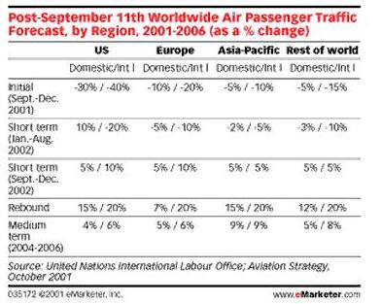

Despite the drop in travel figures since the September 11th disaster the U.S. after a small dip in the industry as a while, the online travel industry is again thriving, and as stated in the statistics above, set to continue to soar. Travel is clearly in the top-spending category online and also lends itself to an effective & efficient digital delivery product/service. The following site recommendations are companies leading in the market and offering a very popular and organized service.

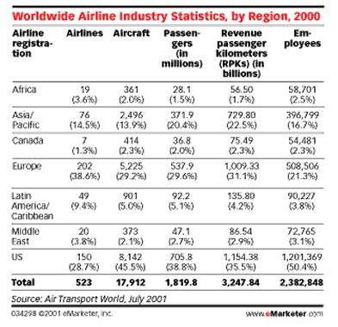

Within Asia’s population of over 3.5 billion people, 371.9 million traveled in 2000. Being over 20% of the international market, traveling already, and the number of Internet users set to jump to 173 million by the end of 2004, the online travel industry is a huge growing potential market in Asia.


Expedia.com

“The fastest-growing, most highly-praised travel site on the Web.”

“Since our launch in October 1996, Expedia.com has grown into the leading online travel service by ensuring customers don't just travel but travel right. In addition to the U.S., Expedia is available in Canada, Germany, and the UK. With a host of integrated services for suppliers and customers, and an exceptional level of customer service support. We're one of the top 75 most-visited sites on the Web, with 11,187,000 unique visitors in January 2002 alone.”

– Expedia Website

"Expedia's well-organized home page makes it easy to book planes, cars, and hotels for your vacation or business trip...And if you're not sure where you want to go, Expedia.com offers vacation ideas, packages, and all sorts of information from travel news to driving directions to 360-degree virtual tours to help you make the most of your vacation time."

--Catherine Geistkemper, Smart Computing, Oct., 2001.

Purchasing on Expedia
You can make hotel and car reservations on any Expedia site, even if your country is not listed. The same is true for car reservations, which you can make on the U.S., Canada, Germany, and UK sites. However, air tickets and packages are only available to residents of the United States, Canada, Germany, and the United Kingdom. Expedia has sites for the U.S., Canada, Germany, the U.K., France, the Netherlands and Italy, but none in Asia Pacific.

Audience
According to @plan winter 2001, Expedia customers are 64 percent more likely to have purchased something online in the last 30 days than average Web users. Expedia categorizes their customers by destination preference or travel interests, noting their average user is well educated with a high discretionary income and a mean age of 41.
Male
Female
Female Singlegle
Married

Reach

11,187,000 unique users, January 2002

10.5% World Wide Web reach

One of top 75 most-visited Web sites

Contact/Customer Support:

Expedia have customer service available 24 hours a day, 7 days a week to answer e-mail and phone calls. Customer Service email support is provided by a web-submitted form & guaranteed 25 hour return.
Customer Service Phone: 1 (800) EXPEDIA [1 (800) 397-3342] or 1 (404) 728-8787.

Publicist E-mail: publicst@expedia.com.

Marketing E-mail: travsup@expedia.com

Expedia, Inc.
13810 SE Eastgate Way, Suite 400
Bellevue, WA 98005

Orbitz.com – http://www.orbitz.com

Service

Created by the World's Leading Airlines & designed with the traveler in mind, Orbitz claims to give you “access to the most low airfares on the Internet, plus great values on rental cars, hotel rooms, and more” and:

The most available fares from over 450 airlines. No scavenger hunts.

Scans more than two billion possibilities in seconds with our advanced search engine.

The most airline Web-only fares in the business.

Features

Orbitz emphasizes its Superior customer care before, during and after the trip, and this is shown in their “Travel Alerts program. “Traveller Alerts, staying in touch throughout the process - with alerts when weather or gates change, with local destination information and with automated confirmations 48 hours and 3 hours before departure.”

Contact

Email: info@orbitz.com

Address: Orbitz
200 South Wacker Drive,
Suite 1900
Chicago IL 60606

Phone: 312-894-5000

Fax: 312-894-5001

Lifestyle

Lifestyle is perhaps the most diverse category of online business. With services available from dieting to sports coaching, parenting to painting and fitness to flamenco dancing directories, theres a world of choices out there. Among these interests, most have web presences, even less have paid services, and even less have digital delivery services. In this category, the most out standing area is health and fitness, followed by cooking and parenting.

Some interesting and popular (free) Lifestyle Service sites are:

http://www.soccerclinics.com/
http://www.dancetv.com/



Cooks Illustrated - http://www.cooksillustrated.com/

“Cooksillustrated.com, brought to you by the editors of Cook's Illustrated magazine, is the Web's most trusted source for cooking information. From cooking techniques and recipes to food tastings and equipment ratings, we provide you with the results of thorough and meticulous tests that show you what works best and why.”

Service:

Cook’s Illusrated branched from a bi monthly print cooking magazine in the U.S. to a TV show, an internationally circulated magazine and a comprehensive subscription based website. They are based on understanding the techniques and principles of good home cooking, with a huge database of recipes and ratings of cookware & taste-tests on food products such as flour, coffee, and soy sauce. The publication takes no advertising..

Rates:

Web site subscription rates:

Yearly: $24.95

Monthly: $3.95

Cook's Illustrated magazine subscribers:

$19.95 (Yearly)

If you already subscribe to Cook's Illustrated magazine, you will receive a 20 percent discount on your subscription to the Web site.

Contact:

Boston Common Press, publisher of Cook's Illustrated, is a fast growing publishing company conveniently located on the MBTA Green Line in Brookline Village.

Website enquiries: CooksOnline@bcpress.com.

webmaster@bcpress.com

Address: Boston Common Press
Web Master
17 Station St.
Brookline, MA. 02445

Phone: 617-232-1000


E-diets.com –http://www.ediets.com

Company Overview
eDiets.com claim to offer the most all-inclusive weight-loss and diet services within the marketplace, while providing an interactive community for our members which they utilize to improve and maintain a better overall lifestyle, whilst focusing on personalization, convenience and privacy. They are the largest subscription-based online diet, fitness and counseling network with upwards of 300,000 paid members throughout the fourth quarter of 2001. In addition, eDiets.com publishes one of the Internet's most popular bi-weekly diet and fitness email newsletters, (eDiets Diet & Fitness News,)which is delivered to a community of more than 10 millionsubscribers.

Service
With corporate headquarters in Deerfield Beach, Florida, eDiets.com offers online subscription-based weight-loss programs using proprietary created using personalized software. For a monthly fee, eDiets.com creates custom diet based on a personal profile. To date, millions of consumers have completed the eDiets.com personal profile.

Features

Customized weekly menus, recipes and grocery shopping lists, interactive tools, online meetings, support boards, chats, fitness tips, professional advice. eDiets.com’s management team consists of licensed dietitians and psychologists, an experienced technical staff, and a seasoned corporate organization.

Acheivements

eDiets.com has been honored with the Forbes "Best of the Web" 2000 rating for the fitness and nutrition category by Forbes magazine. Nielsen//NetRatings consistently ranks eDiets.com as an Internet leader for percentage of female viewers and, according to the Boston Globe, in December 2001 ranked eDiets.com as the 2nd "most visited "Health and Family" site on the Internet with a 0.6% reach."

Contact

Address: eDiets.com
3467 W. Hillsboro Blvd., Suite 2
Deerfield Beach, Florida 33442

E-mail: http://www.ediets.com/company/contact.cfm

There is a web based feedback/contact form at this address.

(EDiets.com also has a UK based site.)

Phone: Toll-Free: (800) 265-6170

Local: (954) 360-9022

Fax: (800) 804-3595



Global Health and Fitness – http://www.global-fitness.com

“The very best online fitness program to help you reach all your fitness goals. Whether you are a beginner or advanced, we'll help you avoid the common mistakes that waste your time, teach you techniques for making your routine much more effective, and guide you step-by-step to achieving new results again and again! Move your cursor over each photo below for more information on each of the 5 Components of Optimal Health. “

Global Health and Fitness sell themselves on their ability to personalize to each individual customer’s need in an easy to follow format. “When a new member joins, GHF develops a personalized exercise and nutrition program that's specific to fitness level, including any limitations, and goals and preferences, taking into consideration their available time and equipment. They give emphasis that their program implements all five important components of fitness: Strength Training, Weight Management, Cardiovascular Exercise, Nutrition, and Flexibility Training, rather than focusing on one particular aspect as most programs do. An important feature of their program is also their on-going support to keep patrons enthusiasm up whilst using the program and they claim that there is nothing else on the market like GHF, the reason for their near 20,000 members worldwide.

Site Features

Fitness experts/opinions - qualified experts (ranging from fields of expertise from Dietetics, Fitness, Lifestyle, Chiropractic, Stress, Marathon and Medicine) answer all members health and fitness questions & they develop a personalized program for every new member.

Diet advice – as an add-on to the basic fitness program, GNH offers their “Perfect Diet” program, a personalized eating plan/ program for new members.

Motivation - 22% of people site lack of motivation as the reason for not achieving their fitness goals. GHF provides success stories, Advice from motivational experts, “Motivational boot camp” provided through Tele-training (is live, interactive training classes conducted over the telephone) and the Fitness Challenge (a competition every 12 weeks for the most improved member).

FAQ: GHF address the fact that this is new concept, and people may be skeptical, and so emphasizes then availability of their within 24hr help/reply system.

Users

Around 20,000

Cost
US$59.99 per year.
The Perfect Diet program is an additional US$39.99 or US$69.99 for non-members of GHF.

Conact

Address: Global health and fitness
P.O. Box 2696
Clackamas, OR 97015-2696

Phone: 503-772-4299

Email: info@globalfitness.com

Music/Video

Today's battle over on-line music is the beginning of a much larger war in software, images, and movies. Rebellious downloaders will drive media empires into accommodating their desire for digital content. At present only a very small number of sites are road testing pay-per view video content and it hasn’t really made that leap into the public market at this stage.

Some sites toying with this concept at the moment are:

http://www.liketelevision.com/

http://www.adventuretv.com/

Music on demand however, has been around for a while now. Although most providers are still in the teething stages, they are doing really well and are set to become bigger and bigger as they get older and the public becomes more comfortable with the idea of downloading a track, rather than going into a record store and buying it.

Within asia, the market for a growing technology like this is growing just as fast. Although Japan comes third in terms of population, it is currently Asia’s largest Internet market due to high per capita GDP, high standards of education and a population with a penchant for adopting high-tech gadgetry. As with South Korea, at fourth, it is a flourishing Internet market with a strong preference for broadband access backed by a proactive government that heavily promotes the Internet as a medium for economic growth. In particularly, new products and developments in mp3, MD, memory stick, and such are gathering huge interest in Asia, and so as this continues, as will interests in music in the appropriate mediums to use these products.

Some other leading subscriber-based music download sites not profiled here are:

http://www.music.net

http://www.napster.com

http://www.listen.com


Emusic.com – http://www.emusic.com

EMusic is the world’s most popular MP3 music subscription service with more than. EMusic’s innovative service offers avid music fans. In July of 1998, EMusic became the first commercial site to begin selling singles and albums in the popular MP3 format. In the Fall of 2000, EMusic became the first company to launch a downloadable music subscription service. They also provide EMusic weekly email updates which provide genre-specific guidance on new releases, editorial picks and featured mixes.

Subscribers

Over 35,000 paying subscribers

Service

Unlike other subscription services that put strict limits on how and where subscribers can listen to music, EMusic offers flexible usage that allow users complete flexibility. All EMusic’s tracks are in the industry standard MP3 format and subscribers are encouraged to make multiple copies for personal use. Subscribers own the music they download, even if they cancel their subscription, subscribers keep the MP3s they downloaded through the service. EMusic’s service includes over 200,000 songs in every genre from 900 worldwide independent music labels and their monthly updated catalog constantly expanding with new albums, artists and labels added.

Price

Commit to a minimum of 12 months and get EMusic for $9.99 per month
Commit to a minimum of 3 months and get EMusic for $14.99 per month

For this one monthly fee users can download unlimited MP3 files from the site (at less than the cost of one CD.)
Contact
Address: 1991 Broadway, 2nd Fl.
Redwood City, CA 94063
Phone: 650-216-0200
Fax: 650-556-9712
Email: info@emusic.com


Pressplay - http://pressplay.com/

“pressplay is an online music service company led by an executive team with deep music, programming, technology and business experience with offices in Los Angeles and New York City. pressplay is an equally held venture of Sony Music Entertainment and Universal Music Group. “

Service
pressplay offers consumers on-demand access to a wide variety of music that can be streamed, downloaded or burned onto a CD, through affiliates that currently include MSN Music, Yahoo!, MP3.com and Roxio. Members have access to one of the largest online music catalogs, which is constantly growing & features tracks from the world's three largest record companies - Sony, Universal and EMI - as well as many independent labels, including Jive, Madacy, Matador, Navarre, OWIE (Orchard Wireless Interactive Entertainment), Razor & Tie, Roadrunner, Rounder, Sanctuary and TVT. They seem to be fairly now and are haven’t given any user numbers.

Price

Pressplay offers a free14-day trial subscription to help new members get started. They have 3 pricing plans ranging from US$9.95 to US$24.95 per month, each offering different amounts of music per month.

Contact

Address: New York
619 W. 54th St.
New York, NY 10019
Los Angeles
9044 Melrose Ave.
Los Angeles, CA 90069

Email: Media Inquiries
media@pressplay.com
Business Development
businessdevelopment@pressplay.com
General
contact@pressplay.com

Finance

Finance as an online business can be very diverse, but also often very localized. This is usually because consumers don’t feel comfortable sending their money too far away and prefer to see more solid, rather than digital transactions. The available finace services online include Insurance, Loans, Banking, Share Trading and just about any financial at all.

Some popular online finance businesses are:
https://quickenloans.quicken.com/
http://www.esurance.com/
http://netbank.com/



Paypal –http://www.paypal.com

Paypal has become the leading payment network for online auction websites, including eBay. PayPal and is also being increasingly used at other e-commerce sites, for the sale of goods such as electronics and household items, the sale of services such as web design and travel, and the sale of digital content. Offline businesses, including lawyers, contractors and physicians, have increasingly begun to receive payments online through PayPal. PayPal's service, which lets users send payments for free, can be used from PCs or Web-enabled mobile phones.

Service

PayPal enables any business or consumer with an email address to securely, conveniently, and cost-effectively send and receive payments online. The network builds on the existing financial infrastructure of bank accounts and credit cards to create a global, real-time payment solution. The product is ideally suited for small businesses, online merchants, individuals and others currently underserved by traditional payment mechanisms. Paltalk is fast becoming the global standard for online payments. With services already offered in 37 countries including some Asian.

Users

Over12 million registered users, including more than 2.2 million business accounts. Their Account base is growing by an average of 18,000 accounts per day, with virtually no traditional sales or marketing.

International Use.

To be eligible for an account, you must be a resident of the United States or one of the approved countries. Asia Pacific approved countries include Australia, China, Hong Kong, India, Japan, New Zealand, Singapore, South Korea and Taiwan. International Users, unlike U.S. Users, must pay fees for moving funds into the Service and for withdrawing funds from the Service. All fees, and all transactions, are made in U.S. dollars, may be subject to exchange rates and are dispayed in US dollars in users accounts. International Users in some countries may not use the Service to receive payments, and may only use the Service to send payments.

International Fees

Sending Funds
Source of Funds  Contact:  Address: PayPal  P.O. Box 45950  Omaha, NE 68145  Other than this address, paypal only provide a contact option via a web submitted form, which is accessible through the “Contact us” section on their website. | Fee
PayPal Balance Payment | Free
Non-PayPal Balance Payment | 2.6% + 30¢

Receiving Payments
Account Type | Fee
Premier or Business - Standard Rate | 2.9% + 30¢
Premier or Business - Merchant Rate | 2.2% + 30¢
Personal | Free

* eCheck payments have a maximum fee of $5.

* Personal Accounts are limited to receiving

non-credit card funded payments.

PayPal only charges Premier and Business

accounts to receive payments. Fees are

the same for receiving international payments.

Summary

There are many successful and popular digital delivery business thriving currently in the market, these have been a selection of ones highly suited to an Asian market, but not yet availed to it.

Following is a glossary of recommended sites, and similar interesting ones in the market.

Travel

http://www.expedia.com

http://www.orbitz.com

http://www.travelocity.com

Lifestyle

http://www.ediets.com

http://www.glogal-fitness.com

http://www.cooksillustrated.com

http://www.soccerclinics.com/
http://www.dancetv.com/

Music

http://www.emusic.com

http://www.pressplay.com

http://www.music.net

http://www.napster.com

http://www.listen.com

http://www.liketelevision.com/

http://www.adventuretv.com/

Finance

http://www.paypal.com

https://quickenloans.quicken.com/

http://www.esurance.com/

http://netbank.com/

