Dear Prospective Employer,

Attached is my personal resume for review and consideration for a position with your company that would best fit my skills, education, and experience.

As you may note from my resume, I have several skills and knowledge of numerous software packages. I am very efficient with Windows and the Microsoft suites such as Word, Excel, Access, PowerPoint, Outlook and Microsoft Publisher). I am also skilled in using Word Perfect, PageMaker, Adobe Acrobat, Lotus Notes, and various desktop publishing programs as well. I have also acquired skills doing bookkeeping in A/P, A/R and Computerized Payroll.

Having great knowledge and experienced with spreadsheets (Excel, Lotus, Quattro Pro), my skills include designing and maintaining of databases (Access, Fox Pro, and File Maker Pro), using tables, forms, queries, and macros, table relations and implementing of charts, graphics, and pivot tables to produce needed reports.

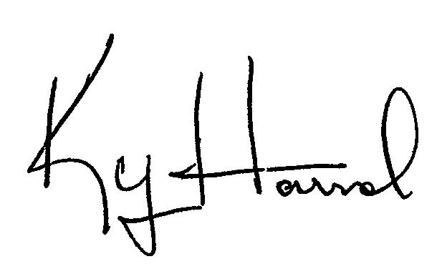
Serving in the military, I have a background in Personnel Administration. Doing a lot of contract work, I have worked on several government contracts offering administrative support to military staff, contract members, and customers. My skills vary from Administrative Support for correspondence, briefs, meetings, event coordination, travel arrangements, orders, budgets, expenses, and other duties as required. Having knowledge of regulations and procedures in a military environment, my background includes some technical support to help desk giving instructional classes and training for various software packages.

I have held key positions which I have outlined in my resume and I believe qualify me for a position and provide valuable service to you and your company. My salary range is from 49,750 to 55,750 but negotiable.

I would like to thank you for your time and any consideration of my qualifications. I am looking forward to meeting with you to discuss any current or future employment opportunities you may have to offer. I am available to meet with you at your convenience to discuss my qualifications. Any consideration for employment will be greatly appreciated.

Sincerely,

Mr Ky Harral
1236 S Taylor St #A
Arlington VA 22204-3721
Ph: 202-536-5298
Fx: 202-403-3797
ky@harral.org

