Welcome Class!

Today in Algebra 1 we will be going on a virtual field trip to Ancient Egypt!! So pack your bags and get into groups of two or three. First on our agenda is, of course, the
Great Pyramids of Giza.

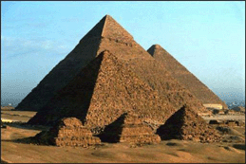
http://mmmgroup.altervista.org/giza1.JPG

Problem 1: Calculating the perimeter around the great pyramid of Khufu (or Cheops)

If the length of the base of the pyramid of Khufu is x, express the perimeter (the total length around the square base) algebraically. Do a Google search to find the length along one side of Khufu's base. Then plug this into your formula to find the perimeter around Khufu. Show your work! Try running laps around that!

Next to the pyramids lies the Nile River whose source comes from the heart of Africa.

http://www.mbarron.net/Nile/bestmap.jpg

Problem 2: Calculating the length of a round trip on the Nile River

If the length of the Nile River is y, express the length of a round trip by boat in terms of y. Do a search to find the length of the Nile. Then find the actual length of a "round trip" on the Nile by putting this into your formula.

Next up, we will visit Amenhotep and Tutenkhamen (otherwise known as King Tut).

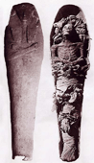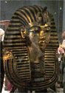

Amenhotep (above left): http://anubis4_2000.tripod.com/subpics1/AmenhotepIIcoffin.jpg

Tutenkhamen (above right): http://jackmaryetc.com/Travel/Other/Egypt/images/Tutenkamen.jpg

Problem 3: Comparing Archeological finds

If Amenhotep was discovered in year x, and Tutenkhamen was discovered in year y, express the difference between the years of discovery in terms of x and y. Do a search for Amenhotep's year of discovery and Tutenkhamen's year of discovery. Given this, find out how many years apart the tombs were discovered from your formula. Again, show your work.

Hieroglyphics was an ancient writing system that had picture-based symbols.

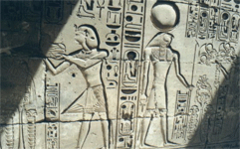
http://www.andypiro.com/images/travel/mideast/heiroglyphics_big.jpg

Problem 4: Comparing Ancient bases to modern ones.

If the Egyptians used base x, and we use base 10, express the difference between the Egyptian base and our base. Do a search for an Egyptian base system. Use the expression to find the difference between their base and ours.

Last but not least is the Great Sphinx!

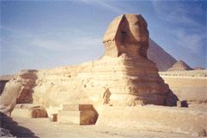
http://www.astro.utoronto.ca/~yao/egypt1999/sphinx.gif

Problem 5: Calculating the perimeter around the Sphinx

If the width of the Great Sphinx was m and the length of the Great Sphinx was n then express the perimeter algebraically in terms of m and n. Do a search for the length and width of the base of the Sphinx. Then find the total distance around the Sphinx from your formula.
--------------------------------------------------------------
To help with your searches, try these sites:

http://www.infinitetechnologies.co.za/articles/thegreatpyramid.html

http://en.wikipedia.org/wiki/Ancient_Egypt

http://www.ancientegypt.co.uk/menu.html

http://www.carnegiemnh.org/exhibits/egypt/

http://www.historychannel.com

http://www.google.com

