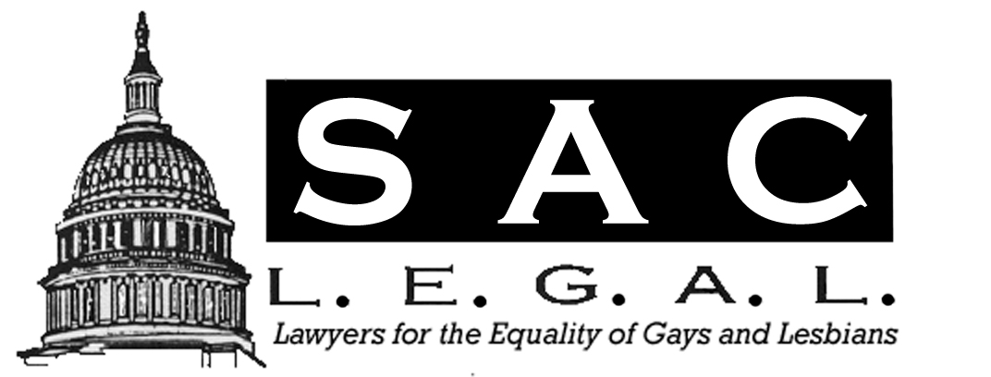
Newsletter
March / April 2002

Playing By the Rules: Baseball as a Microcosm of American Society
By Marc B. Koenigsberg

Three strikes and you’re out. Period. No argument. Three outs and the other team gets a chance up at bat. Period. No argument. “Baseball, our national pastime, is a microcosm of American society. A game of rules; a government of laws. When a team plays by the rules and team members put forth their best effort for personal achievement and the good of the team, those rules of the game help the team to succeed. When society, as a whole, and citizens, individually, obey and uphold the law of the land, success and prosperity follow, and freedom, on a level playing field, is assured.” (Short Outline of the Playing by the Rules Project, November 27, 2001).
Executive Vice President Bob Hemond of the Sacramento River Cats and Associate Justice George Nicholson of California’s Third District Court of Appeal co-chair an advisory committee
Continued on page2
Playing by The Rules
Continued from page1
made up of a “who’s who” in the Sacramento business and legal communities toward the goal of establishing a project that will be a prototype for the nation. The project is called, “Playing by the Rules.”
“‘Playing by the Rules,’ undertaken by the Sacramento River Cats, in cooperation with the courts and government as well as elements of the various communities in the Greater Sacramento Region, [is designed] to promote the development of character, citizenship, service and patriotism among young people. This coordinated effort will utilize the history, culture, stories and heroes of baseball as exemplars and focal points for discussion and education. Ultimately, the project will be offered for possible replication to the remainder of the nation’s 195 major and minor league teams.”
The project’s objectives are to encourage youth to play by the rules of the game, in the game of baseball and the game of life; to educate youth about selfless service, an essential ingredient in promoting citizenship and public service; and recognizing and rewarding young people around the country who exemplify the qualities of good citizenship and character.
The program’s activities will include developing curricular and program materials highlighting the connection between baseball, American history and respect for law, through educational modules emphasizing reading and math skills. Activities will also include multi-media public service announcements utilizing law- and baseball-related figures; establishing and administering a “Presidential Character” Award program (similar to the President’s Physical Fitness Award program); and establishing, promoting and assisting in the administration of a “Baseball Telementoring” project where past and present professional and amateur baseball players and coaches, lawyers,
Continued in next column
Playing by The Rules
judges and legal educators, and others, mentor America’s young people via the Internet.
Playing by the Rules promises to be an inspirational and worthwhile project for all who participate in it. For more information, visit http://www.playingbytherules.org/.

Note from the Co-Chair
By Dianne Robbins
Greetings Members:

It’s springtime, and you know what that means. . . It’s time for our annual Spring Membership Mixer, April 18th from 5:30 to 7:30, which is definitely not to be missed! Founding member Larry Levine has graciously offered to host our event this year. We will be featuring the culinary stylings of our very own Jay Kirkman.
We are happy to report 45 paid members for the year. For those of you who have renewed your memberships, a big Thank You from your Board of Directors. Your continuing membership is truly what keeps Sac L.E.G.A.L. going. For those of you who have not renewed, the Membership Mixer will be your last chance. So bring those checkbooks! We have another exciting year planned, and don’t want anyone to miss out.
We are looking forward to seeing everyone on April 18th.

Upcoming Events
April 18, 2002
Spring Membership Mixer
Home of Professor Larry Levine
2426 H Street
5:30 p.m. to 7:30 p.m.

September 12, 2002
2nd Annual Joint NCLR &
Lambda Legal Defense Fundraiser
Location and time to be announced
Inside This Issue
1 | Playing by the rules
1 | Note from the Co-Chair
1 | UPCOMMING EVENTS
2 | TOLERANCE THROUGH EDUCATION
3 | SAME SEX PARENT ADOPTIONS

TOLERANCE THROUGH EDUCATION

“The Scarlet Professor,” a book by Northampton author Barry Werth about the dismissal of two gay Smith College professors over forty years ago, caused a recent stir in the Ivy League. In 1960, Edward Spofford and Joel Dorius were dismissed from their teaching positions after being convicted of possessing pornography. A third professor - Newton Arvin - was allowed to retire after being convicted of the same crime. All three were exonerated by Massachusetts’ highest court in 1963.
The release of Werth’s book prompted Smith College to create the Dorius/Spofford Fund for the Study of Civil Liberties and Freedom of Expression, a $100,000 fund for lectures, research and programs on civil liberties, as well as a $500 annual scholarship in American Studies in honor of Newton Arvin.
Closer to home, California State University, Stanislaus, now has its first gay and lesbian studies course: Gender and Sexuality Through Literature. Professor Renny Christopher, who created the new class, believes people need to be educated on the presence and legitimacy of gays and lesbians, and the need for equal rights.
Getting people to “talk about it,” especially in an academic setting, is one of the most powerful methods of increasing tolerance for gay and lesbian people. Please consider taking an hour out of your day to speak to local young people on legal issues or tolerance and equality. The 4th and 5th R’s Program still needs volunteers for this semester. Also, please see the announcement for Awareness Week at McClatchy High School April 8th and 9th.

American Academy of Pediatrics Supports Same-Sex Second Parent Adoptions
By K.C. King

In the February 2002 edition of Pediatrics, the American Academy of Pediatrics (AAP) recommended the legal recognition of same-sex second-parents or co-parents. Stressing that children deserve the security and benefits of two legally recognized parents, the article, entitled “Co-Parent or Second-Parent Adoption by Same-Sex Parents,” makes clear AAP’s position to support legislation and litigation to “provide the possibility of adoption of the child by the second parent or co-parent.” The study finds that in general, children benefit from having two loving and supportive parents, regardless of their sexuality.
In the same issue of Pediatrics, the AAP published a technical report detailing multiple studies of parenting by same-sex couples. Evidence from the studies shows that “there is no systematic difference between gay and non-gay parents in emotional health, parenting skills, and attitudes toward parenting.” The study found that family processes, regardless of parental sexuality, are the primary factors that affect children’s behavior. Children are usually well adjusted when parents are more satisfied with their partners, when there are higher levels of love in the household, and when parents fight less. Children in families with higher levels of domestic conflict however, consistently exhibit increased behavioral problems. In general, parents and children were more successful when parenting and household tasks were divided evenly. The report concluded, “parents’ sexual orientation is not a variable that, in itself, predicts their ability to provide a home environment that supports children’s development.”
The AAP states that the legal sanction of co-parent adoption guarantees their custody rights and responsibilities should one parent die or become incapacitated; protects the child’s right to a legally recognized relationship with both parents; ensures child support payments and custody/visitation rights from both parents if the couple separates; permits either parent to give consent for medical treatment and school decisions, and allows for access to entitlements, like Social Security, which would protect the child’s financial well-being.
To help same-sex parents, the AAP suggests that pediatricians familiarize themselves with professional literature about gay and lesbian families, support the right of every child to have legally recognized parents, and advocate for initiatives that legalize co-parent and second-parent adoptions.

References:
1. Committee on Psychosocial Aspects of Child and Family Health, Co-parent or Second-Parent Adoption by Same-Sex Parents, 109 Pediatrics 339 (2002).

2. Ellen C. Perrin, M.D., Technical Report: Co-parent or Second-Parent Adoption by Same-Sex Parents, 109 Pediatrics 341 (2002).

ANNOUNCEMENTS

Workers Comp Defense Position Available in Stockton
The firm of Grancell, Lebovitz, Stander, Marx & Barnes, is looking for a full time attorney for the firm's Workers' Comp Defense practice in Stockton, CA. If you, or anyone you know is interested, send a resume to: Tuen Wong, Managing Attorney email: TWong@glsmb.com
Phone (209)472-3660, FAX (209)472-3661 The firm's web page is: www.glsmb.com

ANNOUNCEMENTS

Workers Comp Defense Position Available in Stockton
The firm of Grancell, Lebovitz, Stander, Marx & Barnes, is looking for a full time attorney for the firm's Workers' Comp Defense practice in Stockton, CA. If you, or anyone you know is interested, send a resume to: Tuen Wong, Managing Attorney email: TWong@glsmb.com Phone (209)472-3660, FAX (209)472-3661 www.glsmb.com

McClatchy High School Awareness Week
The students in the LGSA group on campus are raising awareness in response to gay bashing occurring on campus and are looking for speakers who can relate personal stories on how they've overcome bigotry or who can discuss the history and law of rights protecting gays and lesbians. The speakers will be in classrooms on April 8th and 9th; from 10:30 to 11:30 and 11:30 to 12:30. If you are able to contribute, please contact Lilly Spitz, Chief Legal Counsel of Calif. Planned Parenthood Ed Fund at (916) 446-5247

