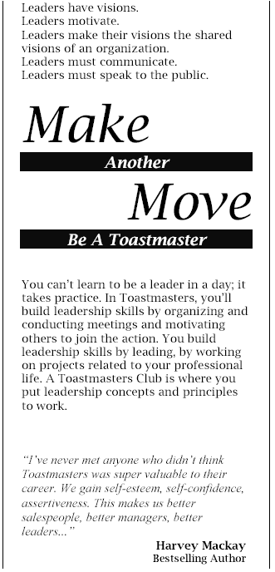

The mission of a Toastmasters Club is to
provide a mutually supportive and positive
learning environment in which every
member has the opportunity to develop
communication and leadership skills, which
in turn foster self-confidence and personal
growth.

A new Toastmasters Club is being built in Plano at the Christopher Parr Library, 6200 Windhaven Parkway, Plano, TX 75093. You are cordially invited to join the new club and hone your leadership and communication skills.

You will not regret this move.

For more information, please contact:



www.geocities.com/westplanoclub
www.toastmasters.org

