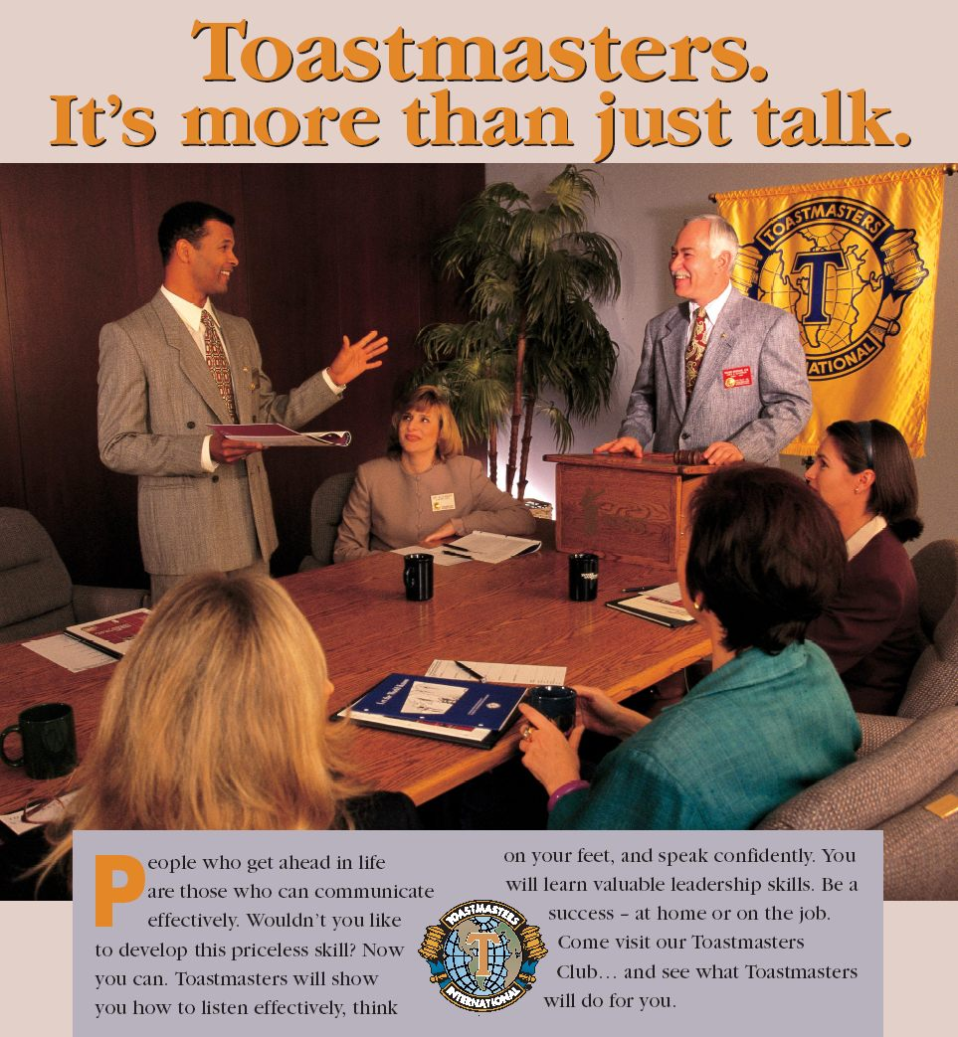

You are cordially invited to join a new Toastmasters Club in Plano.

Christopher Parr Library, 6200 Windhaven Parkway, Plano, TX 75093

For more information, please contact:

