WILD BOAR
Val | Char |  |  |  | Cost |  | 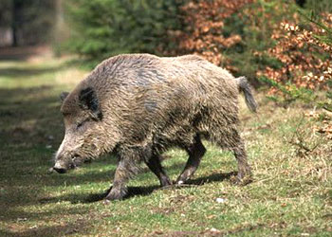
13 | STR |  |  |  | 3
17 | DEX |  |  |  | 21
15 | CON |  |  |  | 10
12 | BODY |  |  |  | 4
5 | INT |  |  |  | -5
5 | EGO |  |  |  | -10
13 | PRE |  |  |  | 3
10 | COM |  |  |  | 0
8 | PD |  |  |  | 5
4 | ED |  |  |  | 1
3 | SPD |  |  |  | 3
8 | REC |  |  |  | 4
30 | END |  |  |  | 0
28 | STUN |  |  |  | 1
Cost |  | Abilities |  |  |  |  |  |  |  |  |  | END
4 |  | 1 pip HKA, reduced penetration (-¼) – bite
12 |  | 1d6 HKA, reduced penetration (-¼) – tusks |  |  |  |  |  |  |  |  |  | 1
3 |  | +2 PD Armor
3 |  | +5 PRE, create fear only (-½)
5 |  | Ultraviolet Vision
8 |  | +4 to smell perception (14-)
8 |  | +4 to hearing perception (14-)
7 |  | Concealment (12-)
15 |  | +3 w/H-to-H combat
50+ |  | Disadvantages
15 |  | Physical Limitation: No fine manipulation
10 |  | Psych Limitation: Bad Temper (Common)
45 |  | Creature Bonus
OCV: 6 |  |  |  | DCV: 6 |  |  |  | ECV: 2 |  | SPD: 3
COSTS |  |  | Char |  |  | Powers |  | Total | Disadv |  | Base
 |  |  | 55 |  |  | + 65 |  | = 120 | - 70 |  | = 50
Hit Location Chart
3d6 |  |  | Loc |  |  | StunX |  | NStun | BodyX |  | CV
3-5 |  |  | Head |  |  | x5 |  | x2 | x2 |  | -8
6-8 |  |  | Forelegs |  |  | x2 |  | x½ | x½ |  | -5
9-14 |  |  | Body |  |  | x3 |  | x1 | x1 |  | -5
15-18 |  |  | Hindlegs |  |  | x2 |  | x½ | x½ |  | -6

