Four short Poems

Ellen Winters

Feeling closed in and cut off from life, I told my
Parents,
Who told me to tell my
Teacher,
Who referred me to my
Guidance Counselor,
Who sent me to the
Assistant Principal,
Who informed the
Principal,
Who said I should go back to my
Teacher,
Who told me to speak to my
Parents.

Norman Moskowitz

My grandfather's picture sits on my desk
While I do my homework.
My father spent money on me.
My grandfather spent time.
As I struggle with trig and other responsibilities
I remember how my grandfather would
Take me for walks in the park,
Explain how a screwball was thrown,
Encourage me to think well of myself.
I really don't want to wrestle with world history,
The gross national product and Nathaniel Hawthorne.
I just want to go to the park with you again, Grandpa.

Dominique Blanco
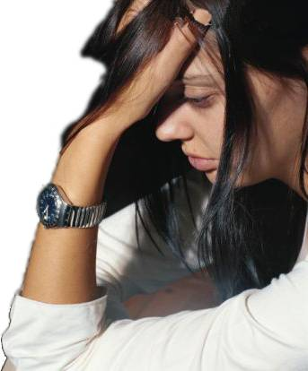
These are supposed to be the best years of my life;
They aren't.
Friends are supposed to be faithful;
They're not.
Teachers are supposed to know how to teach;
They don't.
I have spent four years here on the edge of everything –
Friends, parties, classes –
Rejecting myself before others had the chance to do it.
I can't remember one good time I've had here.
When the yearbook came, I complained to the advisor.
They left out my picture.
It figures.

Charlie Wallinsky

I have a history teacher so old that
When she talks about the Civil War
It's from personal experience.
Her notes are so old
I think they were written on stone tablets.
She never looks up from them.
The printed word protects her from her pupils.
I decided to create a student – Atlin Egors.
If there was homework, I handed in two assignments.
If there was an examination, I handed in two papers.
One day I thought the jig was up.
She peered over her notes and asked for Atlin Egors.
I said quickly he had just left;
He wasn't feeling well.
She said, "Tell him his paper on witchcraft was superb."
I said, "Sure thing."
She went back to her notes, never to emerge again.
I sat back in my seat, smiling like the Cheshire cat.




