FRIENDS of WICKEN WINDMILL ASSOCIATION
Newsletter 3 Winter 2008 – 9

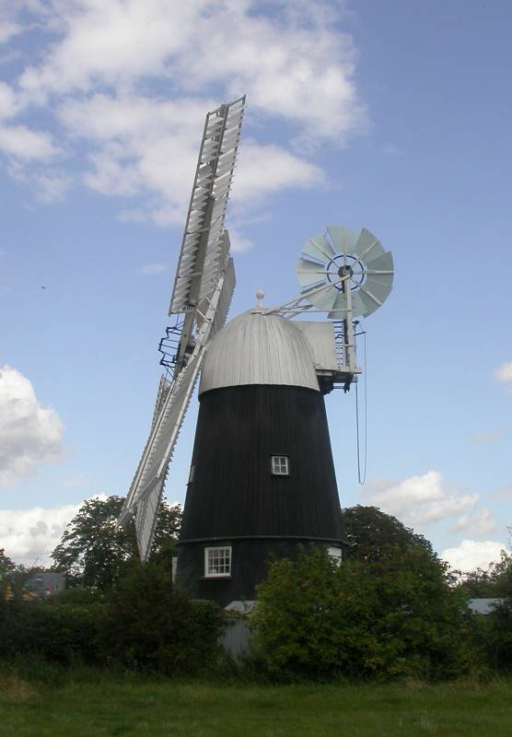
Before the work-in, August 2008 Photo: D.L. Pearce

PAINTING THE SAILS FROM THE ‘CHERRY PICKER’

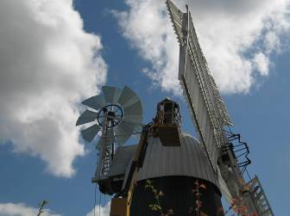
Manoeuvring into position Photo: R.W.D. Sharp

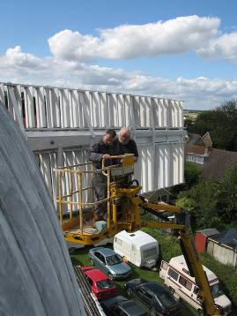
Dominic Grixti and Dave Pearce Photo: R.W.D. Sharp

2008 has been a very busy year at the mill, and 2009 promises to be every bit as busy,

In August we hired a ‘cherry picker’, or mobile hydraulic lifting platform for five days. This was used to hoist our volunteer millwrights up to the level of the sail hub, so that we could paint the rear faces of the sails:

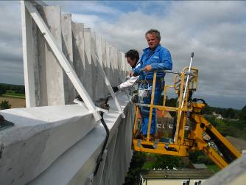Mary Newland and Tony Ward painting the leading face of a sail stock Photo: R.W.D. Sharp

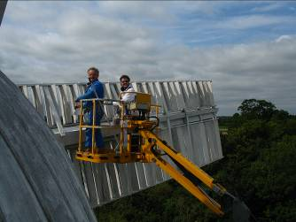
Tony and Mary from the fan stage Photo: R.W.D. Sharp

these are notoriously difficult to paint from ladders, but the job needs doing every three to four years. Much of the mill’s most important machinery has of necessity to be left open to the elements, and the painting work protects the wood from rot, as well as allowing us to detect weak spots.

For the August campaign we bought lead carbonate paste, cold pressed linseed oil and pure turpentine spirit, the principal ingredients of white lead paint. We persist in using lead paint on the white upper works of the

windmill partly because this was what was used during the mill’s commercial working life, but also because of the good protection given to all the exposed woodwork and joints. It is good for the same reasons that it is poisonous: it is unhealthy for wood rotting agents.

We mix our own lead paint to a recipe obtained from Mr G.C. Wilson of Over Windmill. The reason for mixing our own is to ensure that we have paint of a known high quality. For future millwrights, the recipe is recorded in the Millwright’s Data Book for Wicken Windmill, one copy of which is kept at the mill.

The only aspect of the white upper works which are not necessarily coated in lead paint are the sail shutters. These have sometimes been thought of as being relatively expendable, and have often been painted in good but cheaper modern paint. However the benefits of using lead paint are such that we propose to use lead on the shutters in future, with the proviso that we can obtain significant grant aid towards the work. By the way it is estimated that the area of painted surface on the sails is approximately 2,500 square feet (some 230 square meters), and the cost of paint to cover this is considerable. The combined cost of paint and cherry picker hire for the August work-in week was around £1,200, towards which the Society for the Protection of Ancient Buildings has offered a grant of about 25% from their Mill Repair Fund. This is generous, but leaves a tidy sum to be found from flour sales, visitors and donations.

We hope to continue on protective maintenance of the mill in summer 2009. The next step would be to re-tar the northern six sides of the smock tower, again hiring a cherry picker for safety and speed. This work will be dependent on obtaining further grants, otherwise it will have to be deferred until 2010.

INCREASED USE OF THE MILL
A very good way to ensure that the mill is in tip-top running order is by working it frequently. This shows up little imperfections, and curing them makes the difference between a ‘stuffed and mounted’ preserved mill and one which recaptures the feel of a genuine working windmill. There has been a gradual increase in sales of flour over the past few years, since the windmill ground its first bag of wholemeal after the restoration in October 2001. We now sell three principal grades of flour: wholemeal, white, and finest white. Currently we buy organic wheat of bread making quality at cost from Nigel Moon who is based at Whissendine Windmill in Rutland. Three bad harvests in succession in the UK have meant that there has been a steady increase in cost to us, but fortunately there have been good harvests in Germany, which is where Nigel’s grain merchant sources the wheat from.

Despite the increases in wheat costs, selling the flour provides Wicken Windmill with a small but important income which goes towards restoration and maintenance, and helps to publicise the mill. The flour is of high quality, and makes good bread. Let me encourage all supporters of the windmill to experiment with making bread and cakes, and sharing successful recipes. It not only helps the mill funds by increasing sales of flour, it also encourages the use of the mill for its original purpose, and helps maintain the atmosphere we are seeking, of a busy 19th century country flour mill.

Over the past few months we have undertaken an additional flour milling activity at the windmill. Rebecca Rayner of Glebe Farm Organics has asked if we would be willing to mill organic white flour for her business. She would provide wheat which we would grind into wholemeal, and convert to white flour in our wire machine. This work would be carried out at our own pace, to fit in with our other activities. The white flour is sacked up as it is milled, and then returned to Rebecca at her base at Kings Ripton in Huntingdonshire. We then receive another tonne of wheat, and start the milling process again.

The income for this work goes straight into the Wicken Mill funds. Not only does it contribute towards restoration and maintenance, but the whole process has furthered our wish to keep the mill in active operation. Working the mill to this extent gives us the opportunity to make fine adjustments to the performance, and allows us to compare flour quality with other mills.

ENGINEERING NEWS
Some of the machinery is likely to date back to the original construction of the windmill. I suggest that the Spur Gear at the foot of the upright shaft falls into this category. Other machinery, for example the steering worm casting, is thought to be mid 19th century. Not surprisingly for such ancient machinery we get occasional failures. An interesting failure occurred on 13th December 2008 when the iron gudgeon at the top of the lower half of the upright shaft failed. Those familiar with the mill will know that the upright shaft transmits the drive from the sails down the centre line of the mill tower. At Wicken, in common with older mills, the upright shaft is still largely wooden, but in this case there is a coupling about half way up: this is in the form of a cast iron dog clutch. The lower half of the dog clutch is intended to be clamped rigidly into the wooden shaft by means of a gudgeon pin carrying four iron wings or fins which are let into the timber. In the December failure the fins sheered off leaving the sails free to turn the top half of the shaft plus the dog clutch, while the bottom half of the shaft stayed stationary.

There is an interesting history to the Wicken cast iron coupling. At the start of restoration in 1987 the upright shaft was in place, but as part of the scheme to renovate the curb and the cap the top half of the shaft was lowered on to the bin floor and stored there. A number of unsuspected factors became apparent. Although the dog clutch should have kept the top and bottom sections of the shaft reasonably in line, a centring pin of about ¾” diameter (approximately 19mm) had been fitted possibly from the outset. This pin had been located in matching holes bored into the mating halves of the dog clutch. The pin was clearly of very hard metal, and as the mill worked gradually ground out the surrounding grey cast iron, until at last it was able to lie almost flat on its side. The noise and vibration must have been considerable, as the arrangement almost certainly forced the upper shaft to rotate out of true. This may well have fatigued the gudgeon wings at the point where they attached to the gudgeon.

A complete repair would mean moving the upper section of the upright shaft out of the way, and removing the lower part of the coupling, the gudgeon and the now
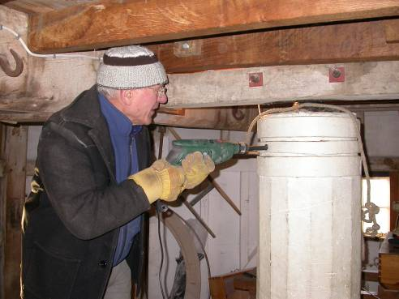
Mike Newland ready to continue drilling the upright shaft Photo: D.L. Pearce

detached wings. This would be a lengthy job: the components of the upright shaft are heavy, and are essentially built into the mill. We would then have to decide on a repair: with luck it would be practicable to weld the wings back in place (cast iron welding is a difficult task), or alternatively a new casting would have to be made. Either route would take considerable time, and then the whole shaft would have to be set up again, and trued up. As an alternative holding repair it was decided to drill radially through the gudgeon at the top of the lower section of the upright shaft. The 20mm diameter hole went through one of the wrought iron clamping rings, through the timber shaft, and through the iron gudgeon and then the rest of the way through the shaft, a distance of 15¾” (400mm) altogether (see picture). A ¾” (19mm) bolt was made and fitted, to transmit the torque. The whole process was repeated in a direction perpendicular to the first bolt.

Further evidence of the mill’s history was revealed from an attempted hole through the third wrought iron ring. When drilling through the gudgeon the metal suddenly became soft. Although it was possible to remove some swarf from the hole it was not possible to withdraw the drill. Inspection showed that the swarf was lead. It would seem there was a significant blow hole from new in the iron casting, and that this was filled with lead for cosmetic reasons. This is likely to have contributed to the recent failure. One wonders if the original miller knew of the fault: even so the coupling lasted at least 100 years, possibly much more, in service.

We will see how the holding repair fairs. If necessary we will have to do a full repair, rebuilding or replacing the failed casting, this would best be begun during the May work-in. This would probably mean the mill being out of action for several weeks during the summer. Hopefully the holding repairs will last a long time.

OBTAINING FLOUR
Flour can be obtained at the mill on open days, see below for 2009’s open day schedule. Also the mill is open on any occasion on which the sails are turning (contact Dave Pearce to find out about these extra open days).

Additionally wholemeal can be obtained on most days from the National Trust at Wicken Fen.

Further, it’s always worth enquiring: if you live near Dave, or Jacqui, please contact them: local flour supply might be possible.

The principal flours we sell are wholemeal, white, and finest white, and we also supply semolina and bran. Most flour is sold in 1½kg bags, but we are now making it available in 25kg bags.

- WORK SESSION & OPEN DAY PROGRAMME
Sat | Jan 3 |  |  | Sat | June 27 | Wicken Fête
Sun | Feb 1 |  |  | Sat | July 4
 |  |  |  | Sun | July 5
Sat | Mar 7 | AGM
Sun | Mar 8 |  |  | Sat | Aug 1
 |  |  |  | Sun | Aug 2
Sat | Apr 4
Sun | Apr 5 |  |  | Sat | Aug 29 | Late Summer Work-in
Mon | Apr 13 | Easter Monday |  | Sun | Aug 30 | "
 |  |  |  | Mon | Aug 31 | Late Summer Bank Holiday
Sat | May 2 | Spring Work-in |  |  | Sept 1  -Sept 4 | Late Summer Work-in
Sun | May 3 | “ |  | Sat | Sept 5
 | May 4 | May Day Holiday |  | Sun | Sept 6
 | May 5-8 | Spring Work-in |  | Sat | Sept 12 | National Heritage Day
Sat | May 9 | National Mills Saturday
Sun | May 10 | National Mills Sunday |  | Sat | Oct 3
Sat | May 16 | SPAB tour late afternoon |  | Sun | Oct 4
Mon | May 25 | Spring Bank Holiday |  | Sat | Nov 7
 |  |  |  | Sun | Nov 8
Sat | June 6
Sun | June 7 |  |  | Sat | Dec 5

Main Work-ins in red. Provisional dates in green.

Voluntary help is still needed as much as ever, as we continue with the mammoth task of maintaining, protecting and working the mill. If you would like to help (and assistance is by no means limited to skilled repair work) please contact us on the phone numbers below.

The mill address: The mill web site:
The Windmill, www.geocites.com\wickenmill
23 High Street,
Wicken,
Cambridgeshire
CB7 5XR

For further information on the work-ins contact Dave Pearce, 01664 822751

For information on the Friends Association, membership, flour etc, contact
Jacqui Ward, 01628 782946, or Dave Pearce.

NB Although Nigel’s milling operation is organic, we cannot describe our flour as organic since we cannot afford to have the mill certificated: this would cost something like £500.

