Nose | Shoulder | Front toes (how many?)
Mouth | Back/Saddle | Back toes (how many?)
Eye | Abdomen | Ear
Crown | Rump/Hindquarters | Hip
Cheek | Chest | Side of Cavy (Flank)

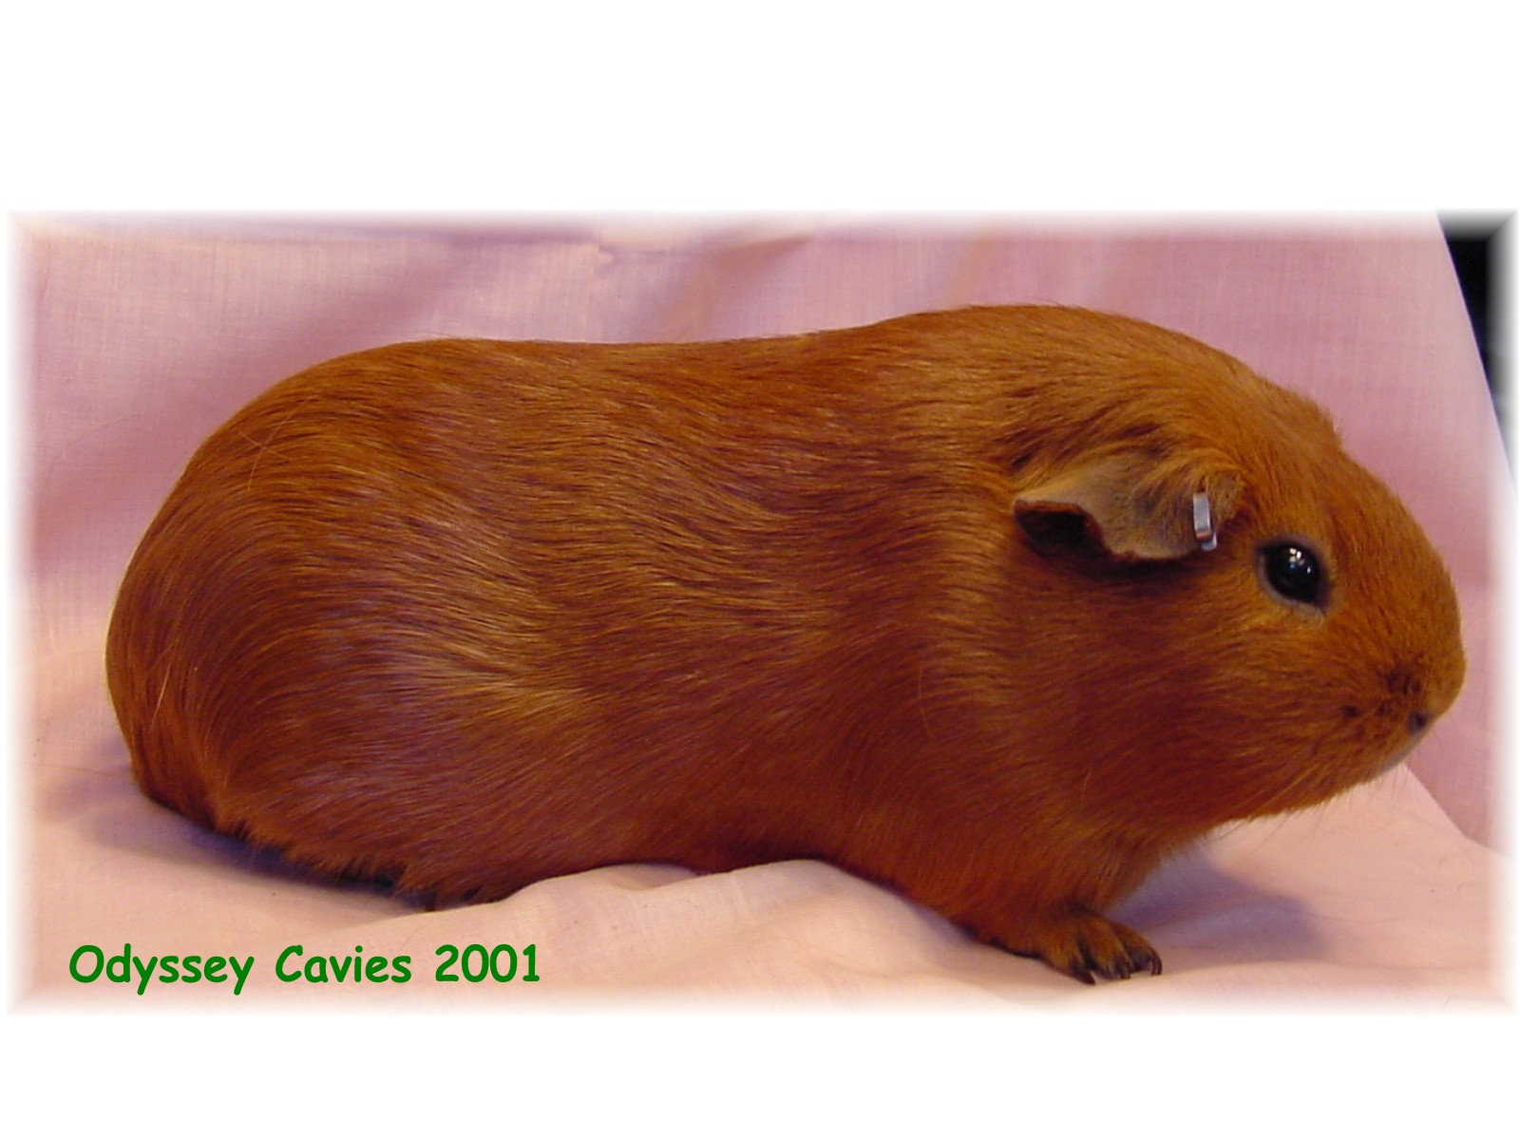

THE CAVY

