In addition to the basic cavy anatomy the Abyssinian and Abyssinian Satin will have….
 | - Rump Rosettes (how many?)
 | - Shoulder Rosettes (how many?)
 | - Hip Rosettes (how many?)
 | - Saddle Rosettes (how many?)
 | - Mane | - Back Ridge | - Mustache
 | - Rump Ridge | - Collar

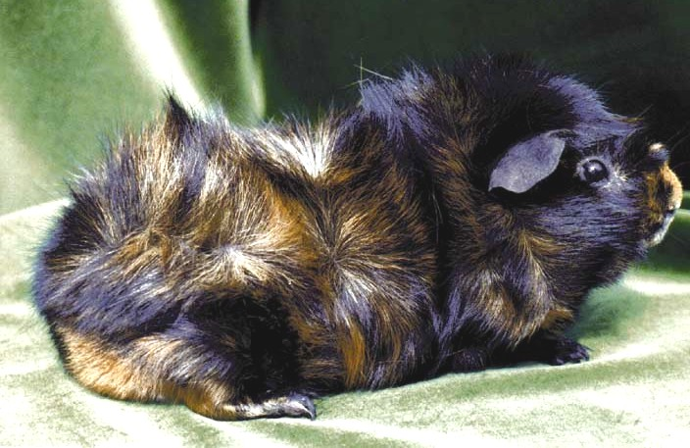

THE ABYSSINIAN AND ABYSSINIAN SATIN CAVY

