In addition to the basic cavy anatomy the Coronet will have….
 | - Coronet | - Cheek Sweeps
 | - Side Sweeps | - Mane
 | - Rear Sweeps

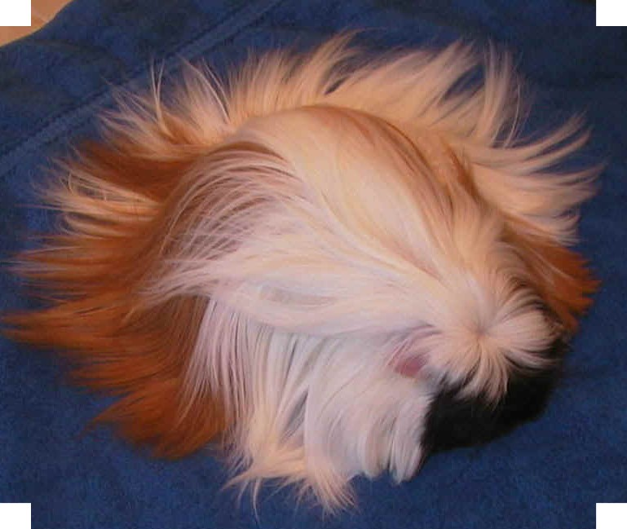

THE CORONET CAVY

