In addition to the basic cavy anatomy the Peruvian and Peruvian Satin will have…
- Head Furnishings (What else is it called?)
- Rear Sweeps
- Side Sweeps

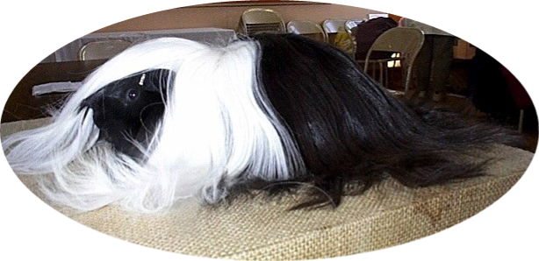

THE PERUVIAN and PERUVIAN SATIN CAVY

