SEARS 3-POINT HITCH - - MODEL NUMBERS 917.253050 AND 917.253060

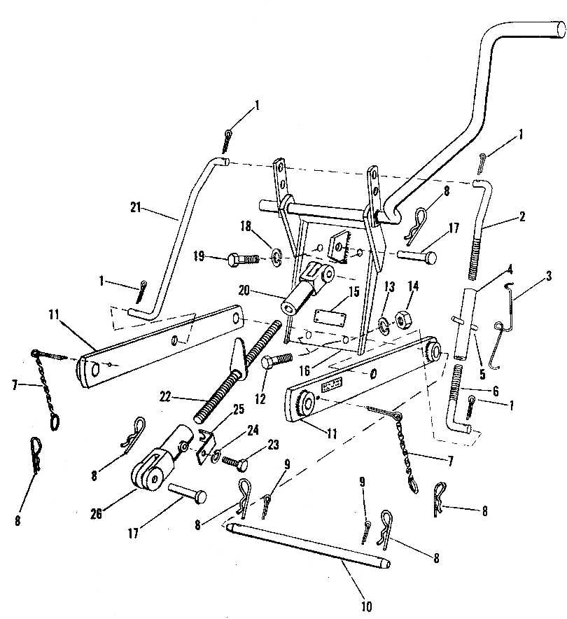

SEARS 3-POINT HITCH - - MODEL NUMBERS 917.253050 AND 917.253060

KEY  NO. | PART  NO. | DESCRIPTION
1 | 120169 | Cotter Pin 5/32 x 1
2 | 8924H | Lift Link, Upper – R.H.
3 | 1592H | Turnbuckle Spring
4 | 606A 108 | Turnbuckle, Spring, and Roll Pin  (Incl. Key No’s. 3, 4 and 5)
5 | 9710M | Roll Pin
6 | 8923H | Lift Link, Lower – R.H.
7 | 5012H | Chain, Ring and Cotter
8 | 4940M | Retainer Spring
9 | 456723 | Cotter Pin 3/16 x 1
10 | 5316H | Link Pin, Lower
11 | 634A290 | Hitch Bar and Bushings, Lower
12 | 100147 | Bolt, Hex 7/16 – 14 x 1¼
13 | 103328 | Lockwasher 7/16
14 | 271501 | Nut, Hex 7/16 - 14

15 | -------- | Model Plate Number
16 | 634A292 | Hitch Mount Assembly with Lever  (For Model Number 917.253050)
16 | 634A295 | Hitch Mount Assembly with Lever  (For Model Number 917.253060)
17 | 8940H | Clevis Pin
18 | 456122 | Lockwasher ½
19 | 120426 | Bolt, Hex ½ - 13 x 1¼
20 | 8936H | Clevis, L.H. Thread
21 | 8925H | Lift Link – L.H.
22 | 634A294 | Adjusting Screw and Handle
23 | 121797 | Bolt, Hex ¼ - 20 x 3/8
24 | 131098 | Lockwasher ¼ heavy
25 | 8939H | Spring, Adjusting Screw
26 | 8935H | Clevis, R.H. Thread
--- | 8947H | Instruction and Parts Book

